

**SIP-T520 / T520（P/G）**

**User Manual**

­­­

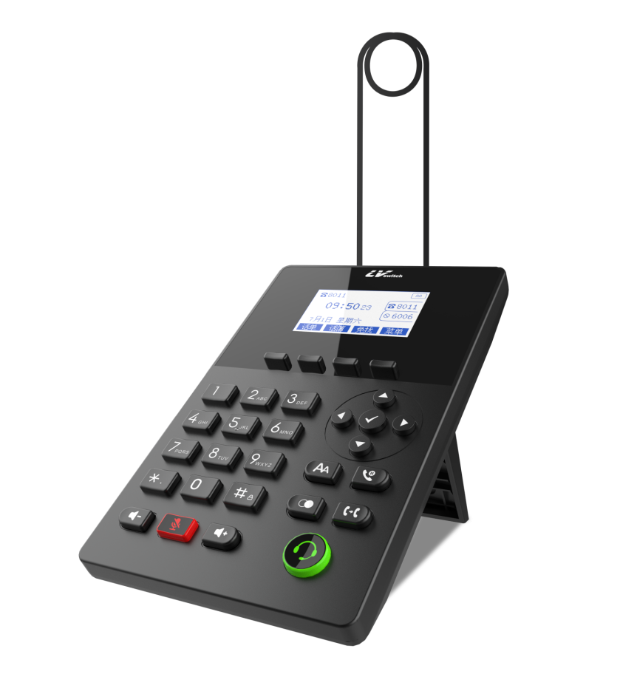

文档版本：V.3.1.0

发布日期：2025/09/04

copyright

**Copyright © 2020 All rights reserved by Guangdong Shanglu Information Technology Co., Ltd.**

Without the explicit written permission of Guangdong Shanglu Information Technology Co., Ltd., no unit or individual may reproduce, copy or translate any part or all of the content of this manual without authorization.

It shall not be used for commercial purposes or profit-making in any form or manner (electronic, video, printing or other means). Guangdong Shanglu Information Technology Co., Ltd. will not be held responsible for any property or other losses caused by any illegal acts resulting from this.

When this document is used for online dissemination, the company allows users to download or print it for personal use.

Pledge

The product specifications and consultations mentioned in this manual are for reference only. If there are any updates, no further notice will be given. Unless otherwise specified, this manual is only used as a guidance for usage. It strives to provide the most accurate statements, information and suggestions, and does not guarantee any express or implied warranties. Users are fully responsible for the application of the product.

Guangdong Shanglu Information Technology Co., Ltd. makes no guarantees for this guide, including but not limited to implied warranties of merchantability and fitness for a particular purpose. Guangdong Shanglu Information Technology Co., Ltd. shall not be liable for any indirect or consequential losses caused by the incorrect use of this guide.

**Statement**

This device complies with the basic requirements of CE and FCC as well as other relevant regulations. You can find the CE and FCC information on the label on the back of the phone.

https://timgsa.baidu.com/timg?image&quality=80&size=b9999_10000&sec=1589776726290&di=ce3772cb458fa039d7fa28dd83625289&imgtype=0&src=http%3A%2F%2Fa.img.youboy.com%2Fcoimg%2F2009%2F9%2F18%2Fg3_1632922.jpg

CE design

**This equipment complies with the EU's safety regulations directive 2014/35/EU and the electromagnetic compatibility directive 2014/30/EU.**

Part 15 of the FCC regulations

The equipment complies with Part 15 of the FCC regulations. When in operation, it must adhere to the following two requirements:

1. The equipment shall not generate harmful interference.

2. The equipment must accept any interference received, including those that may cause accidental operation.

WEEE logo

Due to the presence of certain harmful substances in electronic products, in order to properly dispose of these electronic and electrical waste materials and recover valuable resources, when users plan to discard this product, it should not be thrown together with other household garbage; instead, it should be handled separately.



customer feedback

We are making efforts to improve the quality of the documents and are very glad to receive your feedback. If you have any suggestions or questions regarding the content of the documents, please send your feedback to the following email address: pan.jiandong@lvswitches.com.

The purpose of writing

Thank you for using the SIP-T520/SIP-T520(P/G) desk phone (hereinafter referred to as T520 or T520 phone). The T520 is a feature-rich and simple office phone. Besides, it also has high-definition sound quality, unique design, multi-language interchange; supports dual network ports and POE power supply; and is compatible with many service platforms of various manufacturers, such as IPPBX, cloud PBX, IMS core network, softswitch, etc.

The T520/T520(P/G) use the same firmware and have the same software functions. The differences lie in the hardware. The following table lists the differences in hardware among these models.

|  |  |
| --- | --- |
| Product model | Specification |
| SIP-T520 | Standard version |
| SIP-T520(P/G) | P(With PoE power supply)  G (With Gigabit network port) |

This guide covers all the functions of the phone and provides usage instructions, making it convenient for users to familiarize themselves with the functions of the T520 phone. Before installing the phone, please first read the sections on safe usage instructions and the packing list in this guide, so as to use the phone safely and quickly.

For further assistance, please contact your network administrator or the dealer.

## **The content of the instruction manual**

This guide contains the following contents:

* [1. Overview](#_概述)
* [2. safe Notes on](#_安全使用须知)
* [3. Phones Getting Started with](#_话机入门)
* [4. Telephone customization](#_话机自定义)
* [5. Basic functions](#_基本功能)
* [6. Advanced features](#_高级功能)

# Catalogue

[copyright 2](#_Toc19003)

[Pledge 2](#_Toc21651)

[Statement 2](#_Toc21970)

[CE design 2](#_Toc25134)

[Part 15 of the FCC regulations 2](#_Toc31230)

[WEEE logo 3](#_Toc29780)

[customer feedback 3](#_Toc5808)

[The content of the instruction manual 4](#_Toc14192)

[Catalogue 5](#_Toc18913)

[Overview 8](#_Toc20463)

[Hardware Composition 8](#_Toc29526)

[Display icon composition 11](#_Toc24413)

[Configuration Interface Description 12](#_Toc29634)

[Phone Interface Configuration 12](#_Toc23449)

[Computer Web Configuration 13](#_Toc27059)

[Mobile Scanning Configuration 13](#_Toc4212)

[Using Documents 18](#_Toc815)

[Safe Use 19](#_Toc10103)

[Getting Started with Phones 21](#_Toc28906)

[Packing List 21](#_Toc11936)

[Phone Installation 23](#_Toc12411)

[Mounting base 24](#_Toc7776)

[Connecting headset monitor port（optional） 24](#_Toc19714)

[Connecting the power supply and network cable 24](#_Toc29201)

[Phone initialization 26](#_Toc8677)

[Phone Standby Interface 26](#_Toc19167)

[Check the status of your phone 27](#_Toc27012)

[Setting up the phone network 28](#_Toc14345)

[Register for an account 31](#_Toc10126)

[Phone Input Methods 31](#_Toc30833)

[Phone customization 34](#_Toc21857)

[Basic settings 34](#_Toc1529)

[multilingualism 34](#_Toc15207)

[Time & Date 36](#_Toc11563)

[Call-out button 41](#_Toc10918)

[keypad lock 42](#_Toc24334)

[Backlight 45](#_Toc3003)

[Pop-up notification window 45](#_Toc30391)

[Boot Picture 46](#_Toc13992)

[screensavers 47](#_Toc14427)

[Power saving mode 48](#_Toc25120)

[Sound Settings 49](#_Toc15848)

[Volume settings 50](#_Toc11835)

[Ringtone Setting 51](#_Toc25968)

[Keypad tone 52](#_Toc11699)

[SMS alert tone 52](#_Toc14320)

[Signal tone 53](#_Toc10778)

[Sound Gain 55](#_Toc13103)

[Contact Management 57](#_Toc677)

[local contact 57](#_Toc30675)

[Blacklists 65](#_Toc17033)

[LDAP Configuration 68](#_Toc9435)

[Call Record Management 72](#_Toc13047)

[Remote address book 74](#_Toc13339)

[Update Address Book 77](#_Toc3640)

[Address Book Settings 78](#_Toc1906)

[Headset using 79](#_Toc25729)

[System Customization 80](#_Toc5326)

[Account Management 80](#_Toc2155)

[Programmable keys 84](#_Toc20285)

[Dialing Rules 88](#_Toc18489)

[Basic Functions 99](#_Toc7581)

[make a telephone call 99](#_Toc8792)

[Answer the phone 101](#_Toc29605)

[End a call 102](#_Toc22194)

[Redial 102](#_Toc2142)

[DND 102](#_Toc976)

[Call transfer 104](#_Toc15688)

[Active transfer 105](#_Toc13795)

[Automatic transfer 105](#_Toc9148)

[Call forwarding 109](#_Toc16162)

[Blind transfer 110](#_Toc14924)

[Advisory Transfer 111](#_Toc11306)

[Call Waiting 113](#_Toc2605)

[PIN call 114](#_Toc31805)

[Call hold 115](#_Toc19699)

[Automatic redial 116](#_Toc17553)

[Status return code 117](#_Toc17701)

[Call completion. 117](#_Toc24340)

[Anonymous call 119](#_Toc2160)

[Hotline 121](#_Toc2127)

[Two-dimensional barcode 123](#_Toc12426)

[Conference 124](#_Toc11591)

[Update 126](#_Toc20474)

[Upload ringtones 127](#_Toc29074)

[Capture & Diagnose 128](#_Toc12903)

[Scheduled reset 129](#_Toc30463)

[Configuration management 129](#_Toc27678)

[Advanced Features 131](#_Toc31611)

[Message 131](#_Toc6884)

[Text message 131](#_Toc18201)

[Voicemail 134](#_Toc2649)

[TR069 135](#_Toc29546)

[Automatic update 137](#_Toc16502)

[Preparatory step 137](#_Toc7816)

[Automatic update procedure 139](#_Toc23270)

[Remote control 142](#_Toc28541)

[SIP Configuration 145](#_Toc11347)

[SIP Session Timer 145](#_Toc16116)

[Native SIP ports vs. TLS SIP ports 147](#_Toc16597)

[Action URL 147](#_Toc3667)

[Enables actions to be reported to the server 148](#_Toc27433)

[Description of variables 150](#_Toc2215)

[Web Configuration Instructions 151](#_Toc18525)

[Type of web access 151](#_Toc25622)

[Trusted Certificates 153](#_Toc22031)

# **Overview**

This chapter provides a brief overview of the T520 phone. The main contents are as follows:

* [Hardware Composition](#_硬件组成)
* [Description of display icon](#_显示屏图标组成)
* [Indicator light description](#_指示灯说明)
* [Configuration Interface Description](#_配置界面说明)
* [Using Documents](#_使用文档)

## **Hardware Composition**

The hardware components of the T520 phone mainly include the panel control panel and the liquid crystal display. As shown in the following picture: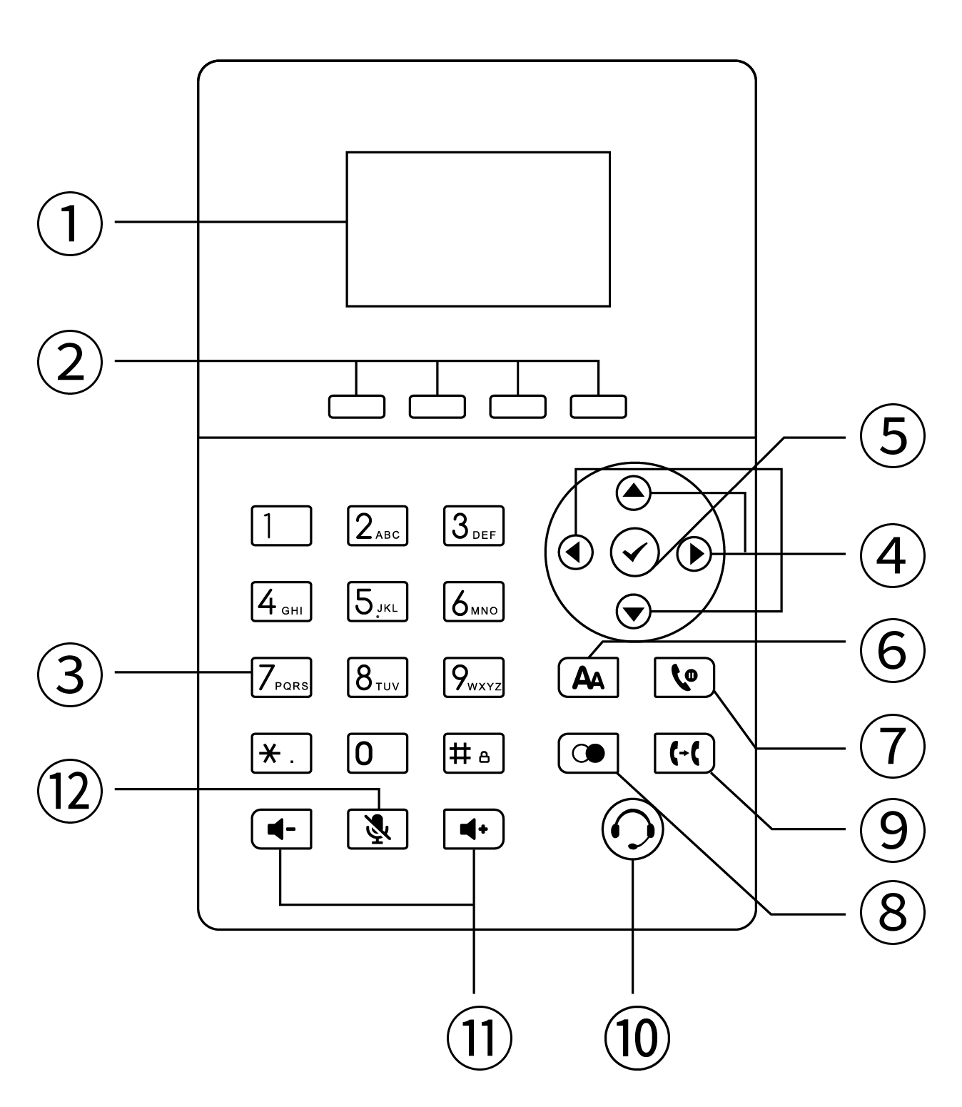

|  |  |  |
| --- | --- | --- |
| Serial number | Name | description |
| 1 | LCD | Display the relevant information of the phone:  - Account registration information (display name, display number).  - Date and time.  - Notification icons (for details, please refer to the display icon instructions).  - Notification messages (incoming call, missed call, email message).  - Operation prompts. |
| 2 | Four soft keys (below the display screen) | The four function names at the bottom of the display screen  (For example, in the main interface, the default 4 soft key functions are: call history, call log, interruption, and menu).  These 4 soft keys will change along with the operation of the phone buttons. In the following function descriptions, the soft keys referred to are these four keys, and the functions of the soft keys correspond to the text at the bottom of the display screen. |
| 3 | numeric keypad | Provide input of numbers, capital and lowercase letters, and punctuation marks (\* # . :) . |
| 4 | Up, down, left and right buttons | Options for switching the display. |
| 5 | 确定按钮_画板 1BUTTON | -Function settings confirmation operation.  - Enter the number and make the call.  - Answer the incoming call.  - View the network status (IP address, MAC address, version information, etc.). |
| 6 | Automatic response key | Used for enabling/disabling the automatic response |
| 7 | Hold key | Used to switch to the hold mode during a call |
| 8 | Redial key | Used for redialing. |
| 9 | Transfer key | - Blind transfer.  - Call transfer upon inquiry.  - Quickly switch call transfer when the phone is idle.  This can also be achieved through the soft keys on the bottom of the screen. |
| 10 | Headset button | Default headset mode. When receiving a call, press the headset button to answer the call. During a call, press the headset button to end the call. |
| 11 | Volume up/down buttons | Provide a volume setting ranging from 0 to 15. |
| 12 | Mute button | Pressing the mute button during a call will mute the call. |

## **Display icon composition**

The T520 display screen mainly uses icons and the corresponding descriptions are as follows in the table:

|  |  |  |
| --- | --- | --- |
| typology | Icon Style | Icon Description |
| account correlation | C:\Users\Administrator\Desktop\话机图片图标\图标\禁用，注册失败.gif | Account not enabled/not registered. |
| C:\Users\Administrator\Desktop\话机图片图标\图标\未注册.gif | Account registration in progress. |
| C:\Users\Administrator\Desktop\话机图片图标\图标\已注册.gif | Account is registered. |
| Voice status | C:\Users\Administrator\Desktop\话机图片图标\图标\DND.gif | Phones are free of interruptions. |
| C:\Users\Administrator\Desktop\话机图片图标\图标\AA.gif | Auto-answer. |
| C:\Users\Administrator\Desktop\话机图片图标\图标\未接来电.gif | Missed calls. |
| C:\Users\Administrator\Desktop\话机图片图标\图标\语音信息.gif | Voice mail. |
| C:\Users\C\AppData\Local\Microsoft\Windows\INetCache\Content.Word\文本信息.png | Text message. |
| 静音模式 | The phone is in mute mode. |
| C:\Users\Administrator\Desktop\话机图片图标\图标\免提模式.gif | Hands-free mode for calls. |
| C:\Users\Administrator\Desktop\话机图片图标\图标\手柄模式.gif | Call Handle Mode. |
| C:\Users\Administrator\Desktop\话机图片图标\图标\耳麦模式.gif | Talking headset mode. |
| C:\Users\Administrator\Desktop\话机图片图标\图标\静音.gif | Call mute. |
| C:\Users\Administrator\Desktop\话机图片图标\图标\呼叫转移.gif | Call Forwarding Enabled. |
| call sheet  icon | C:\Users\Administrator\Desktop\话机图片图标\图标\未接来电.gif | Missed calls. |
| C:\Users\Administrator\Desktop\话机图片图标\图标\已接来电.gif | Received call. |
| C:\Users\Administrator\Desktop\话机图片图标\图标\已拨号码.gif | Dialed number. |
| C:\Users\Administrator\Desktop\话机图片图标\图标\呼叫转移.gif | Transferring calls. |
| system icon | **C:\Users\C\AppData\Local\Microsoft\Windows\INetCache\Content.Word\网络不可用.png** | The network is not available. |

## **Configuration Interface Description**

The T520 supports the following ways to configure the phone:

* [Phone Interface Configuration](#_话机界面配置)
* [Computer Web Configuration](#_电脑网页配置)
* [Mobile Scan Web Configuration](#_手机扫码配置)

Quickly configure the phone, through the phone LCD display and the phone keypad panel you can configure and use the phone functions. If you know the IP address of the phone, you can also enter the IP address of the phone into your browser to view all the features of the phone and configure them through your browser. If you don't have a computer nearby you can use your smartphone to scan the QR code provided by the phone to configure it. The details are described below:

### **Phone Interface Configuration**

**Enter the menu through the soft key of the phone, you can configure the basic settings (language, ringtone, etc.), and configure the advanced settings (account number, network, etc.), to enter the advanced settings you need to enter the administrator password, the initial administrator password of the T520 is admin, enter it and enter. Meanwhile, there are some basic functions in the menu, please check the introduction of specific function settings.** [Function Configuration](#_基本功能_1) **Chapter.**

### **Computer Web Configuration**

**- Method to view the IP address (IPv4 or IPv6) of the phone:**

**It can be viewed in any of the following ways:**

**1. Press the** 确定按钮_画板 1 **button to view.**

**2. Press the Menu soft key -> Enter Status Options to view.**

**Description**  **IPv4 address e.g. 192.168.1.123.**

**IPv6 addresses such as** 2003:4998:c:e33::1004 **.**

**After obtaining the IP address of the phone, enter the IP address in the web browser of your computer, for example: IPv4 address (192.168.1.123 or http://192.168.1.123), IPv6 address ([**2003:4998:c:e33::1004**] or http://[2003:4998:c:e33::1004]), enter the phone login page, use the login account password to enter the main interface, the initial administrator account password is lowercase admin. For the specific function settings, please refer to** [Function Configuration](#_基本功能) **Chapter.**

### **Mobile Scanning Configuration**

**Get the QR code of the phone through the QR code function of the phone, before scanning, the smartphone needs to be connected to the same network as the phone's WIFI, in order to use the smartphone to scan the QR code to access the phone's management page, the specific function setup introduction, please check the** [Function Configuration](#_基本功能) **Chapter. For more help, please contact your network administrator.**

**A comparison of the features that can be configured on the three configuration method is shown below：**

|  |  |  |  |
| --- | --- | --- | --- |
| **functional item** | **Phone Configuration** | **Web Configuration** | **Scanning Configuration** |
| **Status** | **√** | **√** | **√** |
| **├ IPv4** |
| **├ IPv6** |
| **├ MAC address** |
| **├ Version number** |
| **└ MORE** |
| **├ Network** |
| **├ Device** |
| **└ Accounts** |
| **account** |  | **√** | **√** |
| **├ User information** | **√** |
| **├ Label** | **√** |
| **├ Display name** | **√** |
| **├ User name** | **√** |
| **├ Register name** | **√** |
| **└ Password** | **√** |
| **└ Domain name** | **×** |
| **├ Server information** |  |
| **├ Sip server 1** | **√** |
| **├ Sip server 2** | **√** |
| **├ Sip port number** | **√** |
| **├ Transmission mode** | **√** |
| **├ Re-registration times** | **×** |
| **├ Server Expires** | **×** |
| **├ Auto Answer** | **√** |
| **├ Proxy Server** | **√** |
| **└ NAT** | **√** |
| **├ Codec Setting** |  |
| **├ Account codec** | **√** |
| **└ IP direct dial codec** | **×** |
| **└ Advanced** |  |
| **├ DTMF** | **√** |
| **├ User Agent** | **×** |
| **├ SRTP** | **×** |
| **├ RTP Port range** | **×** |
| **├ Share line** | **×** |
| **├Mode of renewal** | **×** |
| **├ Reliable transmission of temporary responses** | **×** |
| **├ Caller ID field** | **×** |
| **├ Session timer** | **×** |
| **├ Session Heartbeat** | **×** |
| **├ SIP Registration retry time** | **×** |
| **├ Conference types** | **×** |
| **├ Intercept feature code** | **×** |
| **├ Unregister when restart** | **×** |
| **├ RFC 2543 hold mode** | **×** |
| **├ Synchronize server time** | **×** |
| **├ is not registered for dialing** | **×** |
| **├ Allows Contact to be overwritten** | **×** |
| **└ Rtp Check** | **×** |
| **Network setting** |  | **√** | **√** |
| **├ Basic Setting** |  |
| **└ IPv4/IPv6/IPv4 & IPv6** | **√** |
| **├ DHCP** | **√** |
| **└ Static IP** | **√** |
| **├ Advanced Setting** |  |
| **├ CDP & LLDP** | **√** |
| **├ VLAN** | **√** |
| **├ Voice Qos** | **×** |
| **├ Web Server Type** | **√** |
| **└ VPN** |  |
| **├ OpenVPN** | **×** |
| **└ L2TP** | **×** |
| **├ Diagnosis** |  |
| **├ Pcap** |  |
| **├ Normal Pcap** | **×** |
| **└ Enhanced Pcap** | **×** |
| **├ log** |  |
| **├ local log** | **×** |
| **└ Cloud log** | **×** |
| **└ Diagnostics** |  |
| **├ Ping** | **√** |
| **└ Traceroute** | **√** |
| **├ NAT** |  |
| **└ STUN** | **×** |
| **└ SNMP** | **×** |
| **Basic functions** |  | **√** | **√** |
| **├ Call forward** |  |
| **├ Always Forward** | **√** |
| **├ Busy Forward** | **√** |
| **└ No Answer Forward** | **√** |
| **├ Call transfer** | **√** |
| **├ Auto answer** | **√** |
| **├ Anonymous Rejection** | **√** |
| **├ Local Anonymous** | **√** |
| **├ Hotline** | **√** |
| **├ call hold** |  |
| **├ hold tone** | **×** |
| **└ hold tone interval** | **×** |
| **├ number filter** | **×** |
| **├ qr code** | **√** |
| **├ DND** | **√** |
| **├ CALL WAITING** | **√** |
| **├ password prefix** | **×** |
| **└ conference** |  |
| **├local conference** | **×** |
| **└ network conference** | **×** |
| **Advanced features** |  | **√** | **√** |
| **├ messages** |  |
| **├text messages** | **√** |
| **└ voice messages** | **√** |
| **├ auto redial** | **√** |
| **├status return code** | **×** |
| **├ dual headset feature** | **×** |
| **├ headset priority** | **×** |
| **├ Action URL** | **×** |
| **├ remote control** | **×** |
| **└ auto provision** | **√** |
| **Customizaiton** |  | **√** | **√** |
| **├ sounds** |  |
| **├ Key Tone** | **√** |
| **├ Ring** | **√** |
| **├ SMS Beep** | **×** |
| **├ Signal Tones** | **×** |
| **└ Sound Gain** | **√** |
| **├ Display** |  |
| **├ Time&date** | **√** |
| **├ Language** | **√** |
| **├ Power LED** | **×** |
| **├ Notification Popups** | **×** |
| **├ Backlight** | **×** |
| **├ BootUP Image** | **×** |
| **└ ScreenSaver** | **×** |
| **├ call out key** | **√** |
| **├ dial plan** | **×** |
| **├ programmable button** |  |
| **└ funtion key** | **×** |
| **├ keypad lock** | **√** |
| **├time reboot** | **×** |
| **├ import/export configuration** | **×** |
| **├ TR069** | **×** |
| **├ softkey setting** | **×** |
| **└ SIP setting** | **×** |
| **Directory** |  | **√** | **√** |
| **├ Local Contacts** | **√** |
| **├ Blacklist** | **√** |
| **├ Remote Phone Book** | **×** |
| **├ History** | **√** |
| **├ Update Directory** | **×** |
| **└ LDAP** | **×** |
| Security | **×** |
| **├ Password** | **×** |
| **├ Advanced setting password** |  | **√** | **√** |
| **└ Trusted certificate** | **×** |
| **├ Local Contacts** | **√** |
| **├ Blacklist** | **×** |

**Explanation: Scanning the QR code for configuring the phone is the same as configuring the phone function through the computer webpage. The following text only shows the illustrations for the configuration on the computer webpage.**

## **Using Documents**

The SIP-T520 is supplied with the following technical support manual:

|  |  |  |  |
| --- | --- | --- | --- |
| name | clarification | Where to get | Language type |
| Quick Start Manual | Includes easy installation and customization of the phone | Comes with phone package | Chinese/English |
| official download |
| SIP-T520P User's Guide | Detailed Functions and Usage | official download | Chinese/English |

# **Safe Use**

Please read the safety instructions carefully before installing and using the phone to ensure safe and convenient use of the phone!

* Use the power adapter specified for the product (included in the package). If you need to use a power adapter supplied by another manufacturer, please make sure that the voltage and current of the supplied adapter are in accordance with the specifications of the product (see details [Connecting the power supply and network cable](#_连接电源与网线) chapter ), and it is also recommended to use a product that has passed the safety certification, otherwise it may cause damage to the equipment or even result in fire or electric shock accidents. Before using this product, please check whether the power cord is damaged or not. Do not use damaged power cords and power cords in abnormal condition, such as twisted, stretched, or bundled power cords, as this may cause fire and electric shock accidents.
* Non-technical service personnel do not disassemble or repair the product by yourself, improper installation or repair may cause electric shock, fire and other accidents, while your product warranty will be invalidated. For technical support, please contact the agent or your network administrator.
* Maintain the temperature and humidity of the product to meet the working requirements of the product. Ensure that the product is placed flat on the working platform, and check that the anti-slip rubber on the base of the product has not come off and caused the phone to slide on the platform. Place the device away from electrical appliances with strong magnetic or electric fields, such as microwave ovens or refrigerators. Keep the device away from sources of ignition.
* Do not put metal foreign objects such as large pins, wires, etc. into the vents or crevices. Otherwise, it may cause electric shock and other injuries caused by the current passing through the metal foreign objects. If foreign objects or similar metal objects fall into the product, it should be stopped in time.
* This product contains small parts inside, place the device out of reach of children to avoid accidental swallowing of small parts.
* If you need to clean the phone, please cut off the power supply, use a dry rag to wipe, and after cleaning, place it in a ventilated place to dry naturally, the power adapter needs to be kept dry and clean, otherwise accidents may occur.

# **Getting Started with Phones**

This chapter introduces you to getting started with the SIP-T520 as follows:

* [Packing List](#_包装清单)
* [Phone Installation](#_话机安装)
* [Phone initialization](#_话机初始化)
* [Phone Standby Interface](#_话机待机界面)
* [Check the status of your phone](#_查看话机状态)
* [Setting up the phone network](#_设置话机网络)
* [Register for an account](#_注册账号)
* [Phone Input Methods and Input Methods](#_话机输入法与输入方式)

## **Packing List**

The following accessories are included in the shipping package of the SIP-T520:

|  |  |  |
| --- | --- | --- |
| Accessory Name | quantities | photograph |
| T520 phone | ×1 | SIP-T520-4 |
| T520 phone stand | ×1 | a8bc3560c8d5756f369b3d8ce777330 |
| **Ethernet cable** | ×1 | C:\Users\Administrator\Desktop\111.png |
| Power adapter (5.5mm DC plug 5V ⎓ 1A) | ×1 | C:\Users\Administrator\Desktop\2222.png |
| Quick Start Guide | ×1 | C:\Users\C\Desktop\ipphone说明书.png |

**Instruction** Before installing the phone, please check the completeness of the accessories according to the packing list, if any accessories are missing, please contact your network administrator or seller.

## **Phone Installation**

If you have already successfully installed the phone, skip this section and navigate to the [Initializing the Phone](#_话机初始化) section.

The installation steps are as follows:

* [Mounting Base](#_安装底座)
* [Connection handle, headset (optional)](#_连接手柄、耳麦（可选）)
* [Connecting the power supply and network cable](#_连接电源与网线)

### **Mounting base**

**- desktop mounting**

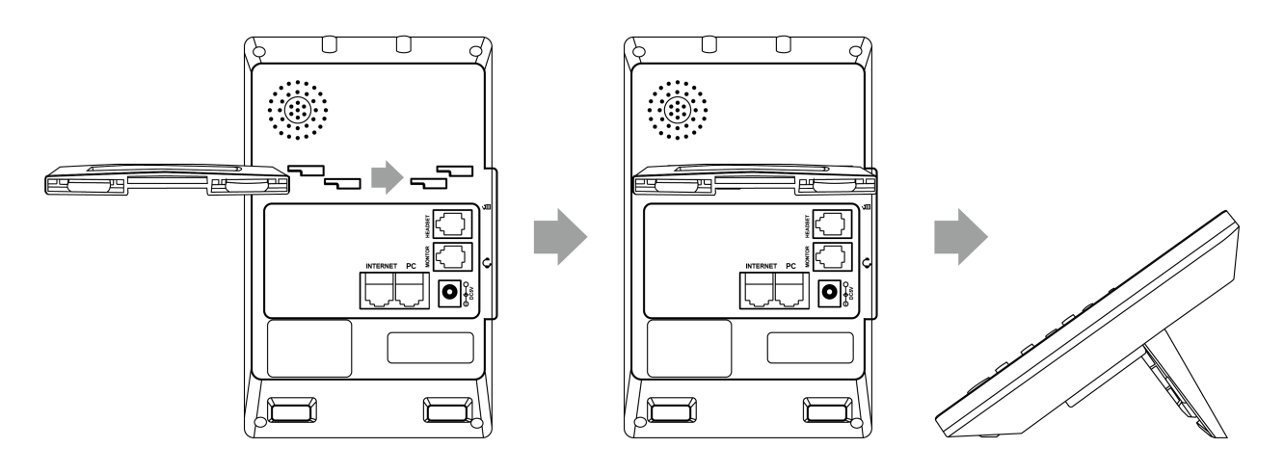

### **Connecting headset monitor port（optional）**

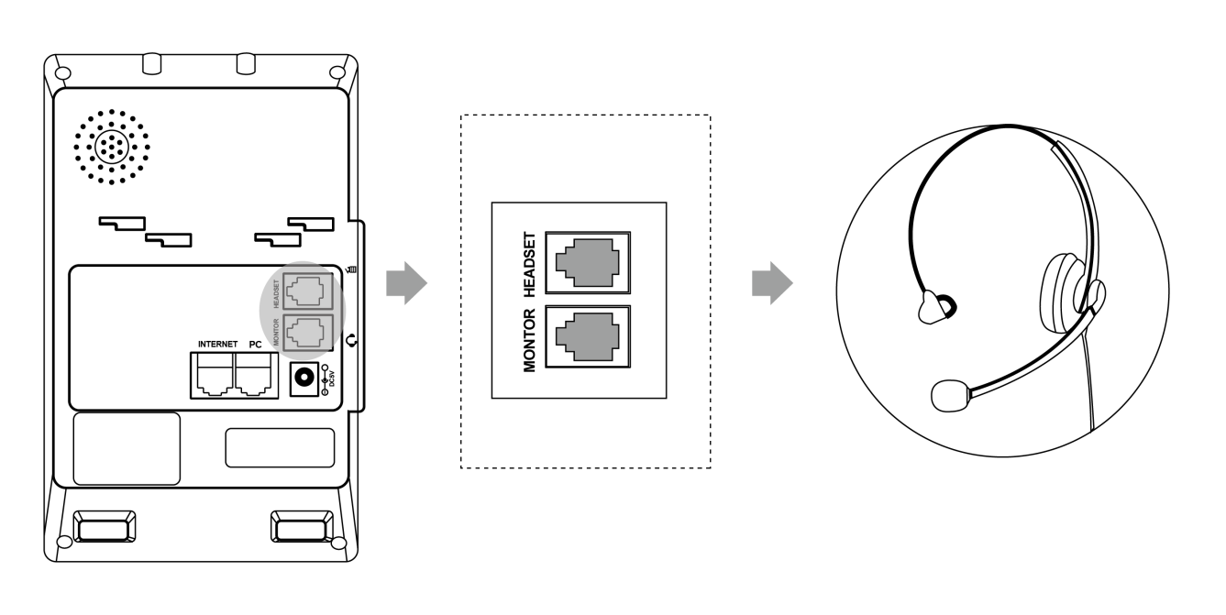

The Headset slot is for the earphone jack, and the Monitor slot is for the monitoring jack. Connect this interface if assistance is needed.

### **Connecting the power supply and network cable**

The phone supports two power supply methods:

a) AC power supply

b) POE power supply

- AC power supply

Use the power adapter provided in the package to connect the power socket to the DC 5V port of the telephone; use the Ethernet cable provided in the package or a standard parallel network cable to connect the upper-level switch/router to the Internet port on the back of the telephone.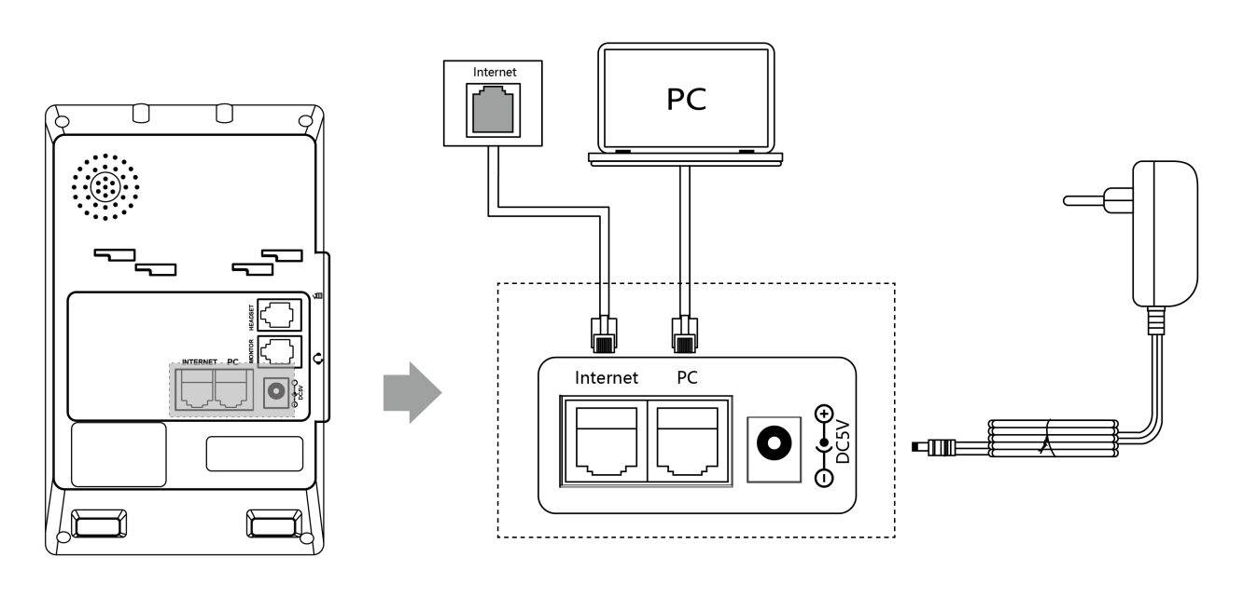­

- PoE power supply

Connect the PoE-powered switch hub and the patch panel to the Internet port on the back of the T520 phone using an Ethernet cable.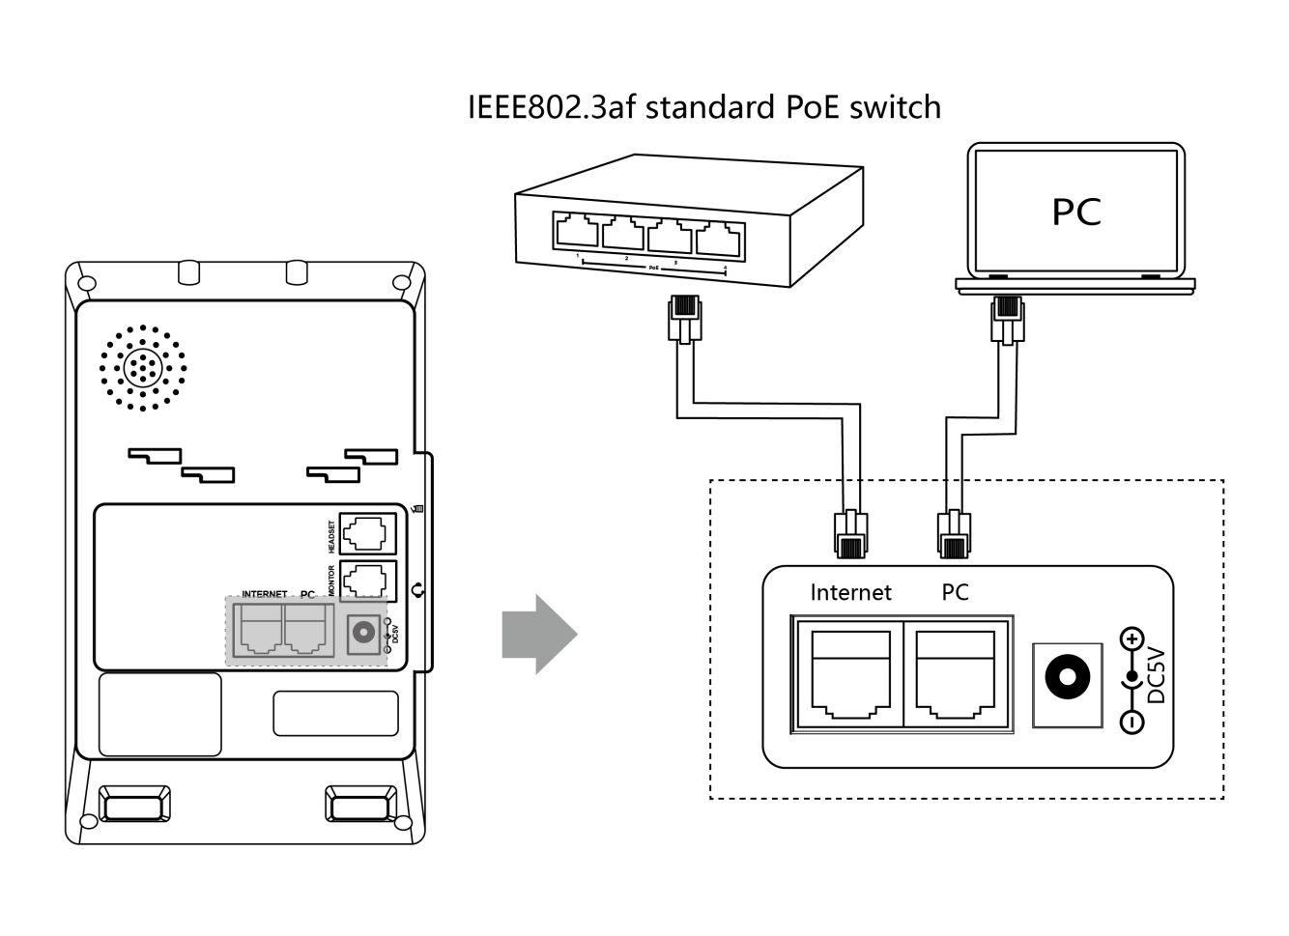

**Explanation: If you are using PoE power supply, please ensure that both your phone and switch support PoE power supply. With PoE power supply, there is no need to connect an adapter for power supply. If you need assistance, please contact your network administrator or dealer for confirmation.**

## **Phone initialization**

When the phone is properly installed and powered up, the phone startup will make the following display:

* Phone initialization

the LCD screen displays "initializating".

* Obtaining a network (the phone's initial network is automatically obtained by DHCP)

After successfully starting the phone, the phone will automatically obtain the assigned IP address, subnet mask, default gateway and DNS server and other network configurations. If the network cable is connected after the phone is started, the LCD display will show a prompt that the network is being obtained.

**Description**  If you are unable to obtain network information, please check the [Network Settings](#_设置话机网络) section, or contact your network administrator or dealer to check.

## **Phone Standby Interface**

The display screen after the phone starts normally is as follows:

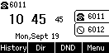

The phone standby screen displays the time and date of the phone, the status of the phone (Do Not Disturb, Auto Answer), the registration status of the account, the extension number, labels, and labels for the four soft keys (**History, Directory, DND, Menu**) at the bottom of the LCD. For icon descriptions of the standby screen, please refer to [Display Icon Composition](#_显示屏图标组成) .

## **Check the status of your phone**

The phone status contains the following information:

* Network information

IP Mode, IPv4 / IPv6 Address, Subnet Mask, Default Gateway, DNS Servers.

* Account Status

SIP account registration information.

* Equipment Information

Firmware version, product name, hardware version, MAC address,

Viewing the status of the phone can be done in the following ways:

**- Phone interface for viewing**

1 . Press the **676b3ef1cf855685675254d7b0c8e29** button or press the softkey **Menu->Status** to access the view.

**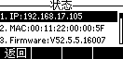**

1. Press or to select up or down, and enter "More..." to see more detailed status.

**- Computer Browser Interface for Viewing**

1. Open your browser.

2. Enter the IP address (IPv4/IPv6) of the phone, such as 192.168.0.130 as shown above.

3. Enter the phone login page, enter the account password to login, the initial account and password are (admin)/admin).

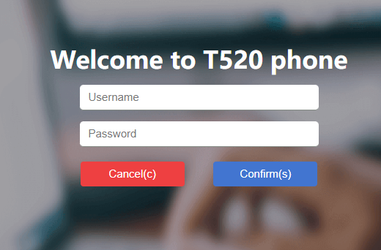

## **Setting up the phone network**

**Explanation**  When you enter an IPv6 address, you must put brackets around the address, such as [fe80::daec:a3ff:fe43:ad34], otherwise you can't access the web page of the phone through the Ipv6 address, and not all servers support IPv6, so please consult with your network administrator before you use it.

The phone can be set up with three network modes: IPv4, IPv6, IPv4 and IPv6.

**- Setting the network mode through the phone interface**

1. Press **Menu->Settings->Advanced Settings (password: admin)->Network->WAN Port**.

2. Press the Switch softkey to select the desired mode (IPv4, IPv6, IPv4 and IPv6) in IP Mode.

3. In case of IPv4 and IPv6 modes, you can configure the mode priority, press or to select the mode priority and press the **Toggle** soft key to switch.

4. Press the **Save** soft key to save after selecting the mode.

**Explanation: If there is no need to configure the network mode, the default IP mode for T250 is IPv4. Please skip this step if applicable.**

- Set the network mode through the web interface

1. Log in to the phone page using the IP address.

2. Click Network Configuration (N) → Basic (b) → WAN Interface, and select from the drop-down list.

3. Click the Submit button to save the configuration.

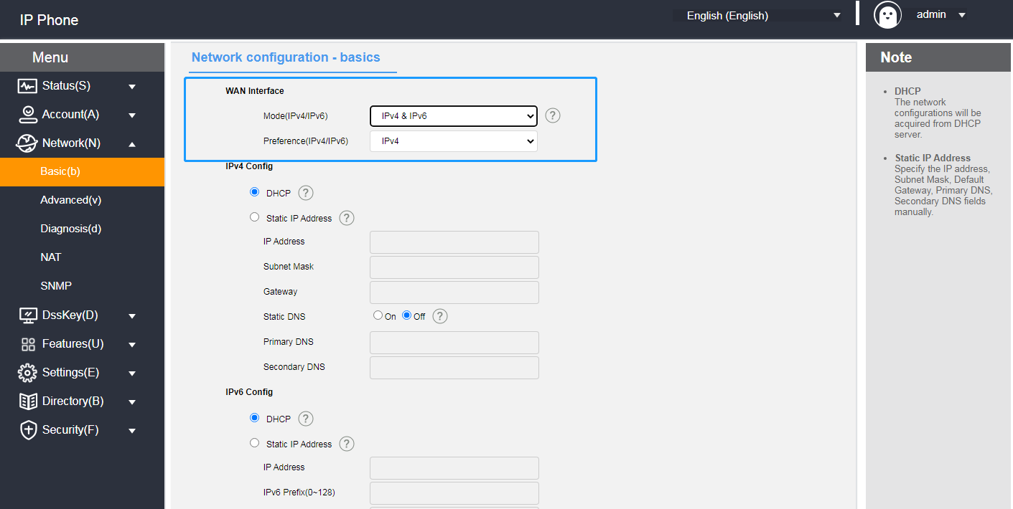

The T520 phone can be set with a static IP address.

- Set the static IP through the phone interface

1. Press the menu → Settings → Advanced Settings (Password: admin) → Network → WAN Port.

2.Press or to select **IPv4** or **IPv6 -> Static IPv4 Client** and press the **Enter** softkey to **enter the** detailed settings.

3.Press or to select.

IPv4 requires filling in the IP address, subnet mask, default gateway, preferred DNS, and alternative DNS.

IPv6 requires filling in the IP address, IPv6 prefix, default gateway, preferred DNS, and alternative DNS.

4. After filling in, press the save key to save the configuration or the return key to cancel the setting.

**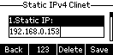**

**-** **Setting up a static IP through a web browser**

1. Log in to the phone page by IP address.

2. Click **Network Configuration (N)->Basic (b)->IPv4 Configuration or Ipv6 Configuration.**

3. Check Static IP address according to the selected WAN interface mode.

IPv4 requires IP address, subnet mask, default gateway, preferred DNS and alternate DNS.

IPv6 requires IP address, IPv6 prefix, default gateway, preferred DNS and alternate DNS.

4. Click the **Submit** button to save.

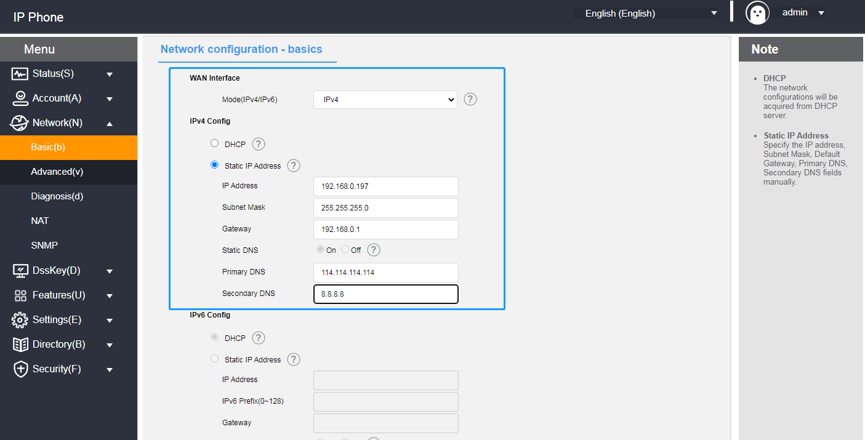

**Explanation**  Wrong IP configuration may cause the phone can not access the web interface, before configuration, please make sure the IP address is not the same as the IP in the LAN, if you need help, please contact your network administrator.

## **Register for an account**

The phone supports two types of configuration:

* Manual Configuration
* Software Batch Configuration

SIP-T520 supports up to dual account registration, the phone is generally configured centrally by the system administrator, when you get the phone that has been configured account, as long as you plug in the Internet cable to get the IP and the account registration is successful, you can use the account to make a phone call. If the phone has not been configured with an account, you need to manually configure the account, for details, please refer to [Account Management](#_账号管理) .

## **Phone Input Methods**

The phone supports keypad input, using the numeric keypad you can enter data into the screen to configure the phone's functions.

It supports four input methods: 123, abc, ABC and 2aB, where you need to enter data, use the soft keys to switch between these input methods, when the input method is in 2aB, press the key repeatedly to switch the characters to be entered (numbers/letters/punctuation), when switching to the character you want, stop and wait for 1 second before the next character is entered.

**- The characters that can be entered by different input methods of the keyboard are listed in the table below:**

|  |  |  |  |  |
| --- | --- | --- | --- | --- |
| **input method**  **keystrokes** | 123 | 2aB | abc | ABC |
| 1 | 1 | 1 |  |  |
| 2 | 2 | 2abcABC | abc2 | ABC2 |
| 3 | 3 | 3defDEF | def3 | DEF3 |
| 4 | 4 | 4ghiGHI | ghi4 | GHI4 |
| 5 | 5 | 5jklJKL | jkl5 | JKL5 |
| 6 | 6 | 6mnoMNO | mno6 | MNO6 |
| 7 | 7 | 7pqrsPQRS | pqrs7 | PQRS7 |
| 8 | 8 | 8tuvTUV | tuv8 | TUV8 |
| 9 | 9 | 9wxyzWXYZ | wxyz9 | WXYZ9 |
| 0 | 0 | 0 | Space | Space |
| 10 | \* | \*.' #?! \-()$@/:\_ | \*.' #?! \-()$@/:\_ | \*.' #?! \-()$@/:\_ |
|  |  | | | |

**- Input Method Introduction:**

|  |  |
| --- | --- |
| Instance | way |
| Input English words  Switch | - Switch input method to 2aB  1. Press the key7 continuously until S appears.  2. Press the key9 continuously until w appears.  3. Press the key4 continuously until i appears.  4. Press the key8 continuously until t appears.  5. Press the key2 continuously until c appears.  6. Press the key4 continuously until h appears.  Finally form the word. |
| Enter IP address  192.168.0.1 | - Switch the input method to 123  1. Enter the number.  2. Press the key10 consecutively until the symbol '.' appears. . |

# **Phone customization**

You can customize the phone according to your own habits, such as: language, time and date, ringtones, contacts, and phone lists, etc. This chapter will give a detailed introduction to customizing the phone, the main contents are as follows:

* + - [Basic settings](#_基本设置)
    - [Sound Settings](#_声音设置)
    - [Contact Management](#_联系人管理)
    - [CDR Management](#_Call Record Management)
    - [System Customization](#_系统自定义)

## **Basic settings**

The basic phone setup consists of the following:

* [multilingualism](#_语言)
* [Time & Date](#_时间&日期)
* [call-out button](#_呼出键)
* keypad lock
* [backlight](#_背光灯)
* [pop-up notification window](#_弹出通知窗口)
* [Boot Picture](#_开机图片)
* [screensavers](#_屏保)
* [power saving mode](#_节电模式)

### **multilingualism**

It supports multi-language, the default language of the initialization of the phone is English, the phone interface and the web interface are integrated: after changing the language of the phone, the web page will update the language synchronously with the phone after refreshing; after changing the language of the web interface, you need to restart the phone.

**- Setting the language through the phone interface**

1. Press **Menu->Settings->Basic Settings->Language**.

2. Press or to select the language you want to change.

3. Press the **Save** soft key to save the language selected by the arrow as shown below.

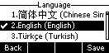

**Explanation**  When the language is changed in the phone interface, the language will be changed to the language set by the phone after the web interface is refreshed (e.g., if English is set in the phone interface and the web interface is refreshed, the language of the web interface will also be changed to English).

**- Setting the language through the web interface**

1. Enter the IP address of the phone to enter the web interface.

2. At the top right of the web interface, switch languages by using the drop-down box.

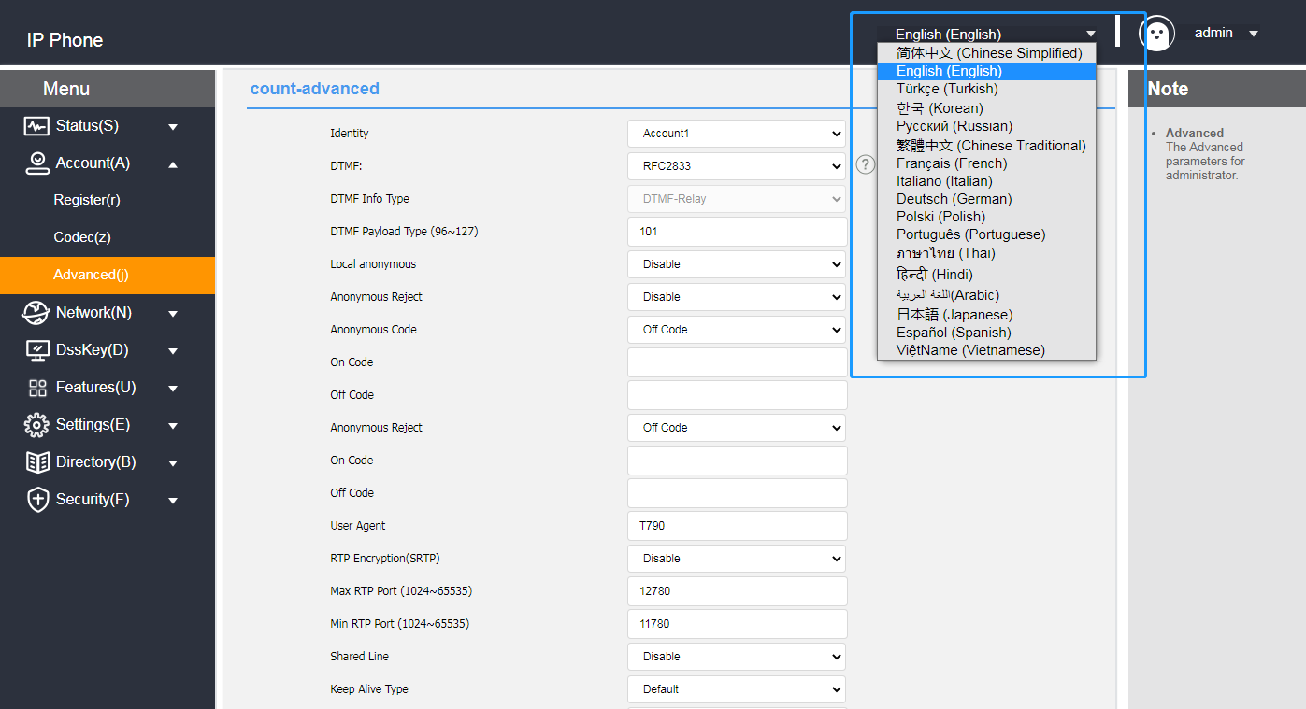

### **Time & Date**

The phone can be set to display the time on the LCD when the phone is on standby, configure your SNTP server to get the time and date automatically, or set the time and date manually.

**- Automatic time and date acquisition through the phone interface**

1. Press **Menu->Settings->Basic Settings->Time & Date->Automatic Timing.**

2. Press the **OK** soft key to save .

**- Manually set the time and date through the phone interface**

1. Press **Menu->Settings->Basic Settings->Time and Date->Manual Time Setting.**

2. Press or to select.

3. Enter the time and date you want to set via the numeric keypad.

4. Press the **OK** soft key to save the settings when they are complete.

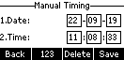

**- Automatically obtaining time through web browsers**

1. Log in to the phone page by IP address.

2. Press **Setup (E) -> Date Time (t) .**

3. Manual settings are disabled by default.

4. You should fill in the SNTP server address in the Preferred Server and Alternate Server.

5. Set the synchronization period in (seconds).

6. Click the **Submit** button to save the settings when they are complete.

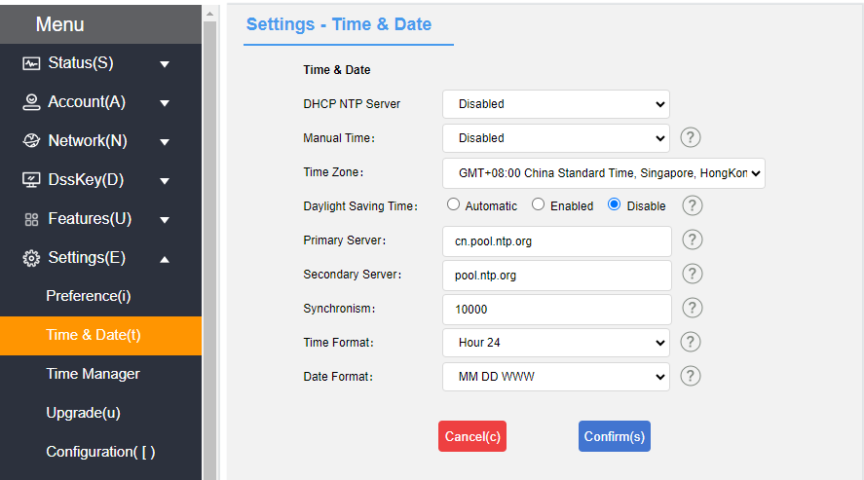

**- Manual time setting via web browser**

1. Login to the phone page by IP address .

2. Press **Setup (E) -> Date Time (t).**

3. Manual setting is selected as Enable.

4. Set the time and date as needed.

5. Click the **Submit** button to save the settings when they are complete.

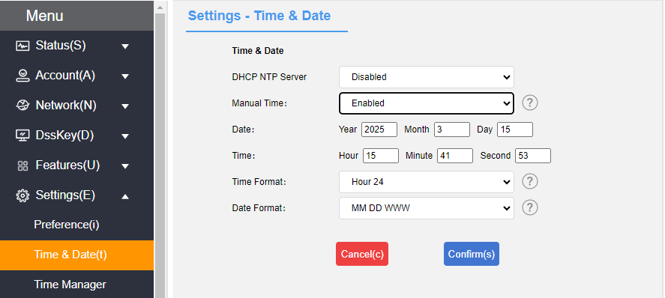

**- Daylight Saving Time setting**

1. Log in to the phone page by IP address.

2. Press **Setup (E) -> Time&Date(t).**

3. Daylight saving time is set automatically, just select the corresponding location.

4.The manual setting method of daylight saving time can divided into weekly and date methods.You should set the start time and end time of Daylight Saving Time.

5. Click the **Submit** button to save the settings when they are complete.

* Automatically sets daylight saving time:

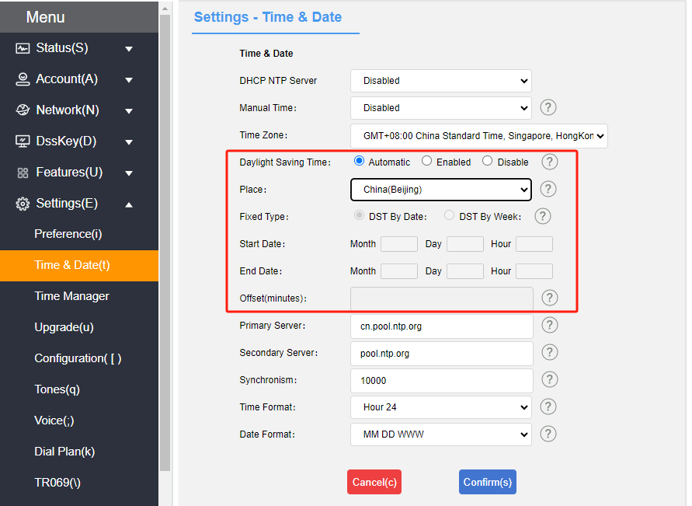

* The date method sets daylight saving time:

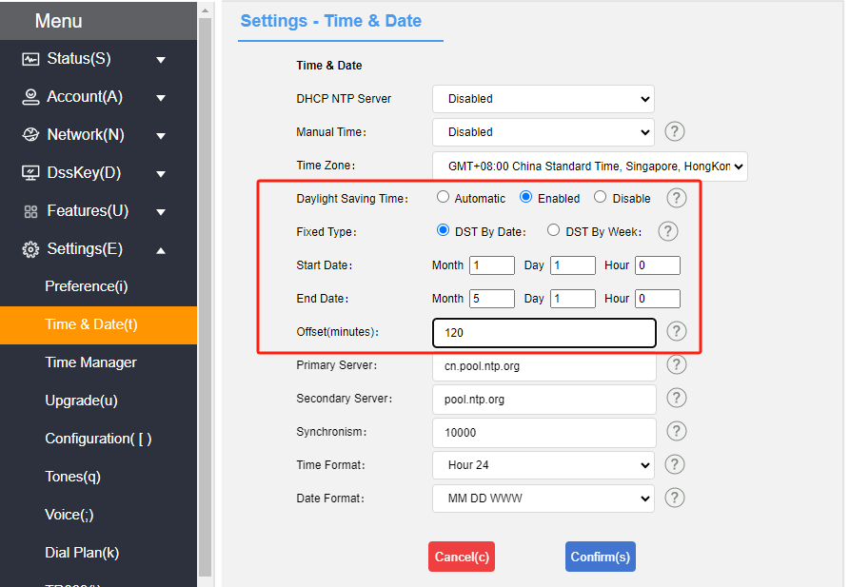

* Weekly way to set daylight saving time:

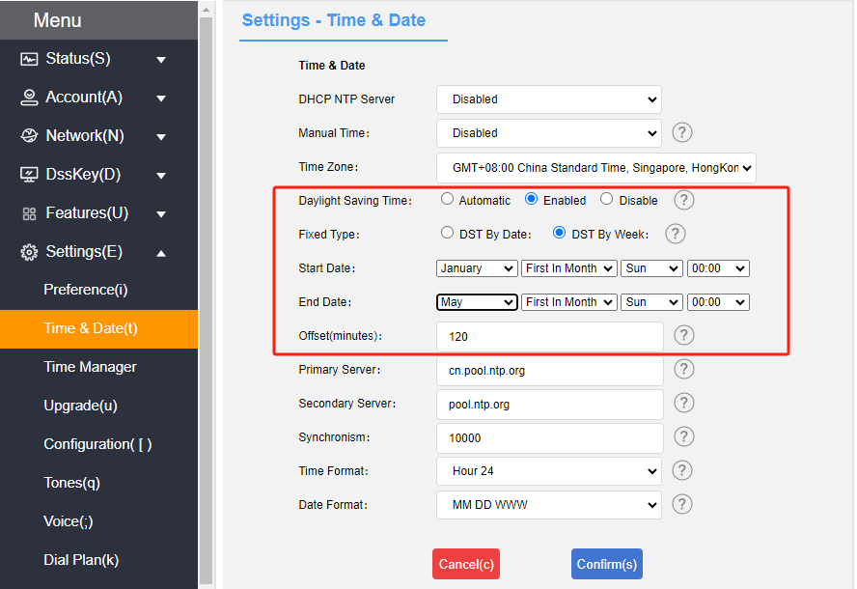

**-** **Setting the time and date display format through a web browser**

1. Log in to the phone page by IP address .

2. Press **Setup (E) -> Date Time (t).**

3. Select the corresponding format in the time format (12-hour and 24-hour systems are supported).

4. The phone supports 7 date formats, different date formats will show the corresponding date on the LCD display of the phone.

The following table shows the dates displayed for each date format:

|  |  |
| --- | --- |
| date format | The display shows |
| WWWW MMM DD | Mon,Sep 08 |
| DD-MMM-YY | 08-Sep-25 |
| YYYY-MM-DD | 2025-09-08 |
| DD/MM/YYYY | 08/09/2025 |
| MM/DD/YY | 09/08/25 |
| DD MMM YYYY | 08 Sep, 2025 |
| MM DD WW | Mon 08,Sep |

**- Configure the DHCP NTP time on the web page**

1. Log in to the phone page using the IP address.

2. Press Settings (E) -> DateTime (t).

3. Enable the DHCP NTP server.

4. Click Submit to save the configuration. You can synchronize the DHCP NTP server time and use the DHCP server on the internal network without connecting to the Internet.

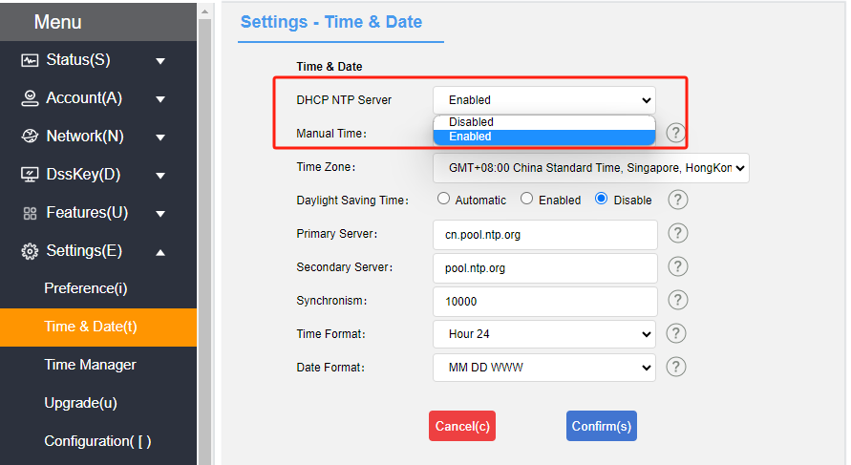

**- Synchronization of server time via web configuration**

1. Log in to the phone page by IP address .

2. Press **Account (A) -> Advanced (j).**

3. Select Synchronize server time.

4. Click Submit to save the configuration, you can realize the synchronization of SIP server time, which can be used in the case of invalid NTP server.

### **Call-out button**

The phone can be set up with the \* and # symbols as call-out buttons, or you can use the  button, **dialing** softkeys for call-outs, depending on your personal habits.

**- Setting the call-out key in the phone interface**

1. Press **Menu->Function->Callout key.**

2. Use the **Toggle** soft key to toggle the callout key (\*, #, disable).

3. Press the **Save** soft key to save the operation after switching.

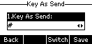

### **keypad lock**

Enabling keypad lock on the phone prevents the phone from being used by unauthorized personnel or accidentally operated due to misuse. Only emergency numbers can be dialed while the keypad is locked; unlocking the keypad is required to dial other numbers.

Keypad locks can be categorized by type: menu keys, function keys, and all keys.

**Menu Key: The** menu soft keys and programming keys set to menu key are locked, all other keys are available.

**Function keys:** Direction navigation key, 30b616ed48f00f8e8229adab6ff252a key, Message key, Transfer key, Redial key, 4 soft keys etc functions keys are locked. Other keys work normally.

**All keys:** except \* key, # key, numeric keypad, headset key, and volume adjustment key,all keys are locked. The dialing screen can only dial emergency numbers with preset values. Incoming calls can be answered by the Headset key, the Answer soft key, . Calls can be rejected with the Reject soft key.

**- Setting the keypad lock through the handset interface**

1. Press **Menu** -> **Settings -> Basic Settings -> Keyboard Lock.**

2. Enter the keypad lock password (factory default password is admin) at the Unlock PIN and press the **OK** soft key to enter.

3. If you enter the default password, you will be prompted to change the password, which is used to enter the keypad lock settings and unlock the keypad.

4. The Enable Keyboard Lock option can be enabled by pressing the **left or right** button or **toggling the** soft key.

5. Press the **left or right** button or **switch** softkey to select the type of keypad lock at the Lock Type option.

6. Enter the auto-lock time (0 to 3600 seconds) in the keypad lock time input box

a.If the setting time is 0 seconds, the keypad lock will not be locked automatically after saving the keypad lock, you need to long press  to enable the keypad lock.

b. Set another time (e.g., set 10 seconds), then the phone will be on lock after the set time (e.g., 10 seconds) in the standby state.

7. Press the **Save** soft key to save the settings.

When the keypad lock is in effect, the handset LCD display will indicate that the keypad is locked. At the same time, the softkeys change to Emergency (for emergency calls) and Unlock (for unlocking the keypad lock). This is shown in the figure below:

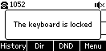

**- Setting the keyboard lock through the web interface**

1. Log in to the phone page by IP address.

2. Press **Function (U) -> Keypad Lock (=).**

3. Enable keyboard lock.

4. Select the keypad lock type.

5. To change the unlock code set the unlock code.

6. Enter the auto-lock time (0~3600 seconds) in the keypad lock time input box.

a. If the setting time is 0 seconds, the keypad lock will not be locked automatically after saving the keypad lock, you need to press and hold to enable the keypad lock.

b. Set another time (e.g., set 10 seconds), then the phone will be locked after the set time (e.g., 10 seconds) in the standby state.

7. Set the emergency call number.

8. Submit for save operation.

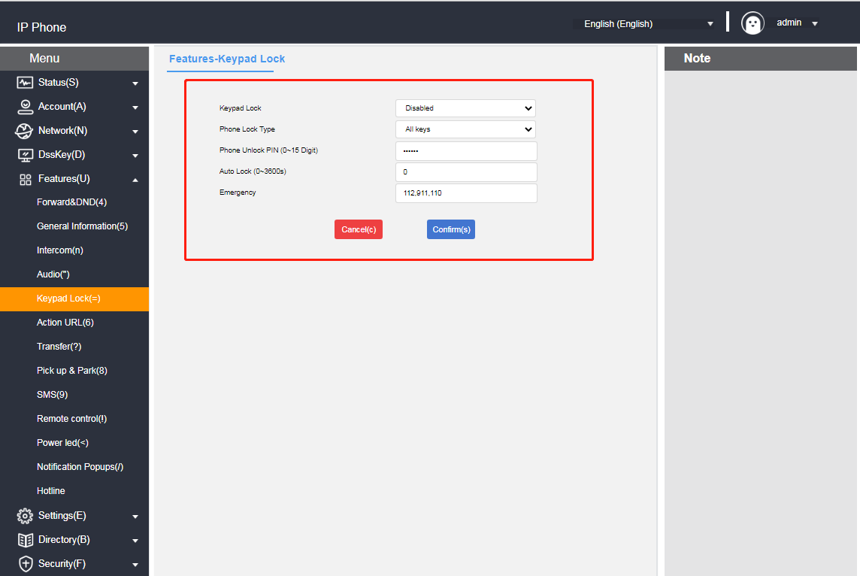

**- Unlocking the keypad lock at the phone interface**

1. Press the **Unlock** soft key or press any locked key, Menu key, Function key, All key.

2. Enter the Unlock PIN at Unlock PIN (default PIN: admin).

3. Press the **OK** soft key.

Standby interface unlock soft key disappears, that is, successfully unlocked, long press  or wait for unlocking timing will lock the key again.

**Instructions**  If you forget to unlock the PIN code, you can log in to the web interface to reset it.

### **Backlight**

The phone can set the backlight status. You can turn off the backlight when the phone is in a silent state for N seconds, or you can set it according to your personal habits.

**- Setting the backlight on the web page**

1. Log in to the phone page by IP address.

2. Click **Settings (E) -> Priority (i).**

3. Set the backlight status.

a. Backlight time: Normal light / Normal dark / 10 seconds / 30 seconds / 1 minute / 2 minutes / 5 minutes / 10 minutes / 30 minutes.

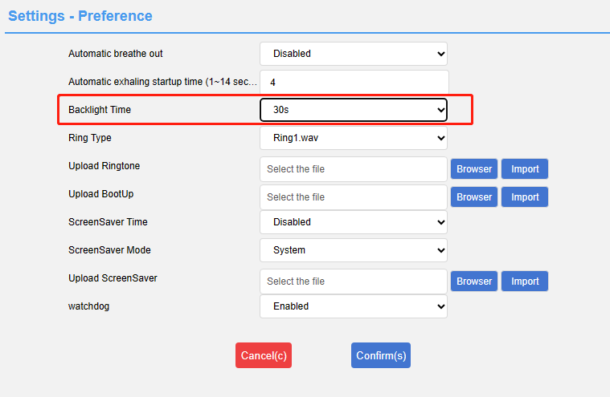

4. Submit for save operation.

### **Pop-up notification window**

It can set the pop-up notification window, whether to display a pop-up box alert when the phone has unread calls or messages, or you can set it according to your personal habits.

**- Setting up pop-up notification windows on web pages**

1. Log in to the phone page by IP address.

2. Click **Function (U) -> Popup Notification Window (/).**

3. Set the popup notification window status.

a. Display the voice message pop-up window.

b. Show missed call pop-up window.

c. Display the Transferred Incoming Calls pop-up window.

d. Display a text message pop-up window.

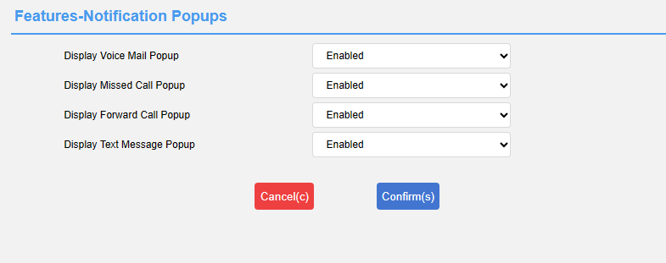

4. Submit for save operation.

### **Boot Picture**

The phone allows you to set the phone's power-up picture, which is displayed when the phone is powered up and started, according to your personal habits.

**- Setting the boot image on the web page**

1. Log in to the phone page by IP address.

2. Click **Settings (E) ->** **Preference (i).**

3. Import the boot image.

a. Requires a png image in the format 132\*64.

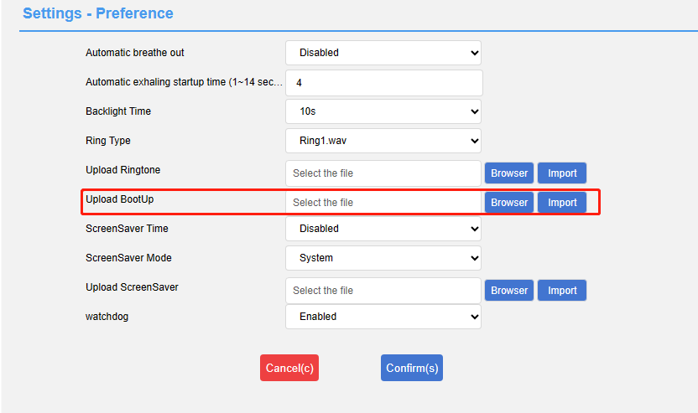

4. Submit for save operation.

### **screensavers**

The phone can be set up with a screensaver for the phone, which enters the screensaver mode when the phone has been inactive for a period of time, and can be set up according to your personal habits.

**- Setting a screensaver on a web page**

1. Log in to the phone page by IP address.

2. Click **Settings (E) -> Priority (i).**

3. Set the screen saver status.

a. Screen saver on time: 10 seconds/30 seconds/1 minute/2 minutes/5 minutes/10 minutes/30 minutes.

b. Screensaver type: Custom/System.

c. Screensaver image: 132\*64px png format image.

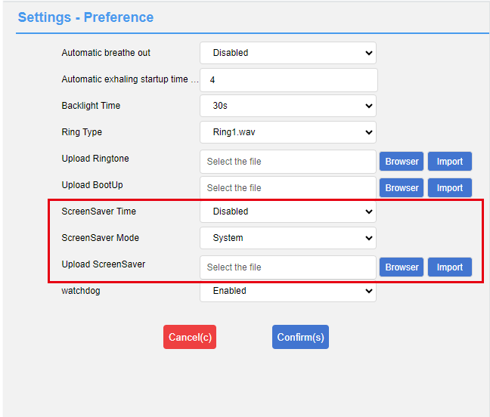

1. Submit for save operation.

### **Power saving mode**

The phone can be set up with a power saving mode, which enters a hibernation state when the microphone is left inactive for a period of time, and can be set up as required.

**- Setting the power saving mode on the web page**

1. Log in to the phone page by IP address.

2. Click **Settings (E) -> Power Saving Mode (&).**

3. Set the power saving mode.

a. Power saving mode: enable/disable.

b. Working time: Define the working time for activating the power saving mode.

c.Working timeout in idle state: default 960 range: 1-960 unit minutes.

d. Timeout in idle state during non-working hours: default 10 Range: 1-10 unit minutes.

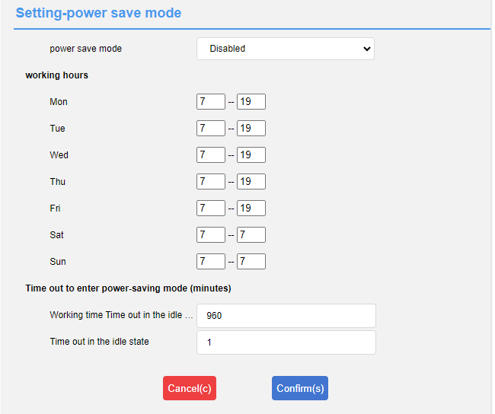

4. Submit for save operation.

## **Sound Settings**

There are several sound settings inside the phone, including the following:

* [Volume settings](#_音量设置)
* [Ringtone Setting](#_铃声设置)
* [keypad tone](#_按键音)
* [SMS alert tone](#_短信提示音)
* [signal tone](#_信号音)
* [Sound Gain](#_信号音)

### **Volume settings**

The handset can set the ringing volume and the volume during the call, the volume setting range is 1-15, and the volume becomes larger with the value.

**- Setting the incoming call ringer volume in standby/ringing mode**

1. Press  to adjust the ringer volume as follows.

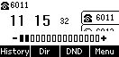

**- Setting the volume of devices such as headsets, etc. on incoming calls**

1. Press  to adjust the call volume as shown.

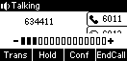

**- Setting the ringing method**

1. The ringing method can be configured in Web **Functions (U) → Sound.**

a) Using Handsfree: Handsfree ringing;

b) Using a headset: headset ringing;

c) Using headset group and handsfree: headset & handsfree synchronized ringing;

1. Click **Submit to** save the configuration.

Note: The headset ringing method only works when the phone is in headset mode:

### **Ringtone Setting**

You can set different ringtones for your phone to distinguish incoming calls. In addition to unified ringtones, you can also set different ringtones for contacts to distinguish incoming calls from different contacts. There are 10 default ringtones to choose from.

**-** **Setting the ringtone for incoming calls in the phone interface**

1. Press **Menu->Settings->Basic Settings->Sound->Ringtone.**

2. Press or for ringer selection.

3. Press the **Save** soft key to save the selected ringtone.

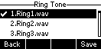

**- Setting a contact's ringtone for incoming calls in a web browser**

1. Log in to the phone page by IP address.

2. Press **Contacts (B) -> Local Contacts (x).**

3. Add a contact or click a contact in the list to edit it.

4. Ringtone selection box for ringtone selection for this contact.

5. Click the **Add** button if you are adding a contact, or click the **Edit** button if you are modifying a contact.

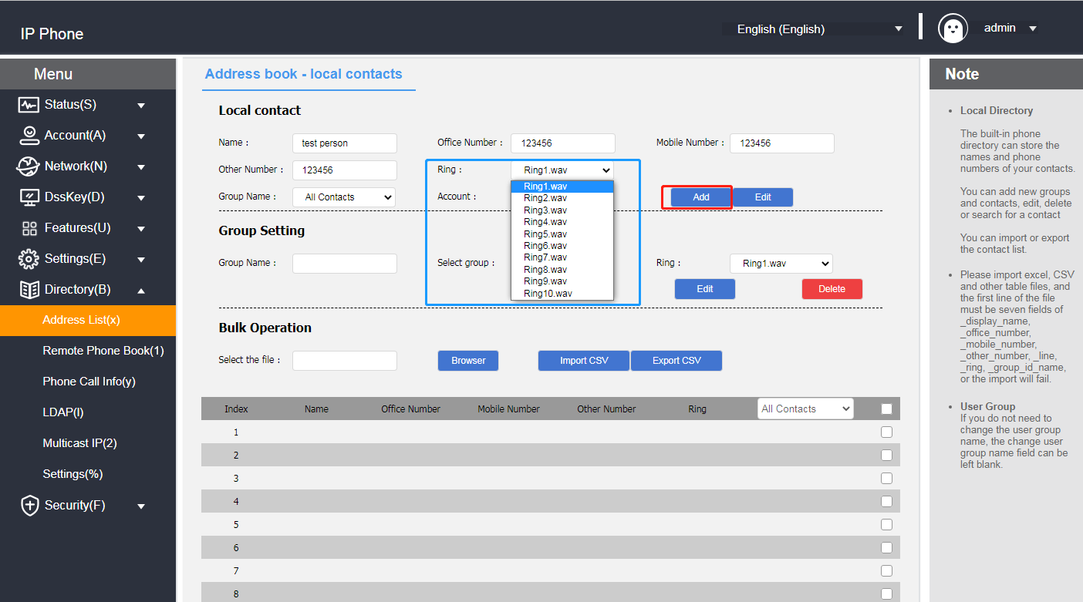

### **Keypad tone**

The phone will emit a key tone when the keypad keys are pressed to indicate that the key has been triggered, and the key tone can be enabled and disabled through the settings.

**- Setting the phone key tones through the phone interface**

1. Press **Menu->Settings->Basic Settings->Sound->Key Tone.**

2. Press the **Switch** soft key to enable and disable the state of the key tone.

3. Press the **Save** soft key to save the operation.

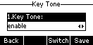

### **SMS alert tone**

Whether or not to play a "drop" tone when the phone receives a voice message or text message can be turned on or off from the web page.

**- Setting SMS alert tones via web browser**

1. Log in to the phone page by IP address .

2. Press **Function (U) -> Basic Information (5).**

3. Configure to turn on or off the voice message tone and SMS alert tone.

a) Enable/disable voice message tones;

b) Enable/disable SMS alert tone;

4. Press the **Confirm** button to save.

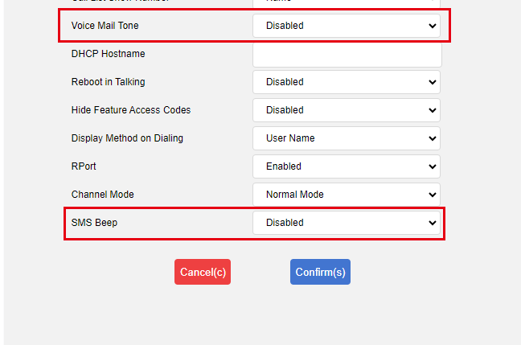

### **Signal tone**

An audible signal sent by the switch to the user to indicate that the phone is in a certain state. The signal tone follows a uniform standard in each device, and you can customize the signal tone according to the national standard, or customize the signal tone; the lower the value, the more subdued the signal tone.

**-** **Setting the signal tone through the web browser**

1. Log in to the phone page by IP address .

2. Press **Setup (E) -> Signal Tone (q).**

3. According to the national standard please select the country. If you want to customize the signal tone, select custom in the country option.

4. Selecting Custom requires you to fill in your own values to change the signal tone.

5. Press the **Submit** button to save.

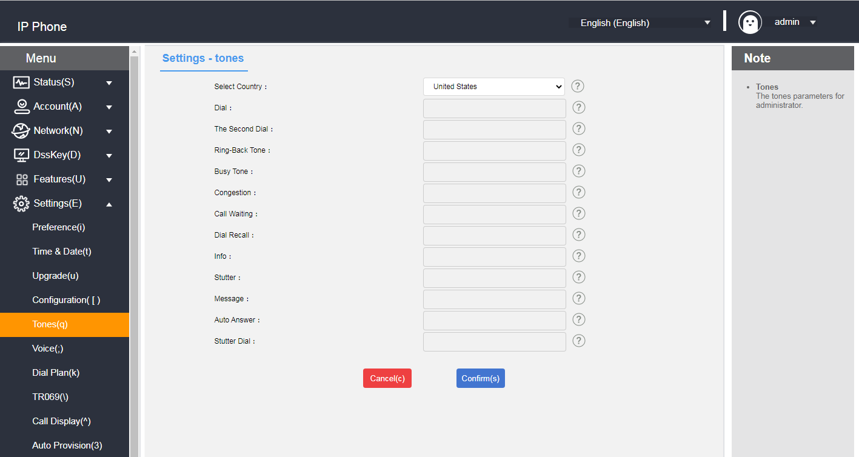

- Signal Tone Types Introduction and Standards

|  |  |  |  |
| --- | --- | --- | --- |
| signal tone | frequency | Transmit frequency (dBm0) | clarification |
| Dial tone | 450±25 | -10±3dBm0 | Used to notify the calling subscriber that they are ready to dial |
| redial | 450±25 | -10±3dBm0 | Tone on second dialing |
| ring-back tone | 450±25 | -10±3dBm0 | Indicates that the called subscriber is in the ringing state |
| busy signal | 450±25 | -10±3dBm0 | Indicates that the line is busy or the called subscriber is busy for this connection. |
| network congestion tone | 450±25 | -10±3dBm0 | Indicates that this connection is experiencing line congestion |
| Call Waiting | 450±25 | -10±3dBm0 | Indicates that the phone is on call waiting |
| callback tone | 450±25 | -10±3dBm0 | Indicates that the phone is in the callback state |
| Special information | 450±25 | -10±3dBm0 | Beep when you receive a special message |
| Voice mail alert tone | 450±25 | -10±3dBm0 | Tone when you receive a voicemail message |
| message tone | 450±25 | -10±3dBm0 | Tone for incoming messages |
| auto-answer | 450±25 | -10±3dBm0 | In auto answer state beep |
| Voice Message Callback | 450±25 | -10±3dBm0 | Voice mail callback tone |

### **Sound Gain**

**- Setting the sound through a web browser**

1. Log in to the phone page by IP address .

2. Press **Settings (E) -> Voice (;).**

3. Configure echo cancellation and RTP jitter buffers as required.

4. Press the **Submit** button to save.

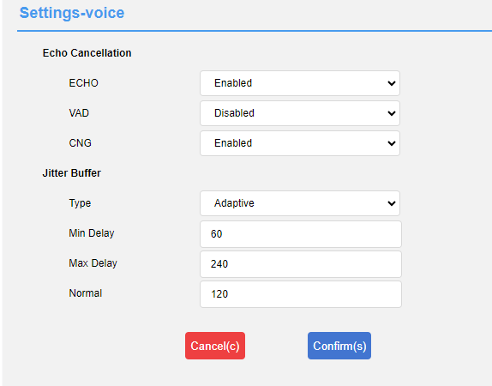

**- Setting the sound gain through the web browser**

1. Log in to the phone page by IP address .

2. Press **Function (U) -> Sound (").**

3. Configure the sound input/output values as required.

4. Press the **Submit** button to save.

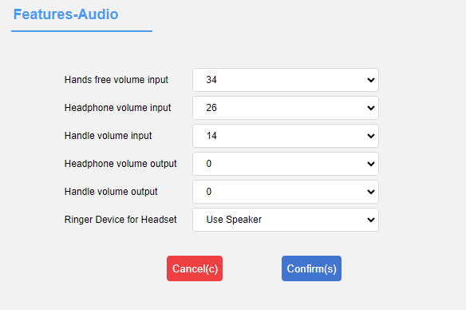

## **Contact Management**

Contact management for the SIP-T520 consists mainly of:

* [local contact](#_本地联系人)
* [blacklists](#_黑名单)
* [LDAP settings](#_LDAP配置)
* [Call History](#_话单（通话记录）管理)
* [remote address book](#_远程地址薄)
* [Update Address Book](#_更新通讯录)
* [set up](#_通讯录设置)

### **local contact**

Local Contacts can save the contact's name, internal extension number, cell phone number, etc. SIP-T520 supports saving 1000 local contacts and 10 contact groups (including default groups). It supports contact adding group, editing, setting ringtone, setting account number, editing contact and other operations.

#### **Add Group**

**- Adding a group by phone**

1. Press the softkey Directory**->Local Contacts->Add Group.**

2. Enter the group name in the Group Name input box.

3. Press the **Save** soft key to save the group.

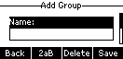

**- Adding Groups via Web Browser**

1. Log in to the phone page by IP address.

2. Click **Contacts (B) -> Local Contacts (x).**

3. Enter the group name in Group Name.

4. Click the **Add** button to add a group.

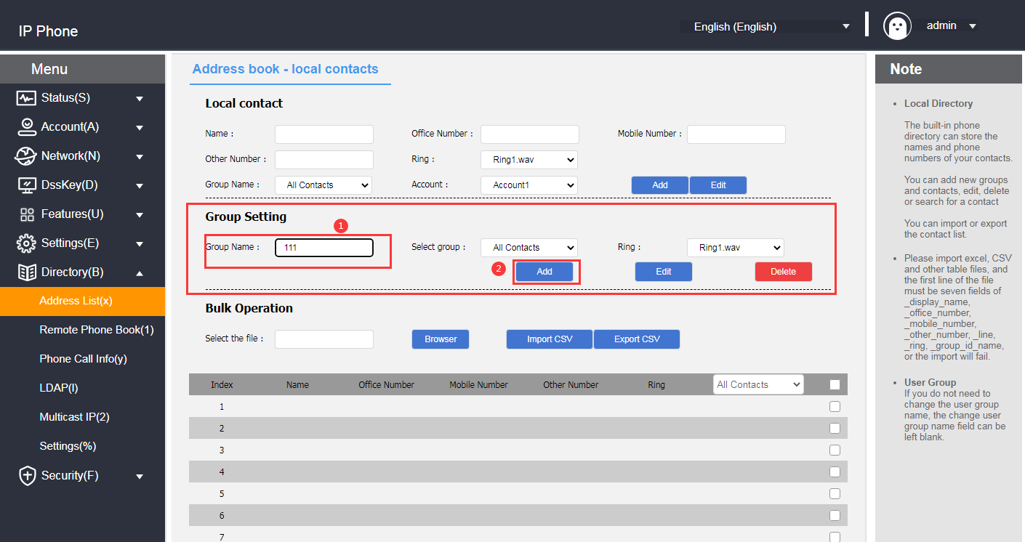

#### **Edit Group**

**- Group editing via phone (default grouping cannot be edited)**

1. Press the Directory**->Local Contacts** soft key.

2. Press or to select the group to be edited.

3. Press the softkey **Options->Details** to enter the edit screen.

4. Enter a new group name in the Group Name edit box (only English can be entered in the phone interface).

5. Press the **Save** soft key to **save the** group.

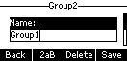

**- Editing of groups via web browser (default groupings cannot be edited)**

1. Log in to the phone page by IP address.

2. Click **Contacts (B) -> Local Contacts (x).**

3. Select the group.

4. After selecting, choose the group to become the input mode, and modify it to the name you want to change.

5. Click the **Edit** button to make changes.

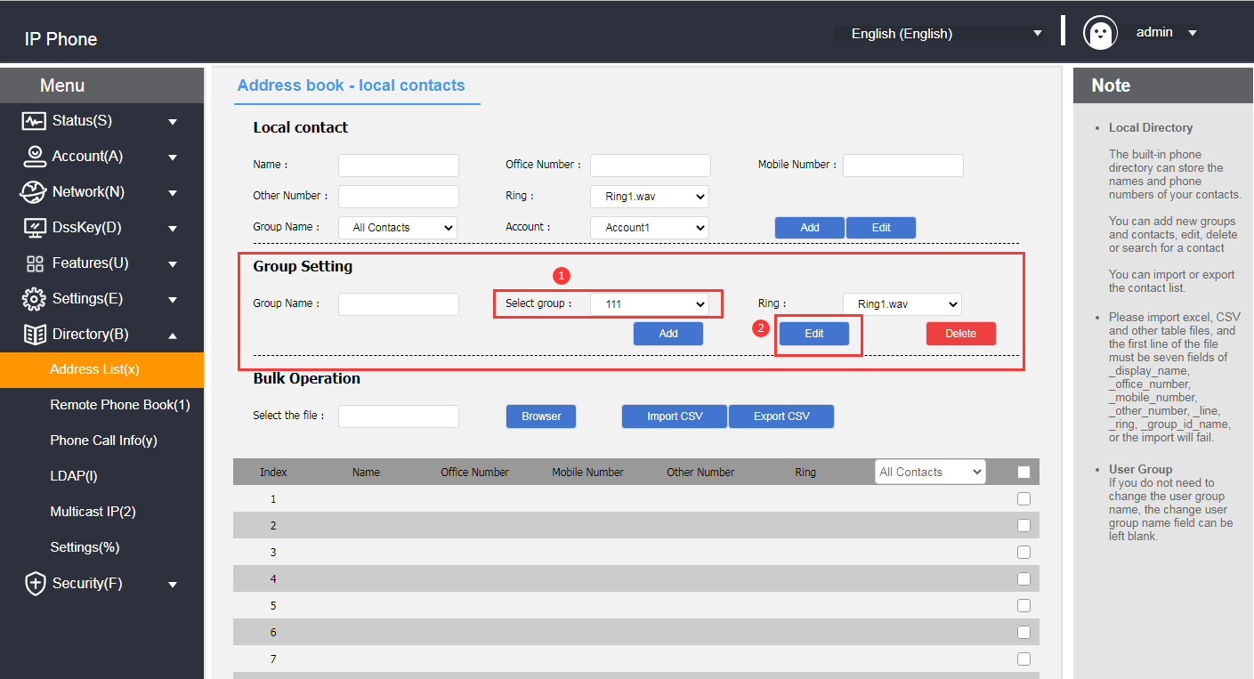

#### **Delete Groups**

**- Deletion of groups via the phone (default groups cannot be deleted)**

1. Press the **Directory->Local Contacts** soft key.

2. Press or to select the group to be deleted.

3. Press the **Option** soft key.

4. Press or to select the delete option.

5. Press the **OK** soft key to delete.

To delete all contacts, press Options -> Delete All.

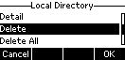

**- Deletion of groups via web browser (default groups cannot be deleted)**

1. Log in to the phone page by IP address.

2. Click **Contacts (B) -> Local Contacts (x).**

3. Select the group in the Groups module.

4. Click the **Delete** button in the Group Settings module to delete it.

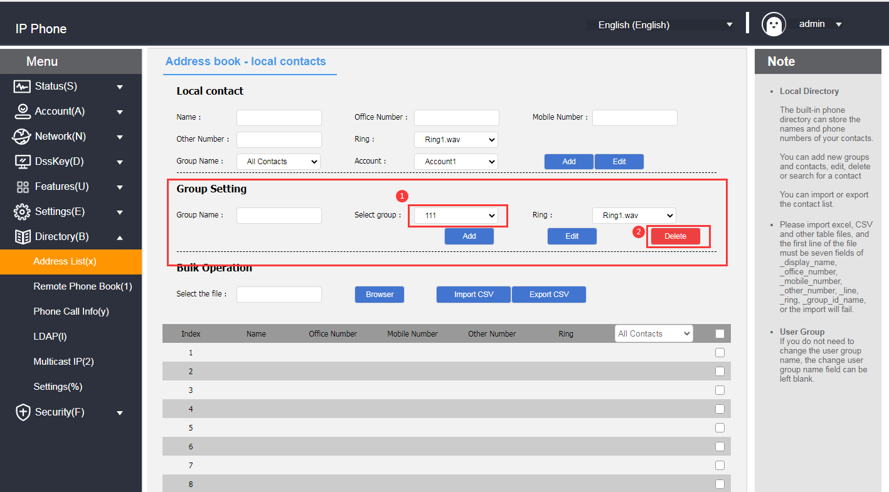

**Description**  If a group is deleted, the contacts in the deleted group will be grouped into the default group "All Contacts".

#### **Add Contact**

Contacts can be added in the following three ways:

* Add manually
* batch import
* Add from call log

**- Adding a contact via call history through a phone interface**

1. Press the **History** soft key in standby.

2. Press or to select the number to add as a contact.

3. Press the softkey **Options -> Add to Contacts.**

4. Press or to complete the contact information (name, group).

5. Press **OK** to save the contact.

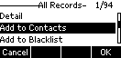

**- Adding contacts via local contacts in the phone interface**

1. Press **Directory->Local Contacts->All Contacts** softkey in standby interface (or press **Menu->Address Book->Local Contacts**).

2. Press or to select the group to which you want to add contacts.

3. Once in the group, press the **Add** soft key to enter the Add screen.

4. Press or to fill in the contact information (name, phone number, you can switch to another group).

5. Press the **Save** soft key to save the contact.

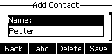

**- Adding contacts via web browser**

1. Log in to the phone page by IP address.

2. Click **Contacts (B) -> Local Contacts (x).**

3. Local Contacts module fills in the contact information.

4. Click the **Add** button in the Local Contacts module to add it.

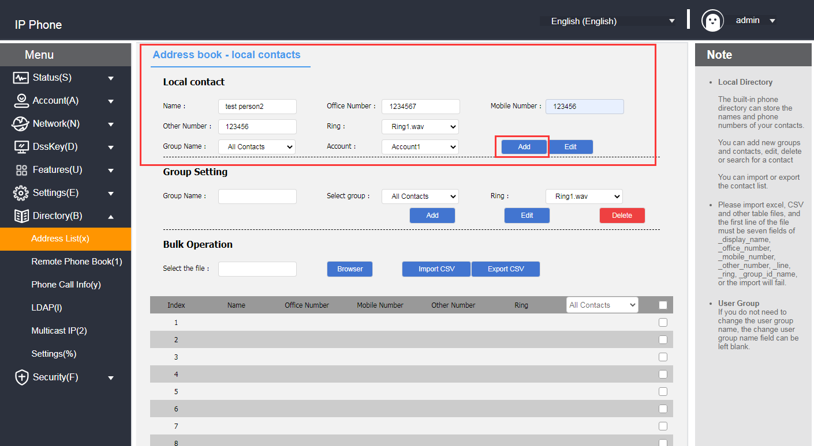

**- Bulk import of contacts via web browser**

1. Log in to the phone page by IP address.

2. Click **Contacts (B) -> Local Contacts (x).**

3. Batch operation module click CSV format export contact template.

4. Add/edit contact information in the form.

5. Batch operation module click Browse to find the CSV file to be imported, click **CSV format to import to** add contacts.

(Currently only supports importing xls, csv, xlsx file types) .

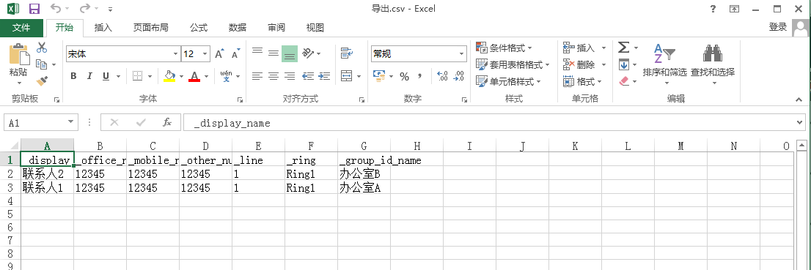 The following prompt appears after you click Import:

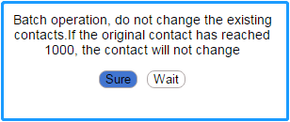

#### **Edit Contact**

**- Editing contacts through the phone interface**

1. In standby mode, press **Directory->Local Contacts** softkey (or **Menu->Address Book->Local Contacts**)**->All Contacts.**

2. Press or to select the contact name to edit.

3. Press the softkey **Options->Details** to enter the contact editing page.

4. Press or to select the contact information to edit.

5. Press **OK** to save the editing operation.

**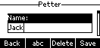**

**- Editing contacts via web browser**

1. Log in to the phone page by IP address.

2. Click **Contacts (B) -> Local Contacts (x).**

3. Tap the contact you want to edit in the contact list below, and the information will be filled into the local contact module.

4. Modify the contact's information in the Local Contacts module.

5. Click the **Edit** button to save the editing operation.

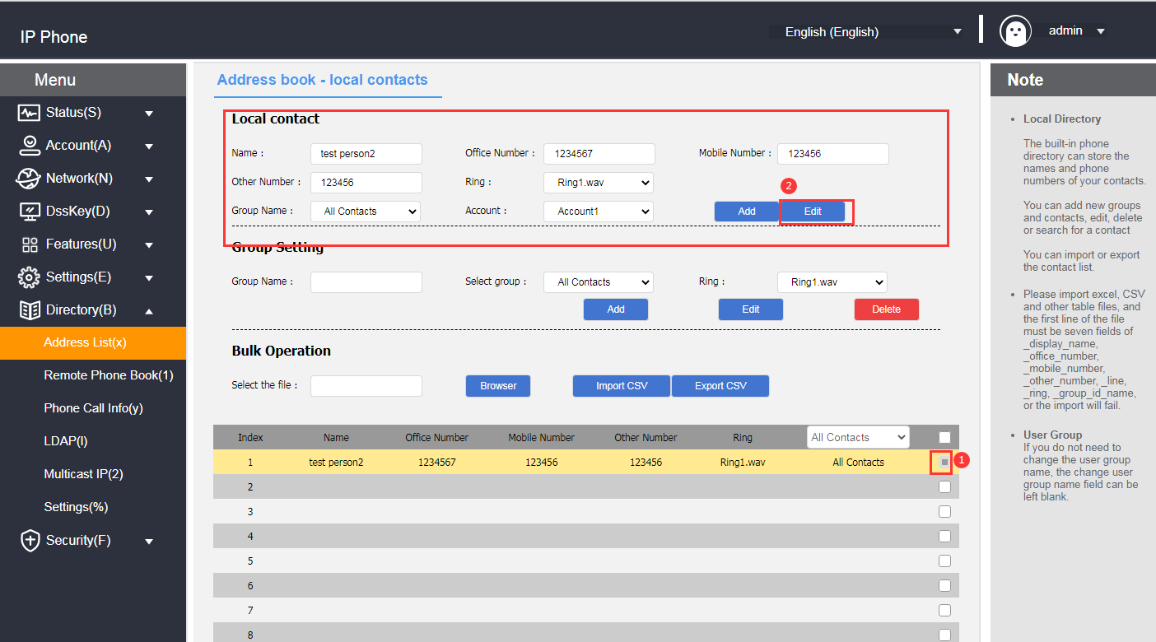

#### **Delete Contacts**

**- Deleting contacts through the phone interface**

1. In standby mode, press **Directory->Local Contacts** softkey (or **Menu->Address Book->Local Contacts**)**->All Contacts.**

2. Press or to select the contact name to delete.

3. Press **Options->Delete/Delete All.**

4. Press the **OK** soft key to delete.

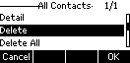

**- Deleting contacts via web browser**

1. Log in to the phone page by IP address.

2. Click **Contacts (B) -> Local Contacts (x).**

3. Tap the contact you want to delete in the contact list below.

4. Click the **Delete/Delete All** button under the list to delete the contact.

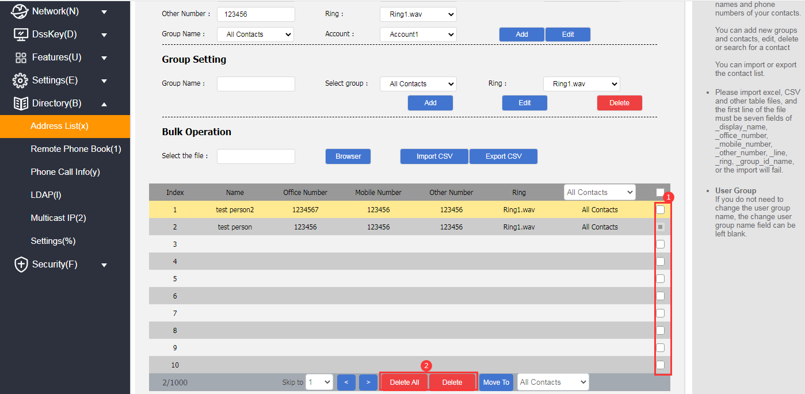

**Description**  Deleted contacts are not recoverable, confirm that you want to delete them before deleting them.

#### **Call a contact person**

**- Calling local contacts through the phone interface**

1. In standby mode, press the softkey **Directory->Local Contacts (or Menu->Address Book->Local Contacts)->All Contacts.**

2. Press or to select the name of the contact to call.

3. Press the **Send** soft key to enter the contact number list.

4. Press or to select the number you want to call to make the call.

5. Press the **Send** soft key to make a call.

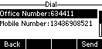

## **Blacklists**

The phone can save up to 30 blacklisted contacts, and phone numbers with blacklists set will be automatically rejected by the phone.

#### **Add Blacklist**

**- Adding a blacklist through the phone interface**

1. In standby mode, press the softkey **Menu->Address Book->Blacklist->Add.**

2. Press or to select Edit Blacklist Information (Name, Number).

3. Press the **Save** soft key to save the changed blacklist members.

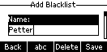

**- Adding blacklists from call history through the phone interface**

1. Press the **History** soft key in standby.

2. Press or to select a number to add to the blacklist.

3. Press the softkey **Options -> Add to Blacklist.**

4. Completion of information on blacklisted members.

5. Press **OK** to save the blacklist.

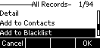

**-** **Blacklisting via web browser**

1. Log in to the phone page by IP address.

2. Click **Contacts (B) -> Local Contacts (x).**

3. Fill in the name and phone number to be added to the blacklist in the Local Contacts module, and select the grouping as BlackList (BlackList ).

4. Click the **Add** button to save the blacklisted contacts.

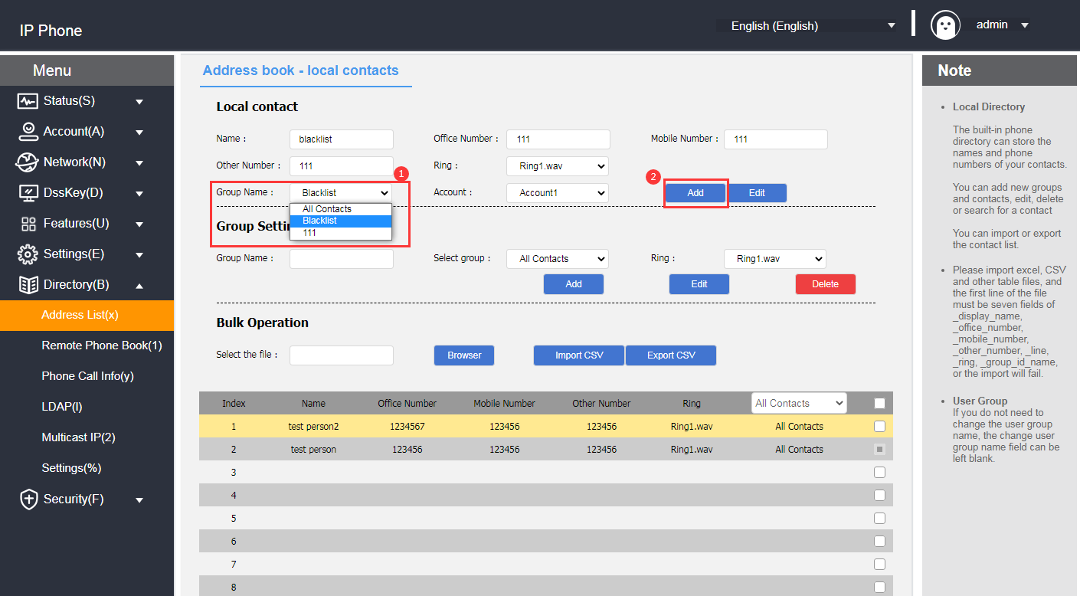

#### **Delete Blacklist**

**- Blacklist removal through the phone interface**

1. In standby mode, press the softkey **Menu->Contacts->Blacklist.**

2. Press or to select the blacklist member to be deleted.

3. Press **Options->Delete/Delete All.**

4. Press the **OK** soft key to delete.

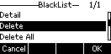

**-** **Blacklist removal via web browser**

1. Log in to the phone page by IP address.

2. Click **Contacts (B) -> Local Contacts (x).**

3. Select BlackList in the drop-down box below the contact list.

4. Check the blacklists to be deleted.

5. Click the **Delete/Remove All** button under the list to remove the blacklist.

### LDAP Configuration

#### **Functional Description**

LDAP (Light Directory Access Protocol) is an application layer protocol that runs over IP networks and provides a range of functions for accessing and maintaining distributed directory information services. Simply put, LDAP is a fast way to get centralized static data about people or resources, and is most useful for storing information that needs to be read from different locations, but doesn't need to be updated often. LDAP is very effective at storing a company's employee phone book and organizational charts, and is especially handy for querying information.

For example: in accordance with the tree structure, the root of the tree is the name of the company, the next logical branch out of the various departments, departments can be branched out of the next various employees can be in a certain range in accordance with specific rules to retrieve contacts, such as retrieval of a company's hardware department name contains "J" of the employees.

You can configure the phone to connect to an LDAP server that supports LDAPv2 or LDAPv3. The phone supports the following LDAP servers:

● Microsoft Active Directory

● Sun ONE Directory Server

● Open LDAP Directory Server

● Microsoft Active Directory Application Mode (ADAM)

The biggest advantage of LDAP is that users can quickly find contacts from the LDAP server without the need to maintain a local phonebook.The contact information returned by the LDAP server is read-only.Users can call the LDAP contacts, but they cannot add, edit, or delete LDAP contacts.Administrators can configure the LDAP query filter conditions on the phone, such as displaying the contact information and how to sort the contacts. The administrator can configure the filters for LDAP query on the phone, such as the number of contacts to be displayed, the information to be returned, and how to sort the contacts, etc. T520 perform LDAP search on the phone:

Enter the search directly into the pre-dial/dialing screen (make sure LDAP is enabled on the caller's contact match list) and the phone will perform a query from an LDAP server. If results are available, they are displayed on the LCD screen and the user can select a contact and initiate a call.

●

Press LDAP programmable button or press Menu->Contacts->LDAP, enter the content to be searched in the LDAP search interface, the phone will query the related contacts from the LDAP server and display them on the LCD interface, the user can select a certain contact and initiate a call, or add the contact to the local address book or black list.

The phone sends a search request to the LDAP server, which searches all contacts based on the search input and configured filters, and then returns the matching results to the phone.

#### **Configuring the LDAP Server**

The following examples are for reference only. You can modify the LDAP attribute values according to your specific needs.

1. Open the Web interface of the phone and log in.

2. Click **Contacts -> LDAP**.

3. Configure the LDAP service. The example is as follows:

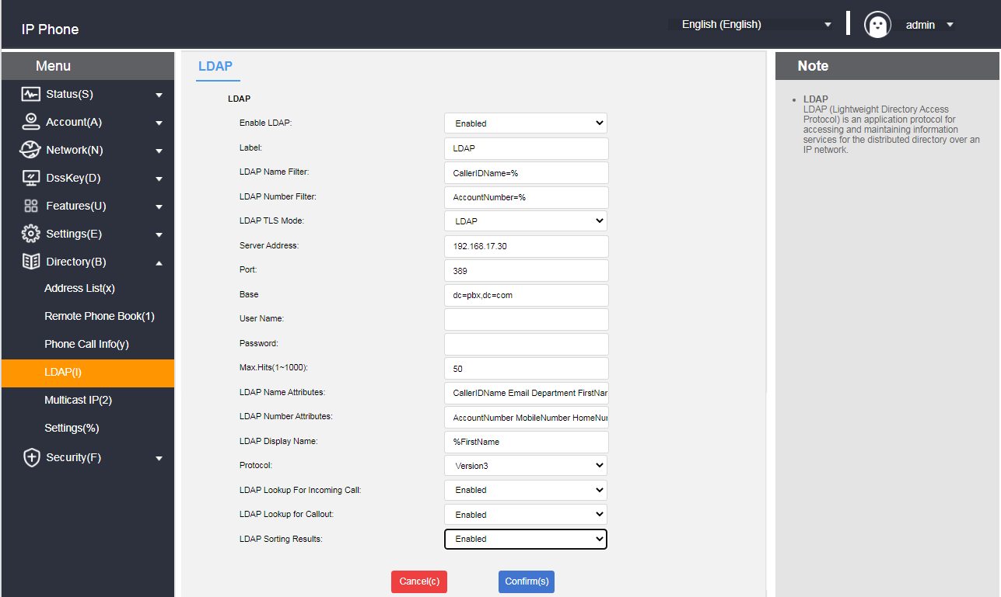

#### **LDAP Setup Instructions**

|  |  |  |
| --- | --- | --- |
| **LDAP settings** | **clarification** | **typical example** |
| **Start LDAP** | Enables or disables LDAP function. | Enable |
| **LDAP Tags** | Fill in the name of the phone book. | Telephone Directory |
| **LDAP Name Filtering** | Sets whether or not the phone can search for contact information by "Nickname" or "Last name".  \* stands for any letter.  The % represents the string entered and is used to filter the prefix criteria. | (CallerIDName=%) |
| **LDAP Number Filtering** | Set whether the phone can search for contact information by "Cell phone number, office number, or home number".  \* stands for the arbitrary letter.  % represents the string and is used to filter the prefix criteria. | (AccountNumber=%) |
| **LDAP encrypted transfer mode** | Set how the LDAP server connects to the SIP-T520:  ①LDAP  ②LDAP TLS Start  ③LDAPS  Note: The S-Series small and medium IPPBX supports LDAP protocol. | LDAP |
| **LDAP server address** | Fill in the IP address of the PBX. | 192.168.17.30 |
| **Ports** | Fill in the LDAP server address port. | 389 |
| **Base** | Fill in the root node of the LDAP server or one of the phonebook nodes from which the LDAP server will start searching for contacts.  ① Fill in the directory node of the LDAP server, and the LDAP server will search for contacts from all phone books.  ② Fill in a certain phonebook node, and the LDAP server will search for contacts from this phonebook. | dc=pbx,dc=com |
| **User Name** | Fill in the user name of the LDAP server. | Username provided by the LDAP server |
| Password | Fill in the password for the LDAP server. | Password provided by the LDAP server |
| **Maximum number of hits (1~1000)** | Set the maximum number of entries in the LDAP server search results. | 50 |
| **LDAP Name Attributes** | Set the name attribute to be acquired. Multiple name attributes can be set, separated by spaces. | CallerIDName Email Department FirstName LastName |
| **LDAP Number Properties** | Set the number attributes to be acquired. Multiple number attributes can be set, each separated by a space. | AccountNumber MobileNumber HomeNumber Fax |
| **LDAP Display Name** | Set the name to be displayed for LDAP server search results. The display name format must begin with %. | %FirstName |
| **protocol version** | The version of the LDAP server protocol.  Note: The S-Series small and medium IPPBX supports version 3. | 3 |
| **LDAP Matching Call** | Sets whether or not LDAP searches are performed on incoming calls. | Enable |
| **LDAP Outbound Queries** | Set whether to search for numbers in the LDAP phonebook when making a call. | Enable |
| **LDAP Search Sorting** | Sets whether or not the search results are sorted in numeric or alphanumeric order. | Enable |

#### **Search for LDAP contacts via Address Book**

**- Enabling LDAP Phonebook**

1. Log in to the phone web interface and click **Contacts -> LDAP.**
2. Enable LDAP phonebook.
3. Click **Submit.**

**- Search LDAP Contacts**

1. Click **Menu** -> **Contacts -> LDAP on the phone interface.**

2. Enter the number or name of the contact, and the contact information that matches the search criteria is displayed on the screen.

3. Use or to select a contact.

4. Press the Sendsoft key to initiate a call.

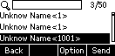

## **Call Record Management**

SIP-T520’s call records contain dialed numbers, missed calls, received calls, and transferred calls. Each record supports up to 300 records.

You can view, delete, add contacts, add blacklists, and so on. For more information about the operation of contacts, please see [Contacts Management](#_联系人管理) section.

**- Viewing the call record through the phone interface**

1. Press the **History** soft key, the LCD display shows a list of numbers for the recent call records.

2. Press or to select the record you want to view.

3 Press the softkey **Options->Details**. Details of the record can be viewed.

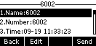

**- Viewing of call history through a web browser**

1. Log in to the phone page by IP address.

2. Click **Contacts (B) -> Call History (y).**

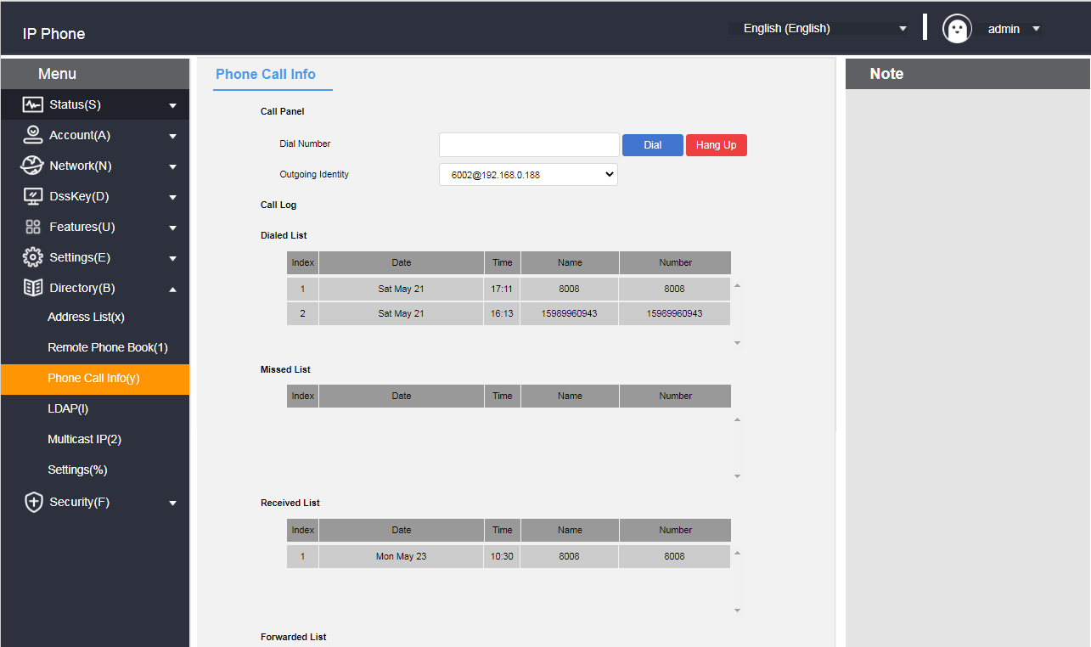

**- Calls made through call record**

1. Press the **History** soft key while the phone is in standby.

2. Press or to select the number to dial.

3. Press the **Send** soft key to dial.

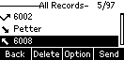

**- Calls made through the web page**

1. Log in to the phone page by IP address.

2. Click **Contacts (B) -> Call History (y).**

3. Enter the call number and press Dial to send the call.

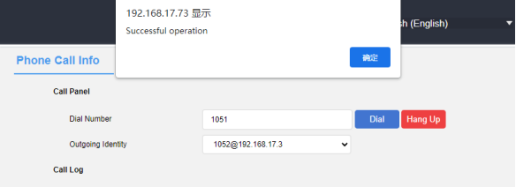

**- Hang up through the web page**

1. Log in to the phone page using the IP address.

2. Tap Contacts (B) -> Call History (y).

3. When the phone is in the talking, incoming, or dialing state, tap Hang up.

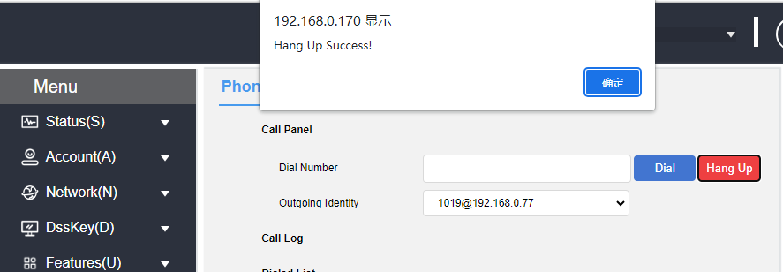

## **Remote address book**

#### **Functional Description**

Remote Phone Book (Remote Phone Book) from the name can be visualized as a remote access address book. Administrators need to add the established format of XML to the remote server. The phone achieve the purpose of expanding the scope of the address book by accessing the remote address book. It is mainly used in the enterprise to facilitate the update of the enterprise address book, maintenance at the same time can save the phone's memory to do a double whammy.

The phone supports accessing the XML file on the HTTP/HTTPS/FTP/TFPT server, reading the contact information in the XML file and displaying it on the screen of the phone to realize the remote address function.

#### **XML format**

|  |
| --- |
| <?xml version="1.0" encoding="UTF-8"? >  <SLIPPhoneMenu>  <T>Company I</T>  <M N="group">  <U N="Zhang San" P1="6131" P2="4566" P3="6788" d\_p="Resource:"/>  <U N="Li Si" P1="6136" P2="4567" P3="6789" d\_p="Resource:"/>  </M>  <M N="Group II">  <U N="Wang Wu" P1="1234" P2="4566" P3="6788" d\_p="Resource:"/>  <U N="Bull I" P1="1235" P2="4567" P3="6789" d\_p="Resource:"/>  <U N="Zhang San" P1="1006" P2="4566" P3="6131" d\_p="Resource:"/>  </M>  </SLIPPhoneMenu> |

#### **Phone Configuration Remote Address Book**

1. Put the XML complying with rules to the remote server that can be accessed. (About server building there is a detailed description in the automatic update chapter, do not repeat here).

2. Web page click **Address Book -> Remote Address Book**.

3. Configure the remote address book service. An example is shown below:

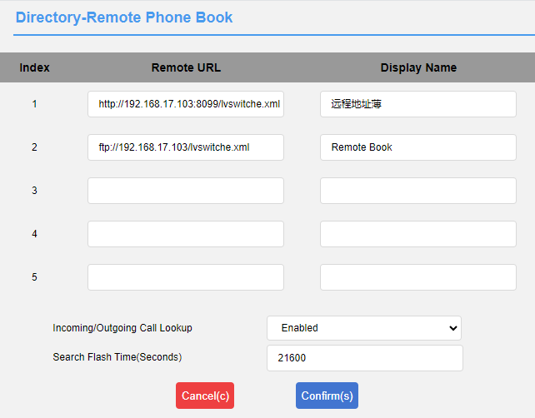

#### **Using the Remote Address Book**

**- View Remote Address Book**

1. Press Phone **Menu** -> **Directory -> Remote Address Book.**

2. Use or to select the list.

4. Press the **Enter** soft key to view the corresponding remote address book.

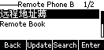

**- Search Remote Address Book**

1. Press Phone **Menu** -> **Directory -> Remote Address Book -> Search.**

2. Enter the number or name of the contact, and the information of the contact that matches the search criteria is displayed on the screen.

3. Use or to select a contact.

4. Press the **Call** soft key to initiate a call.

5. Press the **Options** soft key to view the contact information or add to Contacts/Blacklist.

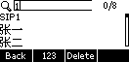

## **Update Address Book**

**- Remote updating of address book via web page**

The Remote Update Contacts feature makes it easy to update local contacts without having to maintain a separate address book for each person. Files with the same MobileNum contacts in front will be overwritten by the later contacts.

1. Log in to the phone page by IP address.

2. Click **Address Book (B) -> Remote Update Address Book.**

3. Configure updated address book information.

a) Server URL: support http/https/ftp/tftp path;

b) Automatic update: enable/disable;

c) Time: Fixed time of the day;

d) Update Now: Click the button to update automatically;

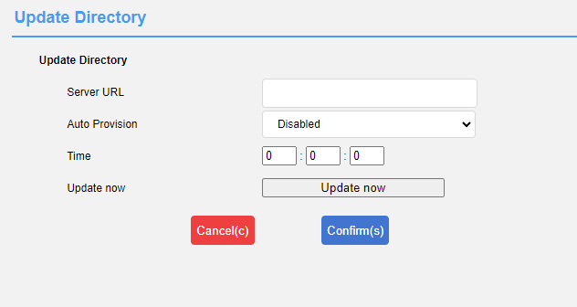

4. Click Submit to save the configuration.

The file format is as follows, just upload it to the server after configuration.

|  |
| --- |
| <?xml version="1.0" encoding="utf-8"? >  <all>  <PhoneBooks>  <book FirstName="adm" LastName="gj" MobileNum="456" OfficeNum="123" OtherNum="789" />  </PhoneBooks>  </all> |

## **Address Book Settings**

The phone supports Address Book Enable/Disable and Caller Contact Match List Enable/Disable.

**- Enable/Disable Address Book via Web**

1. Log in to the phone page by IP address.

2. Click **Contacts (B) -> Settings (%).**

3. Select the address book you want to enable, you can set local contacts, call history, remote address book, blacklist, LDAP.

4. Adjust the sorting by ↑↓ key and then submit;

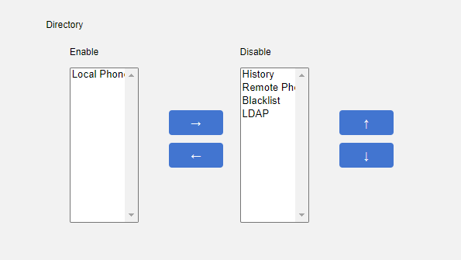

**- Enable/disable caller contact matching via web page**

1. Log in to the phone page by IP address.

2. Click **Contacts (B) -> Settings (%).**

3. Select the matching list of caller contacts to be enabled, you can set local contacts, call logs, remote address book, LDAP.

4. Adjust the sorting by ↑↓ key and then submit;

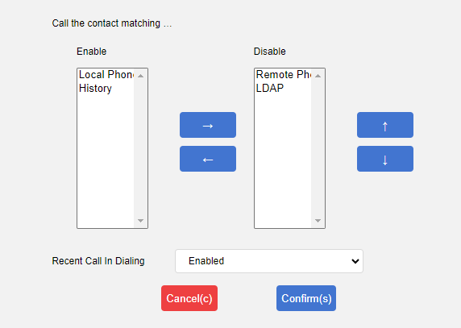

## **Headset using**

The T520 defaults to the headset mode. Before use, you need to connect the headset. Press the 1b4501cc-a268-4f9b-9930-12dc25c4ca81_20917(1) button on the standby screen to enter the dialing interface. When the phone rings, press the "Answer " button to accept the incoming call. For the installation of the headset, please refer to the section on phone installation.

**-**Dual Headset Mode:

To use the dual headset mode, both the headset and the monitor must be connected. After successful configuration, the headset can normally make and receive calls, while the monitoring device can only receive calls.

1. Log in to the phone page via IP address.

2. Click Function (U) → Basic Information (5).

3. Configure to enable/disable the dual headset function.

4. Click Submit to save the configuration.

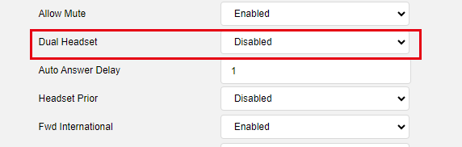

**Description: The dual-headphone function can only be configured through the web interface, and it must be connected to both the microphone and the listener.**

- Headphone Priority:

The headphone priority feature is suitable for users who frequently or exclusively use headphones.

1. Log in to the phone page via IP address.

2. Click on the function (U) → Basic Information (5).

3. Configure to enable/disable the headphone priority function.

4. Click to submit and save the configuration.

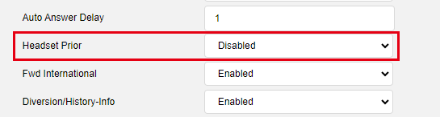

Description: The headset priority function can only be configured through the web interface and must be connected to the headset.

The operator phone defaults to the operator mode and is generally not modified.

The dual headset mode and headset priority mode can be enabled simultaneously.

## **System Customization**

### **Account Management**

The phone can register SIP accounts, up to 2 accounts, and make calls through the registered SIP accounts.

#### **Account Registration**

**- Register for an account through the phone interface**

1. Press **Menu->Settings->Advanced Settings (Password:admin)->Account.**

2. Press or to select the account to be configured and press the **Enter** soft key to enter the configuration screen.

3. Account status can be enabled or disabled by **toggling the** soft key.

4. Press or to select the label, display name, user name, registration name, password, server address, and

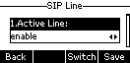Registration server port.

5. Change the transmission mode by **switching the** softkey: UDP or TCP.

6. Press the **Save** soft key to save the account.

**- Registering for an account through the web interface**

1. Log in to the phone page by IP address.

2. Click **Account (A) -> Register (r).**

3. Fill out and **submit** (required fields: user name, registered account, password, server address, port).

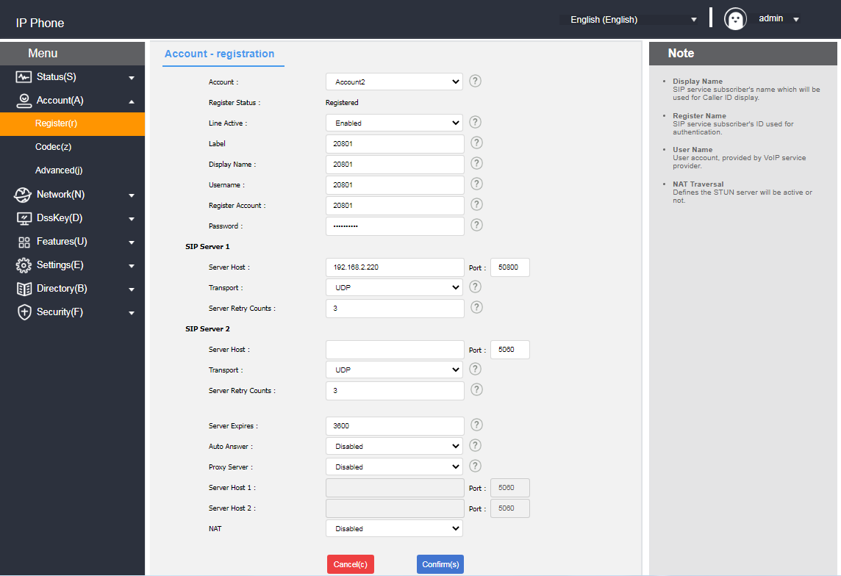

**Instructions**  If you need to register account 2, please repeat steps 2~6.

Standby server and proxy server cannot be configured in the phone interface, if you need to configure these two items, please go to the web interface for account registration.

**- Configuration of codecs through the web interface**

1. Log in to the phone page by IP address.

2. Click **Account (A) -> Codec (z).**

3. Select the codec you want to enable and then **submit it** (support type: PCMA/PCMU/G722/G729/G726, etc.).

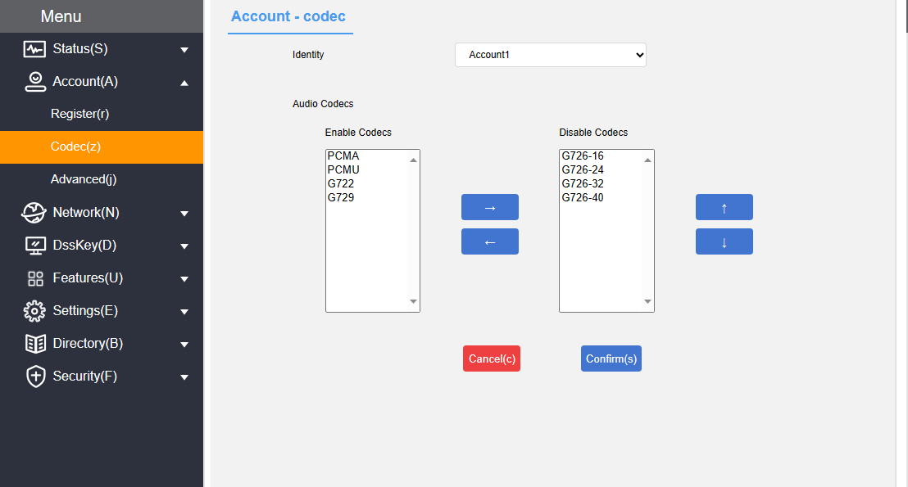

**-Configure IP Direct dial codec on the web page**

1. Log in to the phone page using the IP address.

2. Click Account (A) -> Codec (z).

3. Select the Codec to be enabled and submit it (Support type: PCMA/PCMU/G722/G729/G726, etc.).

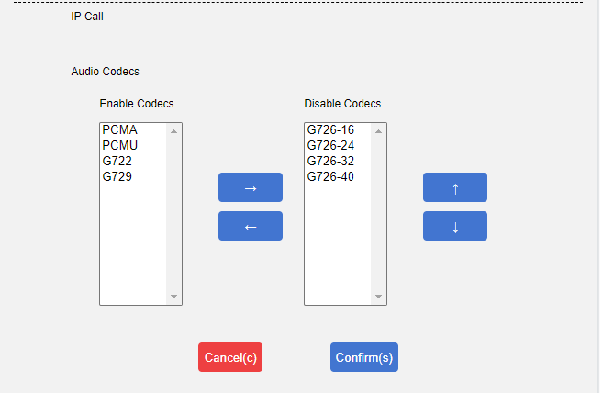

**- Configuration of codecs through the phone interface**

1. Press **Menu->Settings->Advanced Settings (password:admin)->Account Advanced->Codec.**

2. Press or to select the codec input value to be configured, the higher the value the higher the codec priority.

3. Press the **Save** soft key to save.

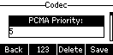

Explanation: If there is a problem with the phone not being able to register, please check whether the registration information is filled in correctly and verify if the network of the phone is functioning properly. If you need assistance, please contact your network administrator.

### **Programmable keys**

You can customize the functions of the soft keys, arrow keys, and functional buttons below the screen for phone according to your personal habits.

#### **Programmable Function Keys**

You can customize the functions of the soft keys, arrow keys, and functional buttons below the screen for phone according to your personal habits.

**- Programmable function keys via web interface**

1. Log in to the Web interface.

2. Click **Programmable Key (D) -> Programmable Function Key (7).**

3. Softkey 1 ~ Softkey 4 set the label content, which can be displayed on the LCD screen.

4. Click the **Submit** button to save.

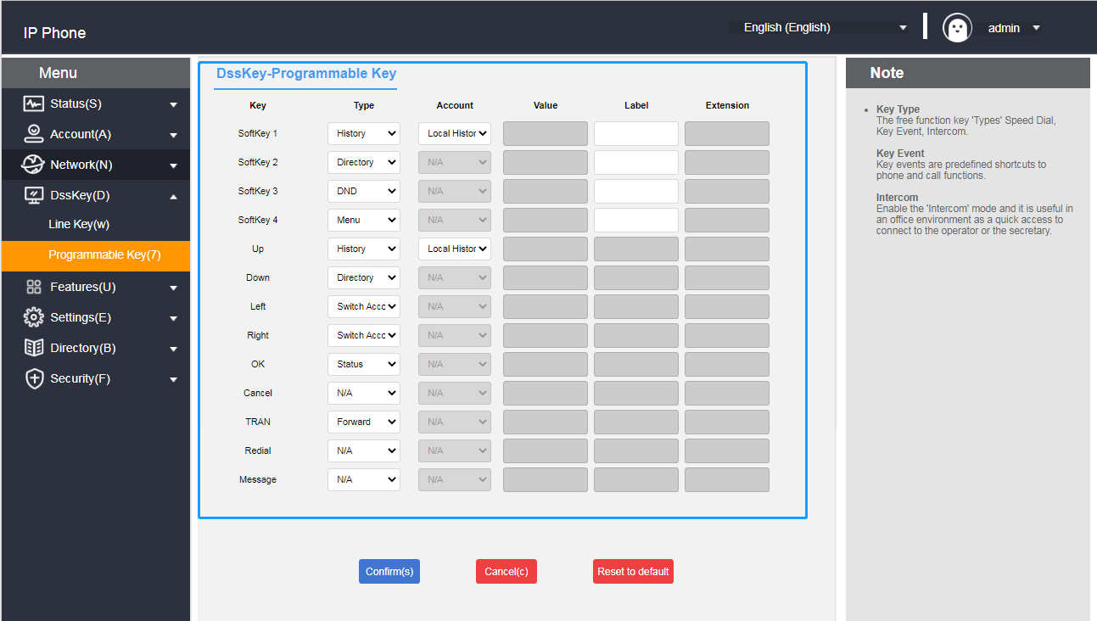

**Description**  Programmable function keys are set in the web interface.

If there is a problem with the settings, you can click Restore Defaults to restore all keys to their factory state.

#### **Programmable Function Key Type Description**

|  |  |  |
| --- | --- | --- |
|  | **typology** | **Instructions and use** |
| **Programmable Function Keys** | NONE | / |
| speed dial | Quickly dial the designated account number.  - Usage:  1. Set the type to "Speed Dial".  2. The account is set to the corresponding account that needs to realize speed dialing.  3. The value field is set to the number of the other party.  4. Set up labels on demand.  5. Pressing after setting will speed dial the set number. |
| group pickup | Setting up group interception allows you to intercept accounts in the same interception group.  - Usage:  1. Set the type to "Group Intercept".  2. The account is set to the corresponding account that needs to realize the group interception.  3. The value field is set to the group pickup feature code.  4. Set up labels on demand.  5. When there are accounts in the Intercept Group in the incoming call status, press the Group Intercept key to realize group interception. |
| prefix | Quickly enter pre-configured prefixes for easy dialing.  - Usage:  1. Set the type to "Prefix".  2. The value field is set to the value you want to configure.  3. Set up labels on demand.  4. Pressing after setting will bring up the dialing screen with the prefix value. |
| local group | Quickly jump to a specific group.  - Usage:  1. Set the type to "Local Group".  2. The account selects the group you need to jump to.  3. Set up labels on demand.  4. Pressing after setting will quickly jump to the designated group. |
| XML Browsing | Browsing XML that conforms to a defined format, with support for browsing text, images, address books, etc.  - Usage:  1. Type is set to "XML Browser".  2. The value field is filled with the XML browser address.  3. Set up labels on demand.  4. After setting up press will browse the related XML. |
| Designated pickup | You can intercept a specified account after you set a specified intercept.  - Usage:  1. Set the type to Specified Intercept.  2. Set the account to the account that you want to intercept.  3. Set the value range to the specified truncated feature code + account.  4. Set labels as required.  5. When the specified account is in the incoming call state, press the specified intercept key to intercept the call. |
| History | You can go directly to the call log page after setting up call log.  - Usage:  1. Set the type to "History".  2. The account defaults to the local call record.  3. Set up labels on demand.  4. Pressing this key takes you directly to the call log. |
| menu | - Usage:  1. Set the type to "Menu".  2. Set up labels on demand.  3. Pressing the key takes you directly to the menu. |
| Forward | - Usage:  1. Set the type to "Forward".  2. Set up labels on demand.  3. Press the key for the first time to enter the page of setting the unconditional transfer number, and set it as the unconditional transfer switch. |
| DND | - Usage:  1. Set the type to "Do not disturb".  2. Set up labels on demand.  3. Set it up as a do-not-disturb switch. |
| Call back | - Usage:  1. Set the type to "Callback".  2. Set up labels on demand.  3. Set up for the callback button. |
| SMS | Quickly jump to the Menu→Message→Text Message screen.  - Usage:  1. Set the type to "SMS".  2. Set up labels on demand.  3. After setting, press will jump to the text message interface. |
| new SMS | Quickly jump to Menu → Messages → Text Messages screen → New Message.  - Usage:  1. Type is set to "New SMS".  2. On-demand labeling  3. After setting, press will jump to the new message editing interface. |
| Status | - Usage:  1. Set the type to "Status".  2. Set up labels on demand.  3. After setting up, press to check the status of the phone. |
| local contact | - Usage:  1. Set the type to "Local Contact".  2. Set up labels on demand.  3. Press to enter local contacts after setting. |
| Hot desking | Clear the current account configuration Enter a new account password to quickly configure the phone.  - Usage:  1. Type set to "hot desking"  2. Set up labels on demand.  3. After setting up and pressing will prompt whether to clear all account configurations. |
| Keypad lock | Keyboard is locked when keypad lock is enabled.  - Usage:  1. Set the type to "Keylock"  2. After setting the keyboard, press it to prompt: The keyboard is locked. |
| Switching Accounts Upwards | - Usage:  1. Set the type to "Upward account switching".  2. Set up labels on demand.  3. After setting up, press the key to switch the default account upwards. |
| Switching Accounts Down | - Usage:  1. Set the type to "Downward account switching".  2. Set up labels on demand.  3. Press the key to switch the default account down after setting. |
| directory | - Usage:  1. Set the type to "Directory".  2. Set up labels on demand.  3. Press the key to enter the address book after setting. |

### **Dialing Rules**

Setting up dialing rules allows the phone to dial conveniently according to the syntax set up by the dialing rules.

**Description**  This function can only be set in the web interface.

#### **Dialing Rule Syntax**

Before using dialing rules, you need to understand the dialing syntax; if you are already familiar with that syntax, you can skip this step and check the

[Dialing Rules Feature](#_拨号规则功能) Content.

Dialing Rule Symbol Description:

|  |  |  |
| --- | --- | --- |
| character | clarification | (for) instance |
| . | Indicates any number of placeholders | Enter "78."  Match "786", "7856", "78911", "7857713", etc. |
| x | Indicates a placeholder | Enter "78x"  Match "781," "782," "783," "784." ... "789", etc. |
| - | Indicates an interval range | Enter "[7-9]".  Match "7" or "8" or "9". |
| [] | Indicates an interval range, there is only one [] in the string, use it with the - symbol. | Enter "12[7-9]45".  Match "12745," "12845," "12945." |
| () | Indicates multiple interval range combinations with multiple [] in the string | Enter "([1-2][7-8])".  Match "17," "27," "18," "28." |

**DESCRIPTION**  For questions about the syntax and use of dialing rules, contact your network administrator.

#### **Dialing Rules Feature**

Dialing rules include the following:

* Replacement rules
* Call out immediately
* Area code
* Restriction of outgoing calls

##### 1) Replacement rules

You can customize the replacement rules up to 100. Replacement rules mean that you can enter a string of characters and the phone will automatically replace it with your customized string. In practice, for example, if you set a substitution rule to input "1" and replace it with "10086", when you dial 1 on the phone and press the Send softkey or #, the phone will automatically replace it with 10086 for dialing.

Using substitution rules, you can also make quick IP point-to-point calls.

**- Adding replacement rules through the web interface**

1. Log in to the phone page by IP address.

2. Click **Settings (E) -> Dialing Plan (k) -> Replace Rules.**

3. Enter a string in the **Prefix** field (e.g., 1).

4. Enter the replacement string (e.g., 10086) in the **Replacement** area.

5. Select the lines to which the rule applies at the **account number.** (where all indicates all accounts).

6. Click the **Add** button to save the rule.

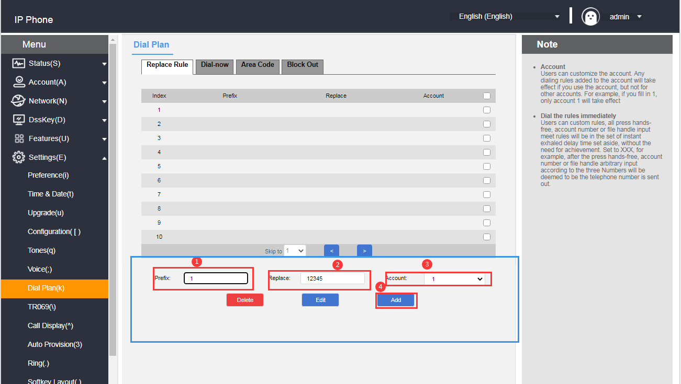

After adding the above rules, when you dial the number "1", press the **Send** soft key or # to call, the phone will automatically replace the number with "10086" for dialing.

**- Modification of replacement rules through the web interface**

1. Log in to the phone page by IP address.

2. Click **Settings (E) -> Dialing Rules (k) -> Replace Rules.**

3. Check the checkbox to the right of the rule you want to modify in the rule list.

4. Modify **prefixes/replacements/accounts** as needed**.**

5. Click the **Edit** button to save the changes.

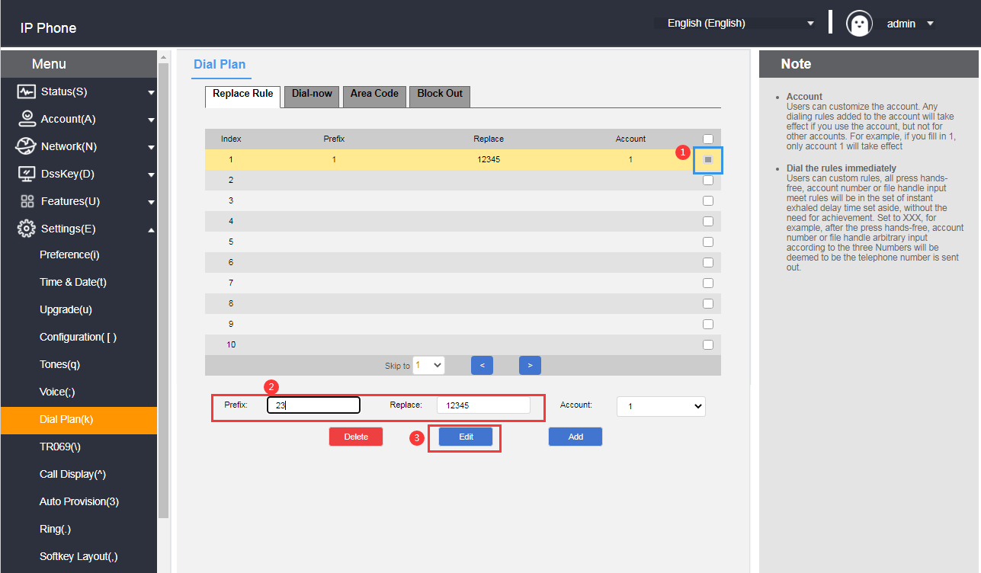

**- Deletion of replacement rules through the web interface**

1. Log in to the phone page by IP address.

2. Click **Settings (E) -> Dialing Rules (k) -> Replace Rules.**

3. Check the checkbox to the right of the rule you want to modify in the rule list.

4. Click the **Delete** button to delete the rule.

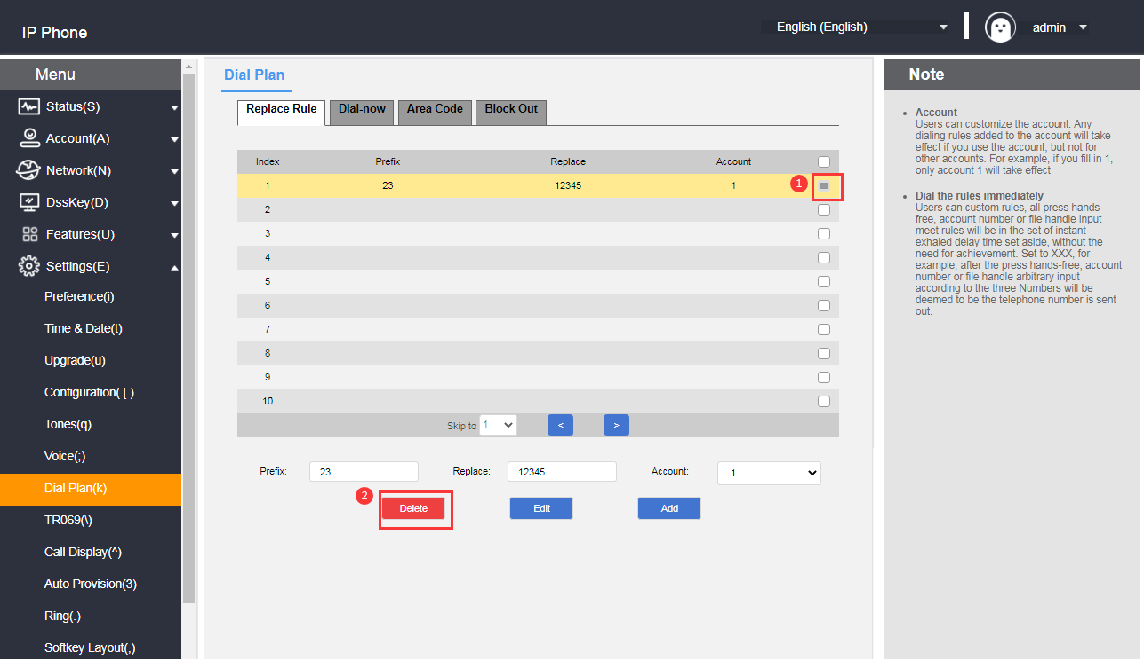

##### 2) Exhale immediately

You can customize the immediate outgoing rules, up to 100 rules, all the numbers that meet the rules by pressing the speakerphone, account number key or lifting the handle will be dialed in the set immediate outgoing delay time, without pressing the send key. For example, when you set the call out rule as xxxxxx, the caller account number is all (any account), when you dial any five-digit number of 10086, the phone will call 10086 immediately when you meet the call out rule.

**- Adding immediate callout rules through the web interface**

1. Log in to the phone page by IP address.

2. Click **Settings (E) -> Dialing Rules (k) -> Call Out Now.**

3. Enter the rule characters to be set in the rule input area (e.g.: xxxxxx).

4. Select the account to which the matching rules apply (eg: the current registered account 80011), the default value is all (indicating all accounts).

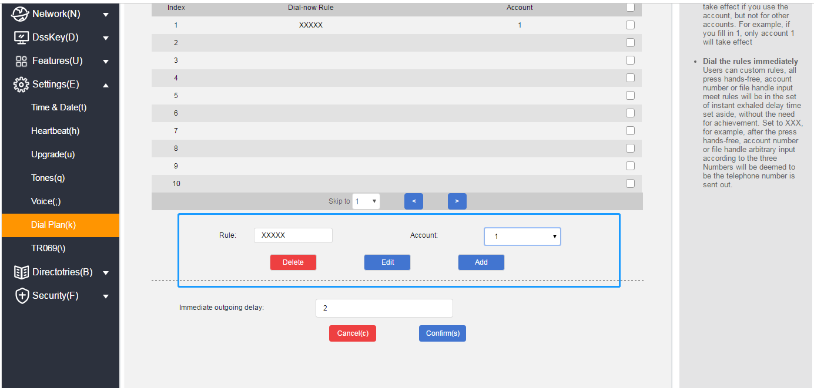

5. Click the **Add** button to save the rule.

When any five-digit number such as 10086 is entered, it will be called out immediately after waiting for the delay time.

**- Modify the immediate call out rules through the web interface**

1. Log in to the phone page by IP address.

2. Click **Settings (E) -> Dialing Rules (k) -> Call Out Now.**

3. Tap the rule you want to modify in the rule list.

4. Modify the rule in the rule input area, e.g.: (original: xxxxx --> change: 1xxxx).

5. Account area to select the account to which the matching rule applies (e.g., the current registered account 8001), the default value is all (indicating all accounts).

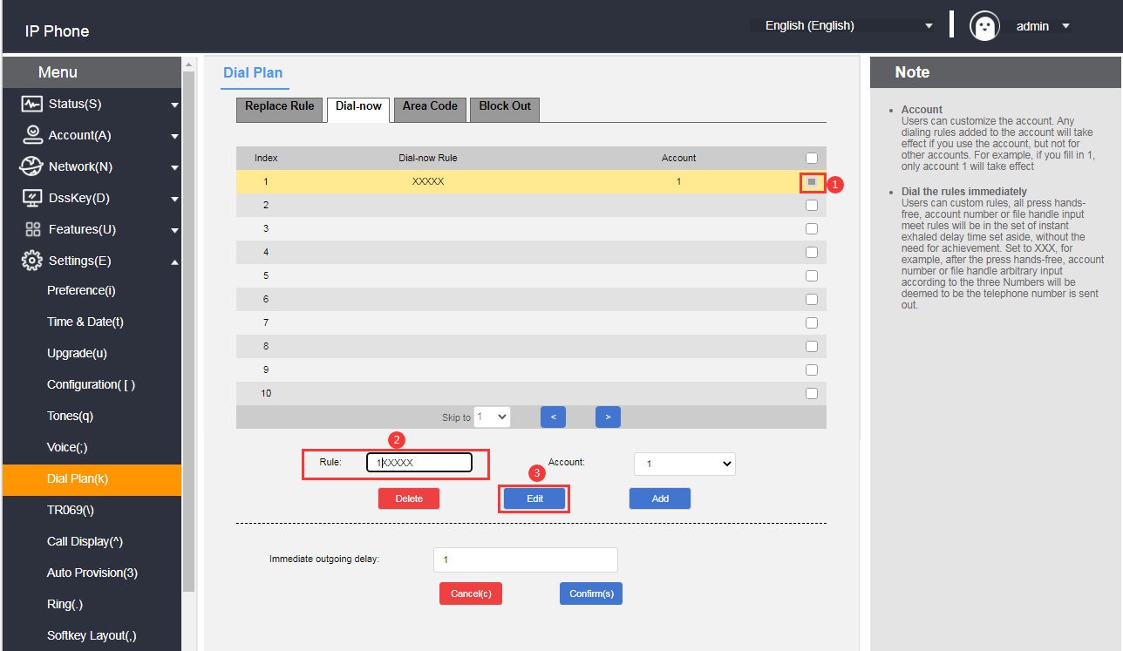

6. Click the **Edit** button to save the modified rule.

**- Remove immediate call out rules through the web interface**

1. Log in to the phone page by IP address.

2. Click **Settings (E) -> Dialing Rules (k) -> Call Out Now.**

3. Tap the rule you want to delete in the Rule List.

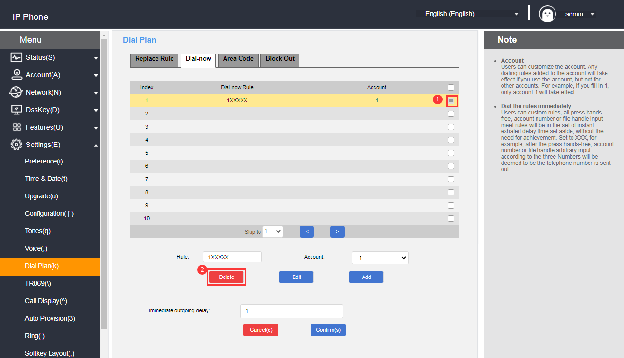

4. Click the Delete button to delete the rule.

Immediate outbound delay time

Immediate call out needs to set the delay time, the default time is 2 seconds, the setting range is 0~14 (unit: second), when the number entered when dialing meets one of the immediate call out rules, the phone will automatically call out the number after the delay time, without pressing the send key.

**- Setting the delay time for immediate outgoing calls through the web interface**

1. Log in to the phone page by IP address.

2. Click **Settings (E) -> Dialing Rules (k) -> Call Out Now.**

3. In the Instant Call out Delay entry field, fill in the time.

4. Click the **Submit** button to save.

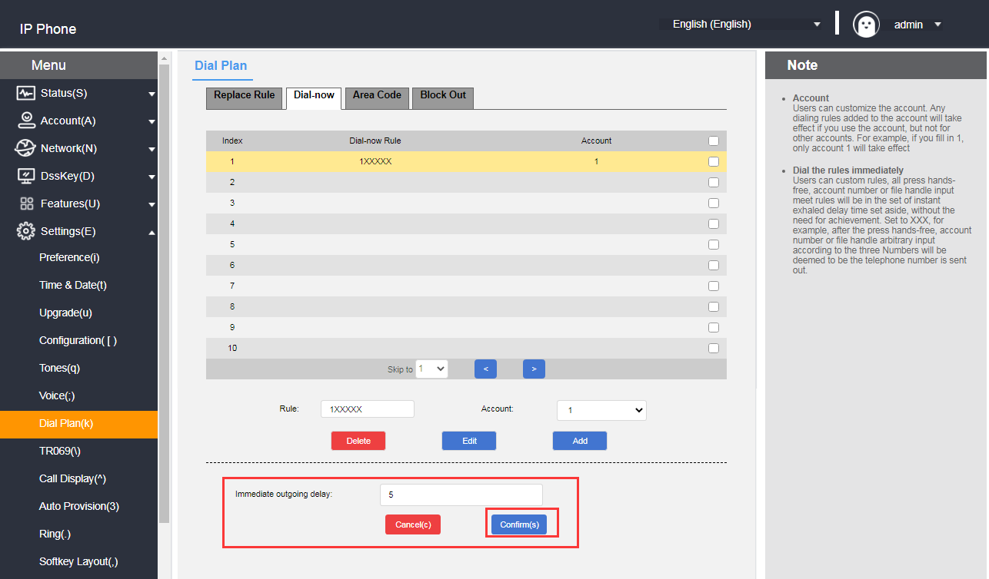

##### 3) Area code

You need to add the area code to make calls between different regions, which are different from one region to another. If you need to call a phone number in a certain area frequently, you need to manually dial the area code prefix of that area. By using this feature it will automatically add the area code/prefix in front of your outgoing number.

**Description**  Only one area code can be set for the T780N.

Example:

|  |  |
| --- | --- |
| Setting the area code (length range: 1~15 digits) | 0757 |
| When you dial the number (length range: 1~15 digits)) | 12345 |
| The actual outgoing number is changed to | 075712345 |

**- Setting up area codes through the web interface**

1. Log in to the phone page by IP address.

2. Click **Settings (E) -> Dialing Rules (k) -> Area Code.**

3. Fill in the area code (length range: 1~15 digits).

4. The account number can be filled in with the registered account of the matching area code or the default value is all (all accounts).

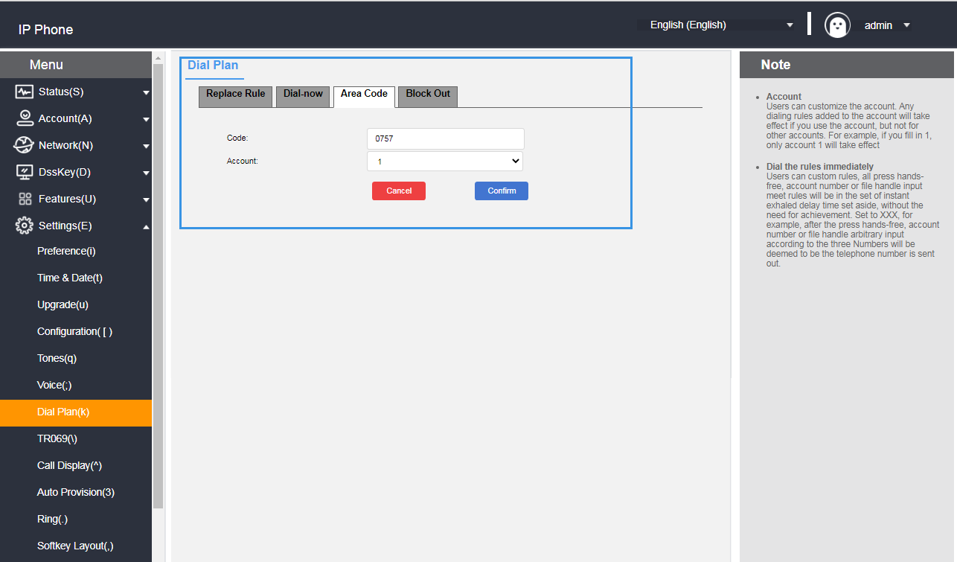

##### 4) Restriction of outgoing calls

You can restrict the phone to call certain numbers by setting the restricted outgoing numbers, It supports up to 10 restricted outgoing numbers, when the number you call matches with the rule, the phone will show "prohibited number" on the LCD display.

**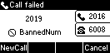**

**- Adding outbound restriction rules through the web interface**

1. Log in to the phone page by IP address.

2. Click **Settings (E) -> Dialing Rules (k) -> Restrict Outgoing Calls.**

3. Fill in the Blocked Numbers field with the number you want to restrict calls to.

4. Account fill in the registered account of the restricted call.

5. Click the **Add** button to save the rule.

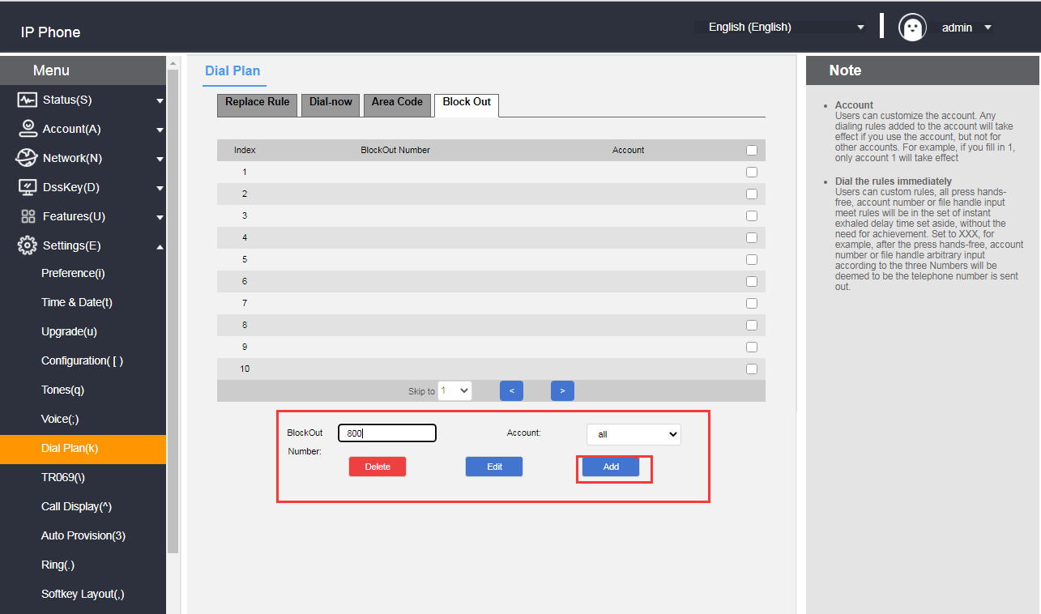

**- Modify outbound restriction rules through the web interface**

1. Log in to the phone page by IP address.

2. Click **Settings (E) -> Dialing Rules (k) -> Restrict Outgoing Calls.**

3. Restrictions on Outgoing Rules List Tap the rule you want to modify.

4. Modify the rule in the rule input area, e.g.: (original: xxxxx --> change: 1xxxx).

5. Account area fill in the matching account (eg: the current registration account 8001), the default value is all (that all accounts).

6. Click the **Edit** button to save the modified rule.

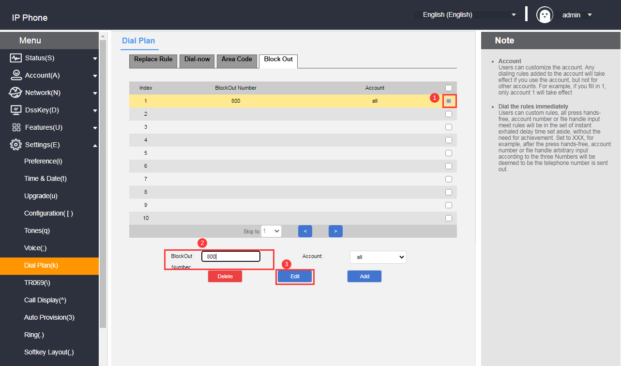

**- Remove outbound restriction rules through the web interface**

1. Log in to the phone page by IP address.

2. Click **Settings (E) -> Dialing Rules (k) -> Restrict Outgoing Calls.**

3. Tap the rule you want to delete in the restricted outgoing rule list.

4. Click the **Delete** button to delete the rule.

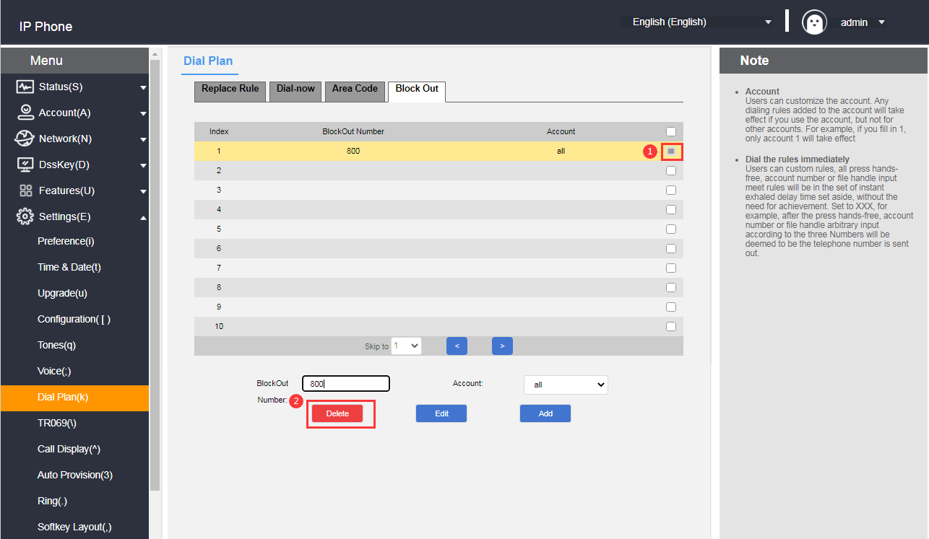

# **Basic Functions**

This chapter introduces the basic functions of the telephone as follows:

* [make a call](#_拨打电话)
* [answer the phone](#_接听电话)
* [end a call](#_结束通话)
* [redial](#_重拨)
* [D](#_免打扰)ND
* [Call transfer](#_呼叫转移)
* [Call forwarding](#_呼叫转接)
* [Call Waiting](#_呼叫等待)
* [PIN call](#_密码呼叫)
* [call hold](#_呼叫保持)
* [Auto redial](#_Automatic rewiring)
* [Call completion.](#_呼叫完成)
* [Auto Answer](#_自动应答)
* [anonymous call](#_匿名拒接)
* [hotline (communications link)](#_热线)
* [two-dimensional barcode](#_二维码)
* [sessions](#_会议)
* [Update](#_升级)
* [Upload ringtones](#_上传铃声)
* [Capture & Diagnose](#_抓包&诊断)
* [Timing reset](#_reset)
* [configuration management](#_配置管理)

## **make a telephone call**

You can choose the way to make a call ① manual dialing, ② call list, local contact selection number dialing.

For the way to dial a phone Record and local contacts, please see [Contact Management](#_联系人管理) and [CDR Management](#_话单（通话记录）管理) for more information.

The T520 is a desk phone that enables calls through the headset:

**- Make a call**

Any of the following may be used：

|  |  |
| --- | --- |
| **Mode 1** | **Mode 2** |
| 1.After connecting the headset，press 1b4501cc-a268-4f9b-9930-12dc25c4ca81_20917(1) to enter headset mode | 1.After connecting the headset ,input the number |
| 2．Input the number | 2.Press09b6c513247ee992fa6450bde675337、or 1b4501cc-a268-4f9b-9930-12dc25c4ca81_20917(1)key to dial out the number |
| 3. Press 09b6c513247ee992fa6450bde675337 , or the **Dial** soft key to call out the number. |  |

**- multi-way calling**

The IP phone supports multiple calls, each account supports up to 2 calls, while one call is in progress, other way of call is on hold.

A new call can be initiated using any of the following methods:

1. During a call, press the **Hold** soft key and the current call will be on hold.

2. Press the **New Call** soft key to enter the dialing interface and enter the number.

3. Press the 09b6c513247ee992fa6450bde675337or **dial** Soft key to make the call.

4. Press or to switch numbers, and press the Resume soft key to resume the call.

**- Number filtering**

T520 supports number filtering to filter out invalid input during dialing.

1. Log in to the web interface.

2. Click Function (U) → Basic Information (5).

3. Call Number Filtering: \*#.

4. Click Submit to save.

**- Allow IP calls**

The phone supports configuration of whether to allow IP calls.

1. Click **Functions (U) → Basic Information (5)** from the homepage.

Enable: the phone allows direct IP dialing;

Disable: when calling IP, it prompts: account is unavailable; when called, you cannot receive direct dialing from IP, and you will receive missed calls from IP after restoration.

2. Click **Submit to** save the configuration.

**- IP Direct Dial Auto Attendant**

The IP phone supports the configuration of whether or not to activate IP direct dialing auto-answer.

1. Click **Functions (U) → Basic Information (5)** from the homepage.

Enable: Automatically answer the incoming IP calls;

Disable: need to manually answer an incoming IP call.

2. Click **Submit to** save the configuration.

## **Answer the phone**

The T520 handset is an operator phone that uses a headset for communication:

**- Answering incoming calls**

When the phone receives an incoming call,Press the answering soft key or press the 1b4501cc-a268-4f9b-9930-12dc25c4ca81_20917(1) headset key to answer.

**- Reject Incoming Calls**

Press the reject button to reject incoming calls.

If Do Not Disturb mode is enabled, incoming calls will be automatically rejected. For details, please refer to the Do Not Disturb section.

## **End a call**

If you want to end the call during the conversation, you can do it in the following ways:

1. Press the "Hang Up" soft key during the call to end the current conversation.

2. Press the1b4501cc-a268-4f9b-9930-12dc25c4ca81_20917(1) Headset during the call to end the current conversation.

## **Redial**

The phone can quickly redial the last call or any other call. You can perform the redialing by using the buttons on the phone. There are various ways to redial, and the specific operation is as follows:

- Redial

1.Redial the last call

Pressbutton twice to redial the last call.

2.**Redial any call**

1) Press the button once

2) **Press** **or** to switch the number

3) Press , the **Call** soft key or 09b6c513247ee992fa6450bde675337to redial any call.

## **DND**

You can set the phone for Do Not Disturb mode, after setting the Do Not Disturb mode, the phone will display icon on the upper right corner of the phone, the phone will not ring when receiving an incoming call and inform the other party that it is busy, and display a missed call alert on the local phone, as shown below:

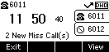

DND has two modes to choose from:

* **Phone Do Not Disturb (Factory Default Mode):** Turning on this mode will turn on Do Not Disturb for all accounts.
* **Customized Do Not Disturb:** You can select a specified account to set do not disturb.

**- Setting up do-not-disturb on web pages**

1. Log in to the web interface.

2. Click **Features (U) -> Call Forwarding & Do Not Disturb (4)**.

3. In the Do Not Disturb Settings area, select Do Not Disturb Mode: **Phone or Custom Mode**.

4. If you select Custom Mode, select the extension you want to turn on Do Not Disturb.

5. The Do Not Disturb status is set to **On.**

6. Click Submit to save.

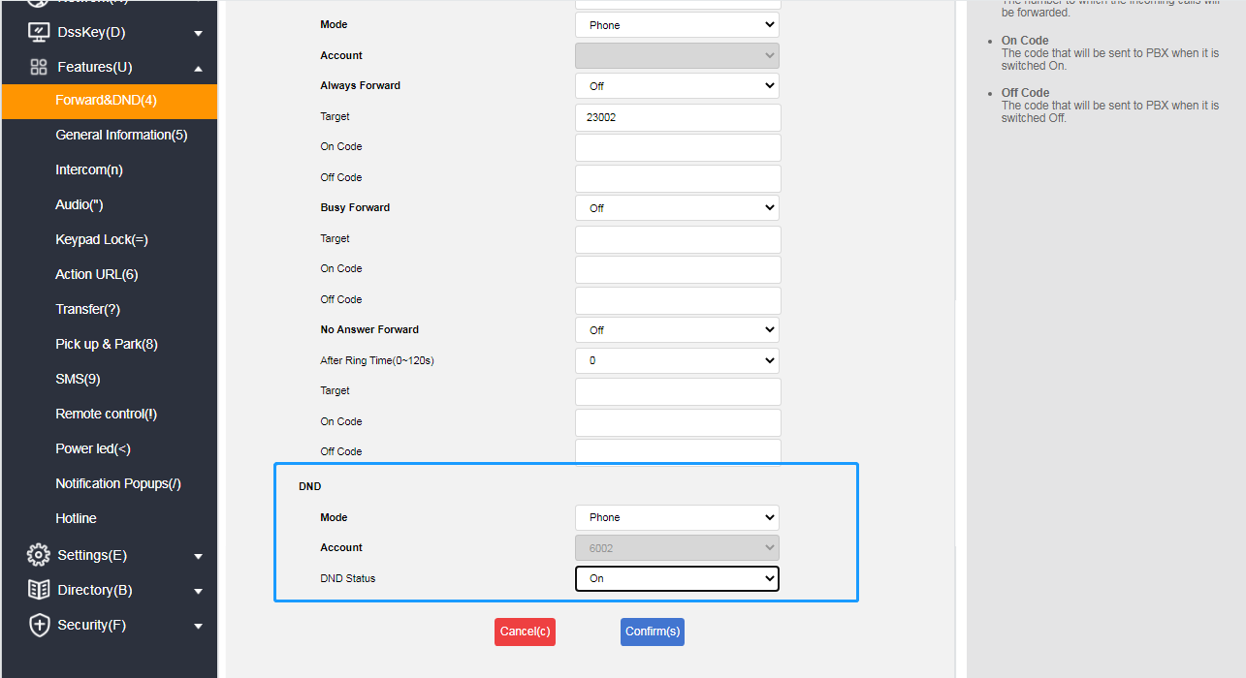

**Description**  The Do Not Disturb mode can only be set in the web interface.

**- In phone mode, turn on Do Not Disturb in the phone screen.**

1. Press the **Do Not Disturb** soft key while the phone is in standby to set it.

2. or press **Menu->Functions->Do Not Disturb.**

3. Press the **Toggle** soft key to toggle.

4. Finally, press the **Save** softkey to save the operation.

When Do Not Disturb is turned on, the icon is displayed in the upper right corner of the phone.

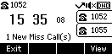

**- Enable Do Not Disturb in the phone interface in customized mode**

1. When the phone is in standby, press the **Do Not Disturb** soft key or press **Menu->Functions->Do Not Disturb** to enter the customized Do Not Disturb setting interface.

2. Press or to select the account for which you want to set up Do Not Disturb.

3. Press the **Toggle** soft key or the **Left and Right** buttons to select Enable.

4. Press the **Save** soft key or the 09b6c513247ee992fa6450bde675337 key to save the operation.

## **Call transfer**

After setting the call transfer on, the external call to the IP phone will be automatically transferred to the set up of other phones or cell phones, call transfer is divided into two types, when the phone has an incoming call ringing press the **transfer** soft key to dial the number to transfer (active transfer), when the phone has an incoming call automatically transferred to a pre-set number (automatic transfer).

### **Active transfer**

**- Transfer operation process**

1. When there is an external incoming call, the handset is in the ringing state.

2. Press the **FWD** soft key.

3. Enter the number to be transferred.

4. Press the 09b6c513247ee992fa6450bde675337 **button/Send** soft key to transfer the call.

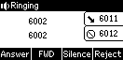

### **Automatic transfer**

There are several main types of automatic transfers:

* + - * Unconditional transfer: all incoming calls to the phone are transferred to the preset number .
      * Busy Transfer : When the phone is busy, calls are transferred to a preset number.
      * No-Answer Transfer: When no one answers during the ringing period of an incoming call, the call is transferred to a preset number after a timeout.

**-Set the call forwarding authentication number through the web page interface:**

1. Click on Features (U) -> Call Forwarding & Do Not Disturb (4);
2. Enable Call Forwarding Emergency Number under Call Forwarding Area;
3. Enter the corresponding numbers in the Call Forwarding Authentication Number field, with multiple numbers separated by ",";
4. Click Submit to save the operation.

After the authentication number is turned on, the number comes to the telephone set without transfer processing, and the authentication number is applicable to all accounts;

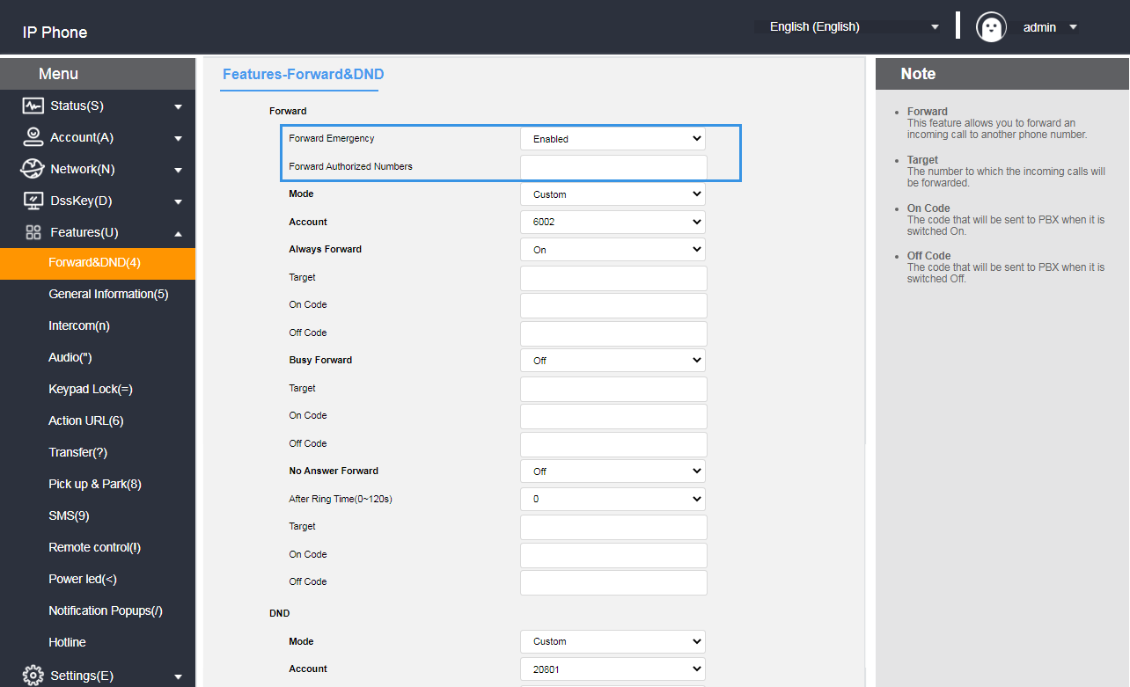

**- Setting up call forwarding through the web interface**

1. Press **Function (U) -> Call Forwarding & Do Not Disturb (4)**.
2. Select the mode under the Call Forwarding Mode area:Custom: Custom mode enables the call forwarding feature for a specific account or for all accounts; Phone Mode: the call forwarding feature will be applied to all accounts on the phone.

3. Select the transfer method to be set as desired and select On.

4. Fill in the **target number** to be transferred.

5. Setting the feature code on and off in the call forwarding area (optional)

6. Click the **Submit** button at the bottom of the page to save

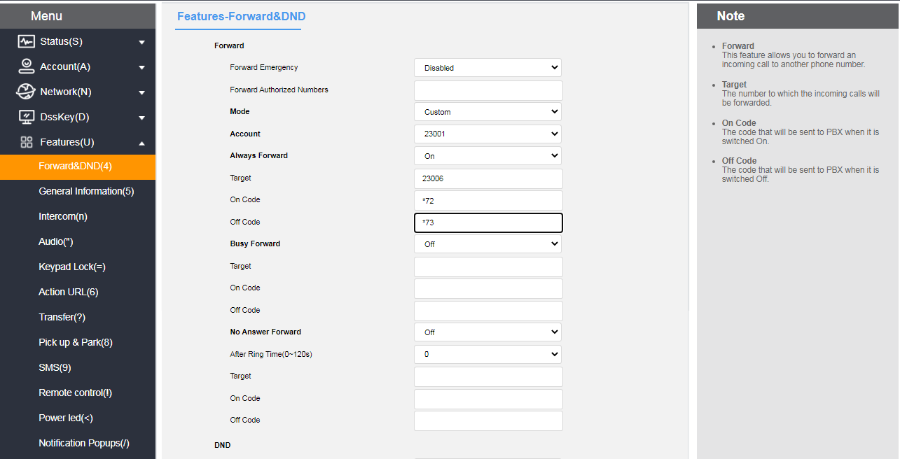

Note: If you configure a call forwarding feature code, the phone will send the corresponding feature code to the server. For example, if you set the feature code of unconditional transfer on to \*72, and the feature code of unconditional transfer off to \*73, and the transfer number is 1000, when you turn on the unconditional transfer, the phone sends \*721000 to the server, and when you turn it off, it sends \*731000 to the server, so that the server can synchronize the unconditional transfer function to be turned on/off.

**- Setting up call forwarding through the phone interface**

1. Press **Menu->Functions->Call Forwarding.**

2. Select the transfer method to be set as desired:

* unconditional transfer

1) Press or to select Unconditional Transfer.

2) At the Status option, press the **Toggle** soft key to turn on/off.

3) Press or to select the number item and fill in the number in case of unconditional transfer.

4) (Optional) Enter the unconditionally transferred on feature code and off feature code in the on feature code and off feature code areas, respectively.

5) Press the Save soft key to save the operation.

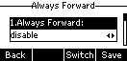

* Call forwarding when busy

1) Press or to select Busy Transfer.

2) At the Status option, press the **Toggle** soft key to turn on/off.

(3) Press or to select the number item and fill in the number in case of busy transfer.

4) (Optional) Enter the on feature code and off feature code for busy transfer in the on feature code and off feature code areas respectively.

5) Press the **Save** soft key to save the operation.

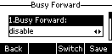

* Nonresponsive transfer

1) Press or to select entering No Answer Transfer.

2) At the Status option, press the **Toggle** soft key to turn on/off.

3) Press or to select the number item and fill in the number to be transferred.

4) Press or to select no answer time, fill in the waiting time before you want to transfer, default 5Seconds.

5) (Optional) Enter the on feature code and off feature code for no-answer transfer in the on feature code and off feature code areas respectively

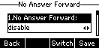

6) Press the **Save** soft key to save the operation.

When Call Forwarding is turned on, the LCD screen displays the Call Forwarding Enabled icon when the phone is in standby.

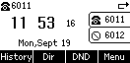

**Description**  If the call forwarding feature has been set up in advance, call forwarding can be quickly turned on/off by using the TRANSFER button on the phone panel.

## **Call forwarding**

Call transfer is categorized into the following two types:

* Blind transfer: Direct transfer to the other party without consultation with the transferring party.
* Consultation transfer: transferring incoming calls to the person to whom the call is to be transferred when the consultation with the person to whom the call is to be transferred has been completed and the transfer has been agreed upon.

### Blind transfer

**- Blind transfer operation process**:

Phones A

Phones B

Phone C

1. A is on the phone with B

③B enter C number and press the **Blind Transfer** soft key to transfer to C

④ A and B are disconnected from the call, and A is talking to C.

②B press **Transfer** soft key, AB call goes on hold (press **Resume** soft key to resume A and B call)

Blind transfer flowchart

1. Handset A is talking to handset B.

2. Handset B presses the **Transfer** soft key or the Transfer button.

3. The called number input for blind transfer can be done in the following two ways:

1. Enter the number directly

1) B enter the number of the transferred phone C. After entering the number, the **blind transfer(BTra)** soft key appears on the LCD display of the phone B.

2) Phones B press the **BTra** soft key.

3) The call between B and A will be interrupted and the incoming call is forwarded to Phone C.

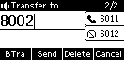

1. Selecting numbers by contact

1) B Press the **Dir** soft key.

2) Press or to select a group and press the **Enter** soft key to enter the group.

3) Press or to select the contact to be transferred and press the **Send** soft key.

4) Press or to select the phone or cell phone you want to transfer to and press the **Transfer** soft key to blind transfer.

5) The call between B and A will be interrupted and the incoming call is forwarded to Phone C.

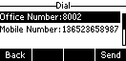

**-** **Eliminate the blind turn operation process**:

When Phones A and B are talking, after Phones B presses the **Transfer** soft key, Phones B and A will enter a call hold state, and the calling party will hear the ringing of the call hold, and if they want to exit the transfer operation, press the **Resume** soft key, and the call between Phones B and A will be resumed.

### **Advisory Transfer**

**-** **Consultation transfer operation process**:

1. Phone A is talking to phone B.

④ If C does not agree to answer, B and C end the call.

⑤B presses the **Resume** soft key to resume the call between A and B. Explain the reason for not being able to transfer the call, and AB ends the call.

④ If C agrees to answer

⑤B press the **transfer** soft key to transfer the incoming call to C.

Consultation Transfer Flowchart

Phones A

Phones B

Phone C

1. A is on the phone with B

③ B enters C's number and presses the **Send** soft key to call C. B communicates with C whether to forward A's call to C.

(vi) B and C are disconnected from the call, A and B are disconnected from the call, and A and C are on the call

②B press the **Transfer** soft key, AB call goes on hold (you can press the **Resume** soft key to resume the call between A and B)

2. Phone B presses the **Transfer** soft key or the Transfer button.

3. Enter the number of the transferred phone C. The LCD display shows the **Send** soft key.

4.After pressing the **SEND** soft key,phone B will talk to phone C. Phone B ask phone C if he wants to accept an incoming call from Handset A.

5. It is divided into the following two cases:

a) Phone C is unable to answer the call

1) Phone C refuses to answer a call from A or Phone C is unavailable.

2) Phones B and C end the call.

3) Phone B presses the **Resume** soft key to resume the call with Phone A and informs Phone A that it is unable to answer.

4) End of transfer.

b) Phone C can answer the call

1) Phones B and C have finished negotiating, and Phones C can answer incoming calls from Phones A.

2) Phones B presses the **transfer** soft key.

3) The call between B and A will be interrupted and the call will be forwarded to C and A will talk to C.

## **Call Waiting**

If you enable Call Waiting feature, you can receive new incoming calls during the call, otherwise new incoming calls will be automatically rejected during the call, if you enable the Play Tone feature, when you receive a new incoming call during the call, the handset will ring a "beep" tone, otherwise new incoming calls will not be reminded.

**- Setting up call waiting via the web**

1. Click Menu → Features (U) → General Information (5).

2. Enable call waiting, set on/off feature code (different feature code for different PBX).

3. Press Submit to save the operation or Cancel to cancel it;

If Enable/Disable Feature Code is set, when Enable/Disable Call Waiting the phone will use the default account to send the feature code to the server (only this account is enabled not all accounts) to synchronize Enable/Disable Call Waiting;

If the phone does not have a feature code set:

When the server turns on call waiting, the phone turns on and off call waiting normally;

It is not valid for the phone to turn on call waiting when the server does not turn on call waiting;

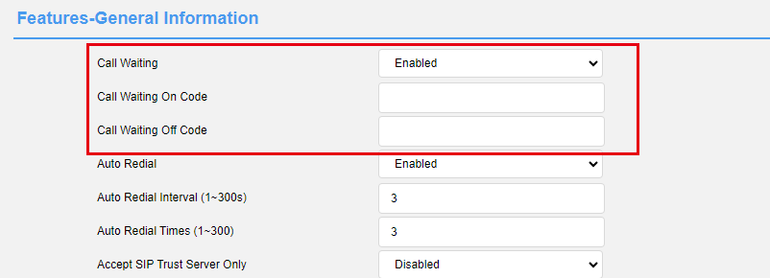

Set the call waiting function on the phone

1. Click Menu → Function → Call Waiting;

2. Enable or disable the call waiting function (common account).

3. Enable or disable the beep tone. Whether a beep tone is played for a new call during a call.

4. Enable the feature code (optional) to be sent to the server during call waiting.

5. Disable the feature code that is sent to the server during call waiting (optional).

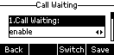

## **PIN call**

If you are making a call and do not want the caller to see the number you are dialing you can enable passcode calling.

**- Setting up password calls via the web**

1. Click Menu → Features (U) → General Information (5).

2. Setting up a password call;

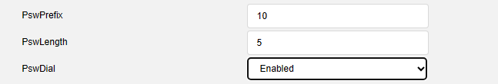

3. Press Submit to save the operation or Cancel to cancel it;

The last 5 digits of a number starting with 10 will be replaced by \* after successful configuration;

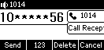

## **Call hold**

When you have an emergency to deal with while you are on a call, you can press the Hold button to enter the call hold state, and the server will play a hold tone for the other end.

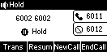

**- Setting the Hold Tone via the Web**

1. Click Menu → Functions (U) → Basic Information (5).

2. Setting the hold tone.

a) Call Hold tone;

b) Call Hold tone delay;

c) Hold tone interval;

d) Call Held Tone;

e) Call Held tone delay;

f) Held beep interval;

3. Press Submit to save the operation or Cancel to cancel it;

When you enter Hold Mode after turning on the beeper, the beeper will play "Di";

**- Setting RFC 2543 Hold Mode via the Web**

1. Click Menu → Account (U) → Advanced (5);

2. Set to enable disable RFC 2543 hold mode;

3. Press Submit to save the operation or Cancel to cancel it;

The PBX does not play hold tones when RFC 2543 hold mode is enabled;

## **Automatic redial**

If you enable auto redial, the phone will show auto redial prompt in LCD interface after call failure, you can also set auto redial interval and auto redial times.

-Set up automatic redialing through the phone interface:

1. Press Menu → Features → Auto Redial;

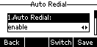2. Select Enable Auto Redial, set Auto Redial Interval (in seconds, default 10, range 1-300), and set Redial Counts (default 10 range 1-300);

1. Press Save to save the operation or Return to cancel it.

The following screen appears when the phone call fails:

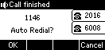

Press the **OK** soft key to activate the Auto Redial feature.

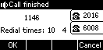

Press the OK soft key or wait for a period of time (redial interval) and the phone will call out the number again.

-Set up automatic redialing through the web interface:

1. Press Features (U ) → Basic Information;

2. Select Enable Auto Redial, set Auto Redial Interval (in seconds, default 10, range 1-300), and set Redial Count (default 10 range 1-300);

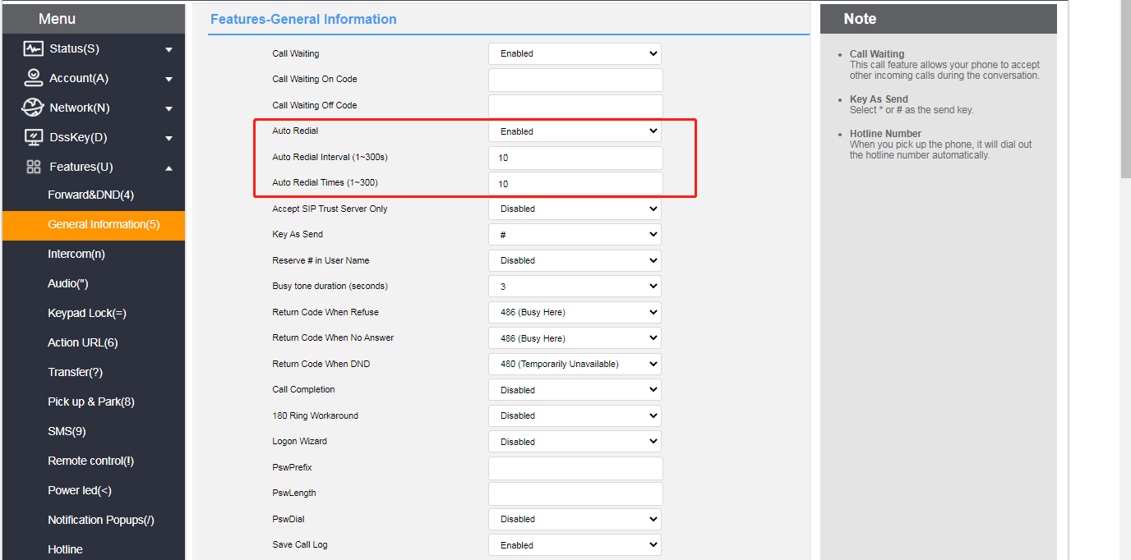3. Click the **Submit** button at the bottom of the page to save it.

## **Status return code**

The phone can set the status return code for Reject/No Answer/Do Not Disturb.

**- Setting the status return code through the page**

1. Log in to the Web interface.

2. Click **Features (U) -> Basic Information (5)**.

3. Set the status return code supporting: 404/480/486/600/603.

4. Click the **Submit** button at the bottom of the page to save the configuration.

After successful configuration the phone sends the corresponding return code to the peer:

## **Call completion.**

When the phone is enabled for call completion, the phone enters the call completion prompt interface when calling a user in busy state, and the server will notify the phone to redial when the called user turns to idle state after clicking Confirm.

**- Set Call completion via web setup**

1. Function (u) → Basic Information
2. Select **Enable**

When the called user is busy, the phone interface prompts as follows:

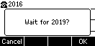

After pressing Confirm, when the called user turns to idle status, the phone interface will show the following prompt:

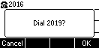

Busy state has been tested to detect only the call state, other states are not detected, all others will prompt the calling user to switch to idle state.

Other can only enter the busy state when it is not possible to dial, it is not possible to detect whether it is idle or not, e.g., DND, blacklist, etc. are not detected;

If the user's transferred number dialed by the phone is busy, the phone will enter the call completion interface but cannot detect the transferred number status, and after detecting the normal state of the dialed phone, it will be prompted to dial the number. For example, if the call completion is enabled on phone A (call completion), phone B (called number, unconditional transfer to phone C is enabled), and phone C (transferred number, DND is enabled), phone A dials phone B, and phone A enters the call completion interface, and after a period of time, it will jump to the dialing interface, and it will not be affected by whether or not DND is turned off on phone C.

Attention:

Call completion requires server support.

Call Completion If there are multiple calls only the dialed call hangs up and prompts for dialing;

Multiple call waiting screens will not appear, and the call waiting screen disappears after operating the call;

Exit Call Waiting prompt does not disappear before entering the dialing screen without dialing, and incoming calls do not interrupt call completion.

**- Setting up Auto-Answer through the handset interface**

1. Press **Menu->Functions->Auto Answer.**

2. Press or to select the account you want to enable auto-answer.

3. Press the **Toggle** soft key to toggle the enabled or disabled state.

4. Press the **Save** soft key to save the operation.

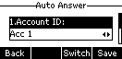

Quick key: In the standby interface, pressing the "Automatic Response" key to enable a quick switch to the automatic response mode.

When Auto Answer is turned on, the Auto Answer icon appears on the display of the handset standby, indicating that the handset is in the Auto Answer state. When the phone is in a call state, it will not answer automatically.

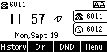

## **Anonymous call**

The phone can turn on the anonymous reject feature to automatically reject an anonymous call when it comes in. If the server supports the anonymous reject function, you can also turn on/off the anonymous reject function of the account by dialing the server's service code.

At the same time, the phone can turn on the local anonymity function, the call initiated by this phone, the other party can not see the caller number, but after turning on the anonymity of the other party may be rejected.

**- Setting up an anonymous reject function through the phone interface**

1. Press **Menu->Functions->Anonymous Call.**

2. Press the **Toggle** soft key to toggle the Enable or Disable state of **Anonymous Reject**.

3. Press the **Save** soft key to save the operation.

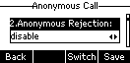

**- Setting up local anonymization through the handset interface**

1. Press **Menu->Functions->Anonymous Call.**

2. Press or to select the local anonymization option.

3. Press the **Toggle** soft key to toggle the **local anonymization** enabled or disabled state.

4. Press the **Save** soft key to save the operation.

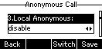

**- Setting up anonymous reject/local anonymization through the web interface**

1. Log in to the Web interface.

2. Click **Account->Advanced**, as shown below.

3. Select the account for which you want to enable anonymous rejections.

4. Select **Enable** in the Anonymous Reject field/Local Anonymous field**.**

5. If you select Enable in the feature code bar of the local anonymous/Anonymous reject switch, the corresponding feature code is sent (optional).

6. Enter the corresponding feature code (optional) in the Enable/Disable feature code field. The server provides different feature codes.

7. Click **Submit** to save.

In this example, the anonymous call enabled feature code \*11 is sent to the server, and the server synchronously enables the anonymous call. Note: The anonymous call function must be supported by the server; otherwise, it has no effect after being enabled.

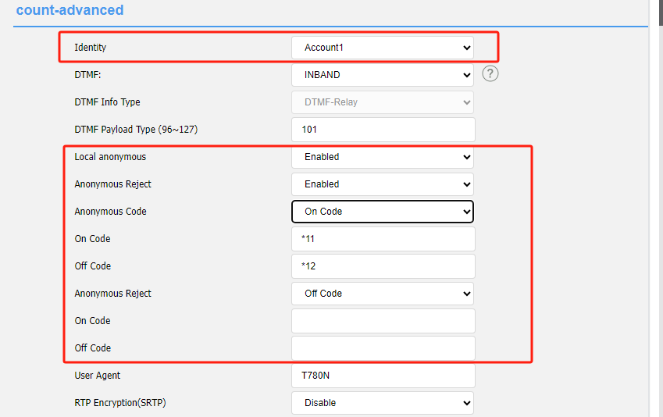

## **Hotline**

You can set a frequently dialed number as the hotline. When using the hotline, when you press the the headset1b4501cc-a268-4f9b-9930-12dc25c4ca81_20917(1) for dialing, wait for the hotline delay time to expire, and the phone will automatically dial the set hotline number. If the delay time is set to 0, the hotline number will be called out immediately upon dialing.

**- Setting up hotline functions through the telephone interface**

1. Press **Menu->Functions->Hotline.**

2. Fill in the hotline number to call.

3. Press or to select Hotline Delay Time and fill in the number of seconds after the handset is taken off the hook to automatically dial the hotline.

4. Press the **Save** soft key to save the operation.

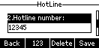

**-** Set the hotline function on the web UI

1. Log in to the Web UI.

2. Click Function (U) -> Hotline, as shown below.

3. If the configuration is common, the entire device is common.

4. Custom can be set according to the account situation.

5. Account: Select the account for which you want to open the hotline.

6. Hotline number: Enter the outgoing number.

7. Hotline delay (0-10S) : Wait for the hotline to be executed after entering into the dial interface( picking up handset or pressing the account key etc.)

8. Click Submit to save.

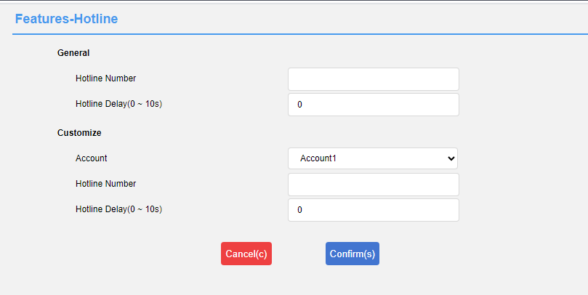

## **Two-dimensional barcode**

The phone supports scanning the QR code provided by the phone to access the web interface, so as to configure the information of the phone on the cell phone. Before scanning the QR code, the cell phone must be connected to the same LAN as the phone, e.g. connected to the router's WIFI.

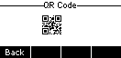

The interface of the cell phone logging in the phone likes the following figure, the specific use method is the same as the computer web operation, to understand the configuration method of each function, please go to the function introduction of each chapter to view, if there is any question about the use of QR code, please contact your network administrator.

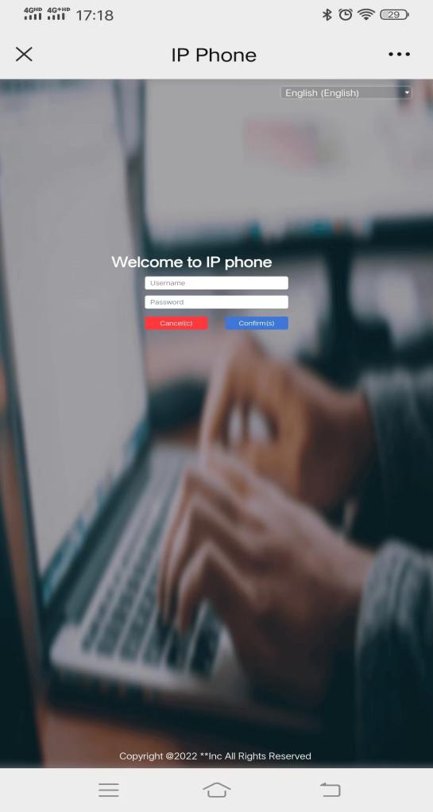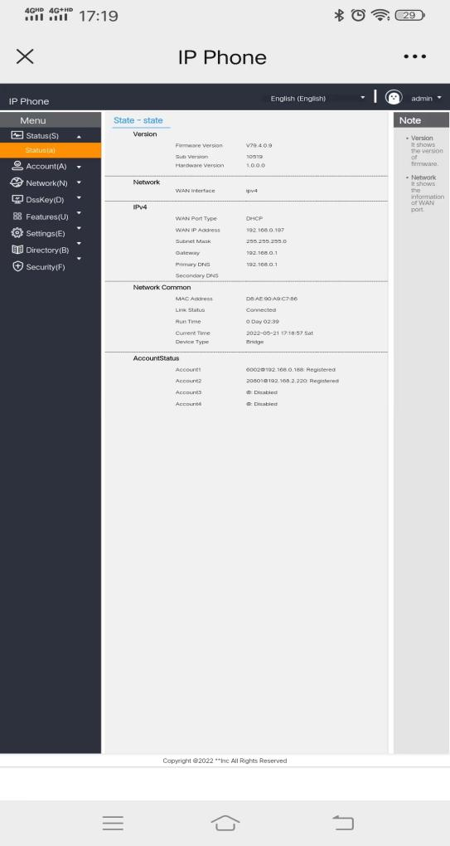

## **Conference**

The phone can initiate a three-way call locally and use the **Conference** softkey during a two-way call to invite a third-party call into the current call.

**- Create a local three-way call at the phone**

1. It happens in the middle of a call between A and B.

2. A presses the **Conference** soft key to initiate a three-way call, the call between A and B goes on holding, and A enters the dialing interface.

3.A Enter the C number and press the **Dial** soft key.

4. When C answers the incoming call, A presses the **Conference** soft key and ABC will start a three-way call.

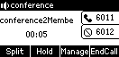

**- Add calls from both accounts to a three-way call**

1. **Account 1** of Handset A is talking to Handset B, and **Account 2** of Handset A is talking to Handset C (but is on hold).

2. If Account 1 is on a call and Account 2 is on hold, press or to switch the call, using account 1 that is on a call, press the **Conference** soft key to enter the dialing page, press to select the held call, and press the **Send** soft key to start the three-way call.

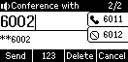

**- What you can do during a three-way call**

1. **Split** soft key: You can split a three-way call into multiple independent calls, press or to switch between calls.

2. **Hold** soft key: You can put two other parties on hold and press the **Resume** soft key to resume the three-way call.

3. **Manage** Soft key: Enter the Management page to perform the following operations on the other two parties' calls:

1) **Delete** softkey: deletes the selected conference member.

2) **Hold** softkey: Holds the selected conference member.

3) **Return** softkey: return to the previous level interface.

4. **Mute** button: so that the other two parties can not hear your own voices, and the other two parties can still make a call.

5. **Hang up** soft key: ends the meeting.

- Change the conference type on the Web UI

1. On the webGUI, tap Account (A) -> Advanced (j).

2. Change the meeting type to network meeting.

3. Enter the meeting URI (please provide server that requires supporting network meetings for the corresponding account).

4. Click Submit to save the configuration.

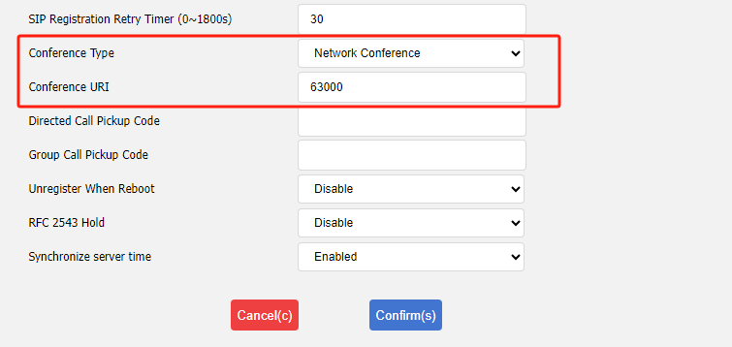

## **Update**

The phone can be upgraded to the latest version via the Web. The latest version can be downloaded from the official website or contact your dealer for a copy.

**- Upgrade Firmware Version via Web**

1. Through the web interface, click **Settings->Upgrade->Upgrade Firmware**, select the version that needs to be upgraded and click Upgrade.

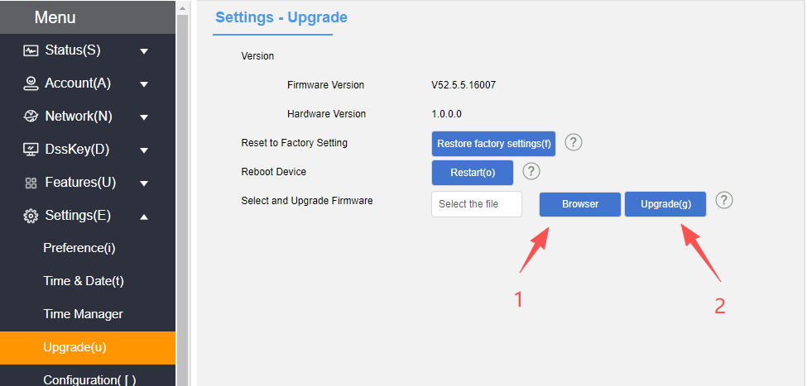

2. Disconnection of power and network is prohibited during the upgrade process, otherwise irreversible problems may occur, such as inability to power on the phone.

## **Upload ringtones**

The phone can upload customized ringtones via the Web.

**- Upload customized ringtones via Web**

1. Click **Settings->Preference->upload Ringtones** through the web interface.

2. Select the ringtone you want to upload in the Load ringtone item, click the Import button to import the ringtone (maximum ringtone limit:100KB).

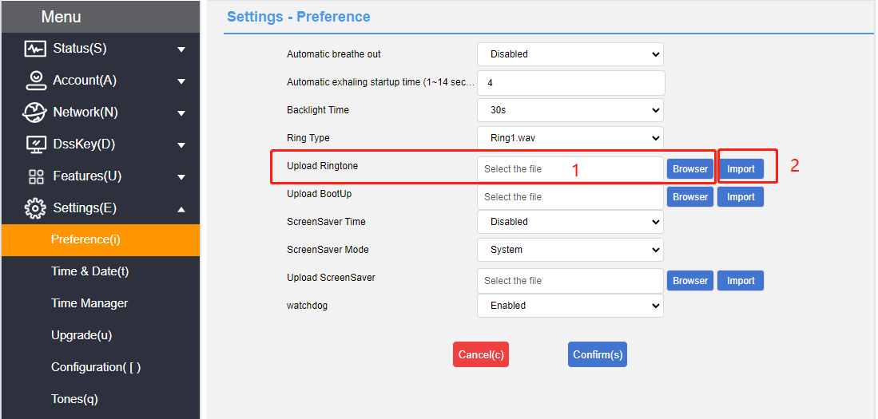3. After successful upload you can select it in the ringtone type option.

## **Capture & Diagnose**

The phone can be used to capture packets via the Web for professionals to easily locate phone problems.

**- Grabbing packets from the web**

1. Click **Network Configuration->Diagnostics** from the web page.

2. Select the packet capture method.

3. Click Start and download the file after the packet capture is finished.

**- Diagnosing the network through the web**

1. Click **Network Configuration->Diagnostics** from the web page.

2. Select the diagnostic command.

3. Click Submit to check the network status.

**- Network diagnostics via phone**

1. The phone clicks **Menu->Settings->Basic Settings->Diagnostics->Network**.

2. Select Ping or Route Trace, enter the IP address or URL and click Start.

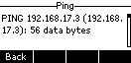

## **Scheduled reset**

The phone can be set to restart automatically via the web page, it is disabled by default.

**- Configure automatic reboot via web page**

1. Click **Settings->Time Management** through the webpage.

2. Configure the restart program.

a) Auto Restart Enable/Disable;

b) Configure the restart time;

c) Configure the restart date;

3. Click Submit to save the configuration.

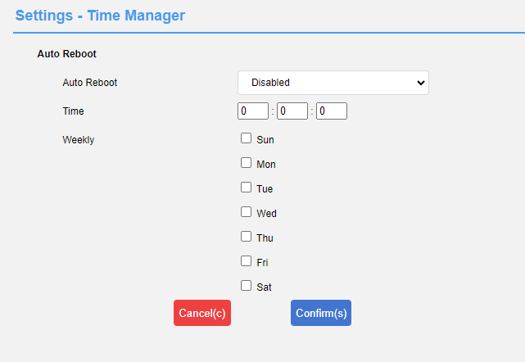

## **Configuration management**

The phones can import/export configurations via web page, and the configurations can be common for the same model.

**- Configuration management via web page**

1. Click Settings->Configuration **Management** from the web page.

2. Click the Export button to export the bin configuration file.

3. Select a configuration file and click Import to import the configuration.

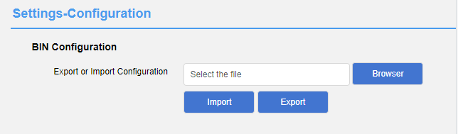

Note: Exported data contains only modified data, default factory Settings will not be exported;

# **Advanced Features**

This chapter introduces the advanced features of the telephone as follows:

* [Messages](#_Message)
* [TR069](#_TR069)
* [SIP Configuration](#_SIP配置_1)
* [Action URL](#_Action_URL_1)
* [Trusted Certificates](#_可信任证书)

## **Message**

### **Text message**

The IP phone can send and receive text messages. When receiving a new text message, the phone will emit a beep, the power indicator will flash red slowly, the LCD interface will indicate "n new text messages" (n means the number of unread text messages, e.g. 1 new text message), and the icon of unread text message will be displayed. The icon图片1 is displayed for unread text messages.

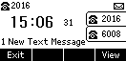

SMS messages can be stored in the Inbox, Sent, Outbox and Drafts boxes, each with 100 messages. If the number of messages exceeds 100, the oldest messages are deleted.

**- Read the text message:**

1. Press **Menu->Messages->Text Messages->Inbox**.

2. Select the message you want to read and press the **View** soft key.

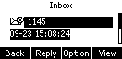

**- Sends a text message:**

**Description**  If the phone prompts to receive a new text message, you can simply press the **View** soft key to read it.

1. Press **Menu->Message->Text Message->New Message**.

2. Compose a new message and press the **abc** soft key to switch the input method.

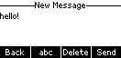

3. Press the Send soft key.

4. (Optional) Press the **Toggle** soft key to select the sending account in the **From** area.

5. Enter the recipient's number in the **Send To** field.

6. Press the Send soft key to send a message or the Return soft key to cancel.

**- Sending text messages through the web interface**

1. Log in to the web user interface.

2. Click **Features (U)->SMS (9).**

3. Select the sending account.

4. Enter the sending number.

5. Fill in the send content.

6. Click the **Submit** button to send the short message.

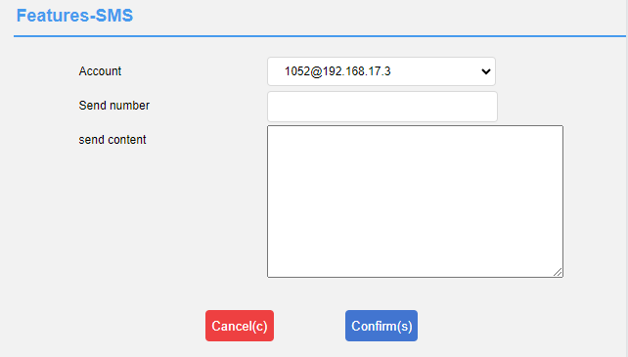

**- Respond to the text message:**

1. Press **Menu->Messages->Text Messages->Inbox**.

2. Select the message you want to reply to and press the **Reply** soft key.

3. Write the message and press **abc** to switch the input method.

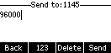

4. When you have finished writing, press the **Send** soft key.

5. Check the **From** and **To** areas and press the **Send** soft key.

**- Delete the text message:**

1. Press **Menu->Messages->Text Messages->Inbox (Sent Messages, Outbox or Drafts)**.

2. Select the message to be deleted and press the **Options** soft key.

3. Select **Delete** and press the **OK** soft key to display "Delete Selected Information?" on the LCD screen. The LCD screen displays "Delete Selected Information?".

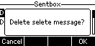

4. Press the **OK** soft key to delete and press the **Cancel** soft key to cancel.

To delete all SMS messages, press the **Options** soft key and select **Delete All**. For more information, see the steps above.

**Description**  You can delete a message by pressing the **Delete** soft key directly after you have received and viewed a specific short message.

### **Voicemail**

The phone can send and receive voice messages. You can subscribe to voice messages cached in the voice mailbox on the phone. This feature requires server pre-setting. Not all servers support voicemail.

When a new voicemail is received, the power lamp of the phone blinks red slowly, the LCD interface displays "N voice messages" (N means the number of unread voice messages, for example: 3 voice messages), and the voice message icon is displayed.

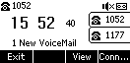

**- Send a voice message:**

When the called user is busy or inconvenient to answer the incoming call, you can leave him a message according to the server's voice prompts, and hang up the phone after leaving the message.

**- Set the voice message access feature code through the phone interface:**

1. Press **Menu->Message->Voice Message->Set Voice Feature Code**.

2. Press or to select the account to be set up.

3. Enter the voice message access feature code (e.g., \*97).

4. Press the **Save** soft key to save the operation or the **Return** soft key to cancel the operation.

**- Listening to voice messages**

1. Press the **SMS soft key** or call out the voice message accessed the feature code after setting the voice feature code.

2. Just listen to the voice message according to the voice prompts.

**- Viewing Voice Messages**

1. Press **Menu->Message->Voice Message->View Voice Message**.

2. Select the account you want to listen to and press the **Connect** soft key to listen to the voice message.

## **TR069**

TR069 is  [the communication protocol between CPE and ACS.](https://baike.baidu.com/item/CPE" \t "https://baike.baidu.com/item/TR-069/_blank) TR069 is the communication protocol between CPE and ACS, through which CPE can complete initialization and operation management such as service activation, function setting, file uploading and downloading, and system testing.

TR069 workflow diagram for IP phones:

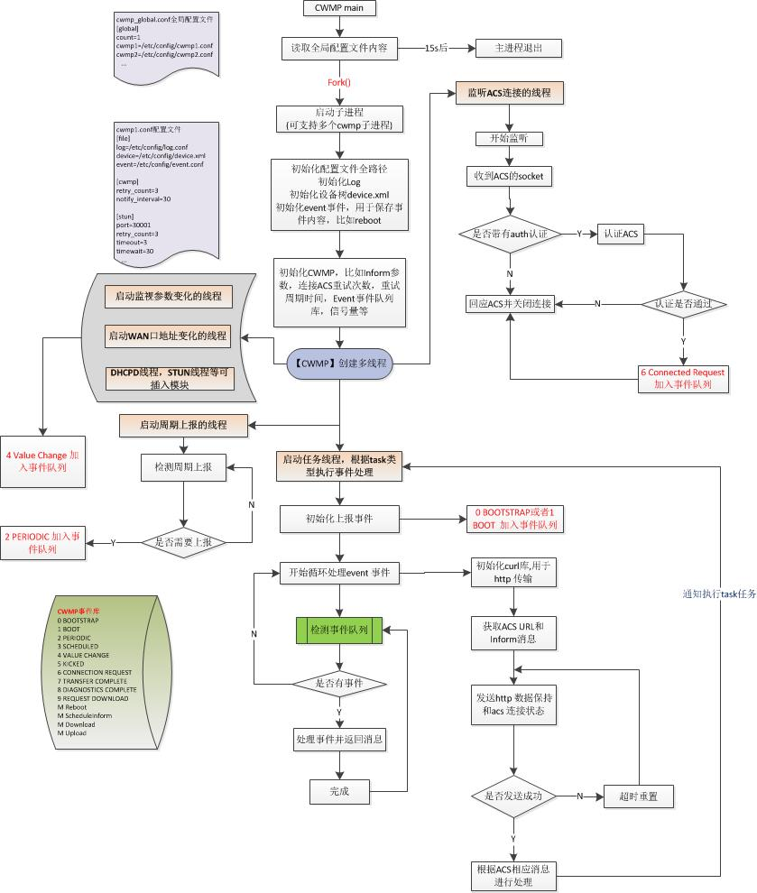

**- Enabling TR069 through the web interface**

1. Log in to the phone page by IP address.

2. Click **Settings (E) -> TR069 (\).**

3. Enable TR069. Enter: user name, password, and server address.

4. Enable periodic notification, periodic notification interval, user name, and password.

5. Press **Submit to** save when you have finished selecting.

As pictured:

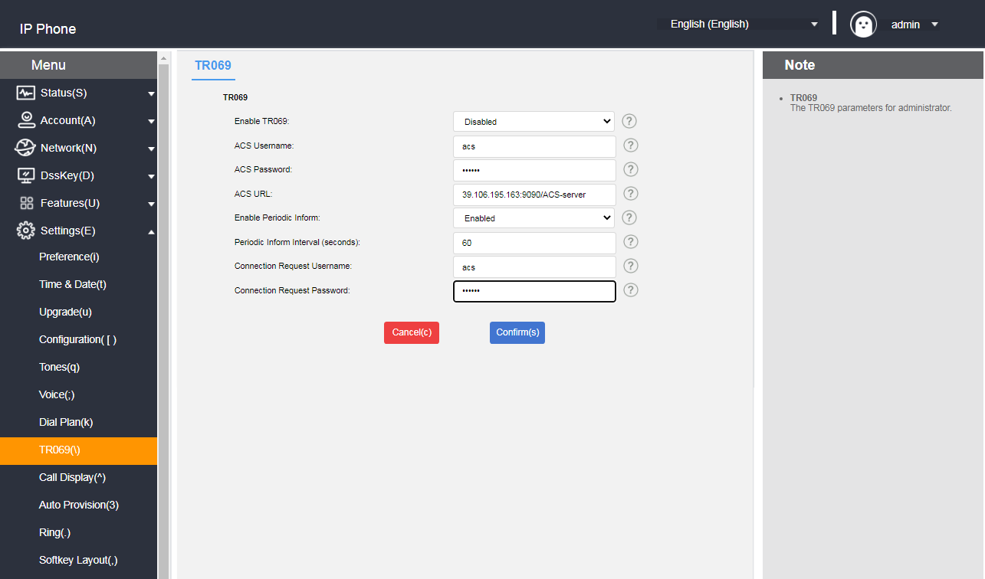

## **Automatic update**

Automatic updates can deploy the same configuration for multiple phones at scale.

### **Preparatory step**

**Prepare the necessary documents:**

The following steps need to be performed before auto-configuration can take place:

1. Get Boot boot file;

2. Get the CFG configuration file;

3. Obtain information about the phone;

4. Setting up a renewed environment.

Bootstrap files, configuration files can be obtained by contacting your dealer for template files;

**- The way to view information about the phone:**

MAC: The phone is viewed in standby mode by pressing the 30b616ed48f00f8e8229adab6ff252a key.

Phone Model: Standby phone press **30b616ed48f00f8e8229adab6ff252a→More→Equipment**, the product name is the phone model.

**- Bootstrap file description:**

When the phone is auto-configured, it will first try to download the common.boot boot file, and according to the boot file, the phone will be guided to refer to the specified CFG configuration file. The sequence is shown below:

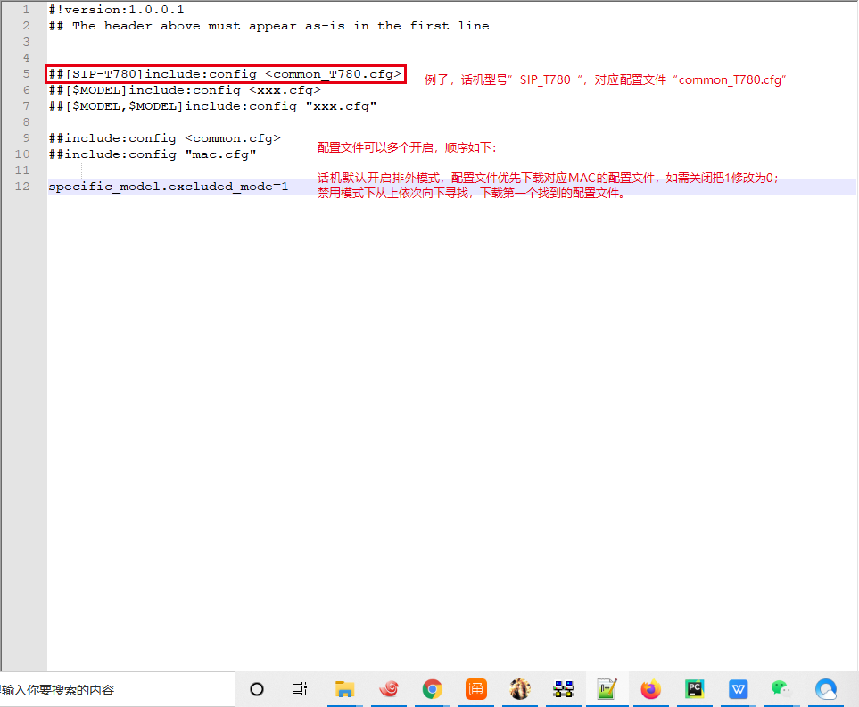

**- Configuration Profile Description:**

Before you configure the phone, you need to get the CFG configuration file, common.cfg for the common configuration file, mac.cfg for the mac-based configuration file; you can also create your own needs according to their own needs of the configuration file such as account.cfg used to configure the phone account and so on.

The list of configuration support is as follows:

|  |  |
| --- | --- |
|  | Content |
| **Phone Configuration** | Account, DTMF, User Agent, Time, STUN, Network, Vlan, LLDP, CDP, Language, Signal Tone, QoS, Sound. |
| **Function Configuration** | Call Forwarding, Anonymous Calling, Intercom, TR069, Programmable Keys, DND, Hotline, Voice Mailbox, Keypad Lock, Action URL, Auto Update. |
| **Other configurations** | Upgrade the phone , pager configuration. |

Example: If the phone needs to be upgraded to a specific version and the language is set to Chinese, create a LanguageAndUp.cfg file, add the configuration and place it in the root directory of the server.

### Language ###

language\_setting.languages = 0

### Upgrade ###

**Description**  If you set up an upgrade, the upgrade file must be in this directory or the upgrade will fail.

static.firmware.url = ftp://192.168.17.xx/V2.0.0.3\_IPhone\_rootfs.sqhfs

### **Automatic update procedure**

#### **HTTP(S) method update**

To configure the server, run HFS.exe directly; after running it, place the configuration file directly in the environment root directory; The configuration file contains files such as xx.boot and xx.cfg.

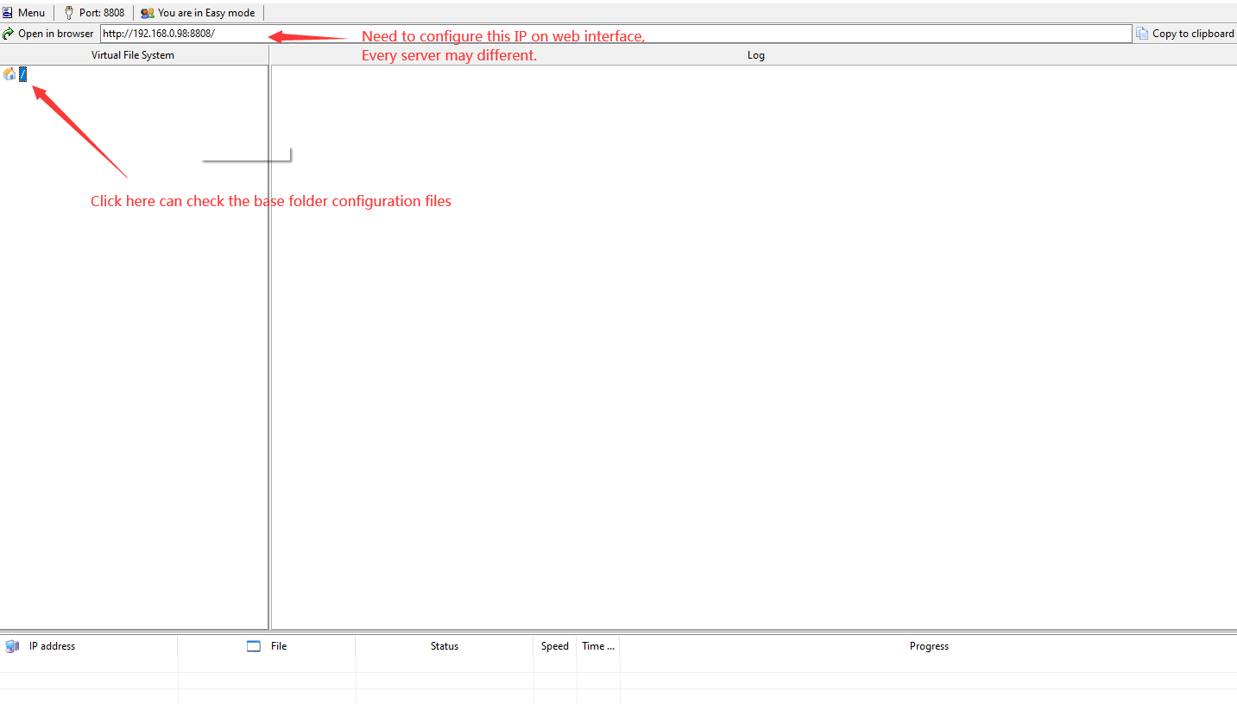

Root directory file map:

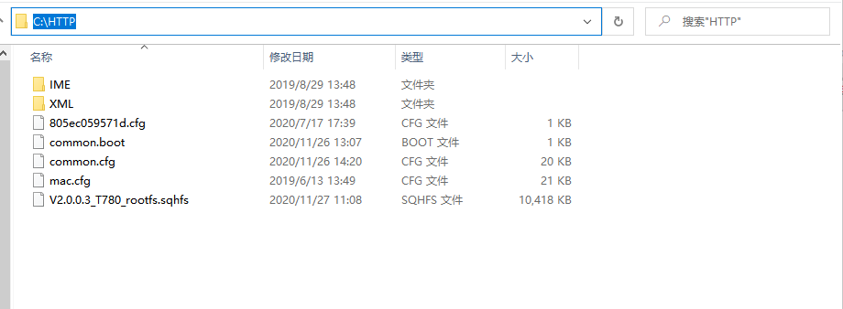

Setup Steps:

Web-side Settings(E)→Auto Update→Fill in http(s) address in Server Address e.g.: http(s)://192.168.17.xx to enable power-on startup; automatically configure the information to be updated after reboot.

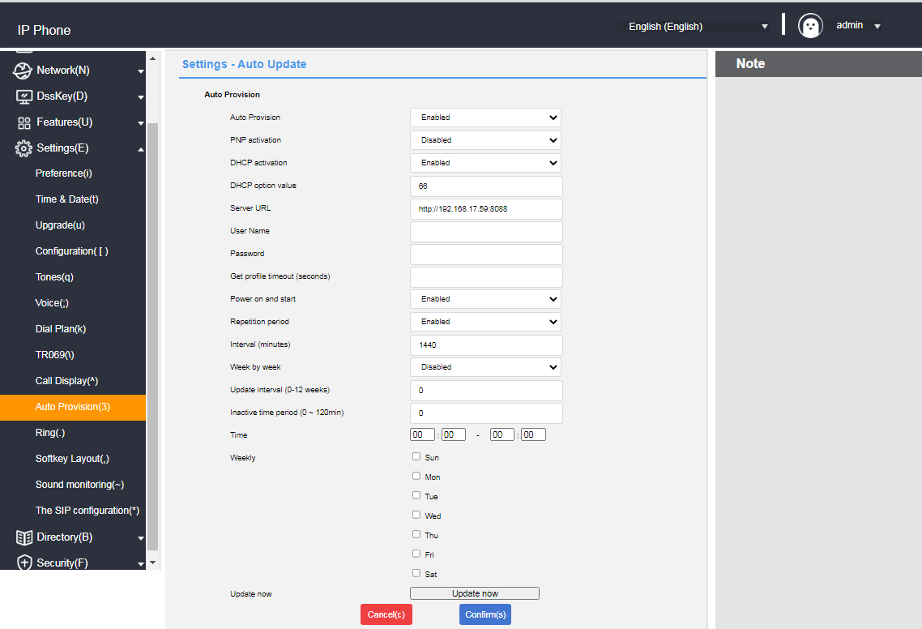

#### **FTP/TFTP update**

Configure the server, directly run IPOP.exe to enable FTP/TFTP inside the service, you can also use 3CDaemon, TFTPD32, etc. as the server; run the configuration file directly in the root directory of the environment; the configuration file contains xx.boot and xx.cfg and other files. The configuration steps are shown in the following figure:

**Setup Steps:**

Web-side Settings (E)→Auto Update→Fill in the ftp/tftp address in Server Address e.g. ftp://192.168.17.xx/ to enable power-on startup;

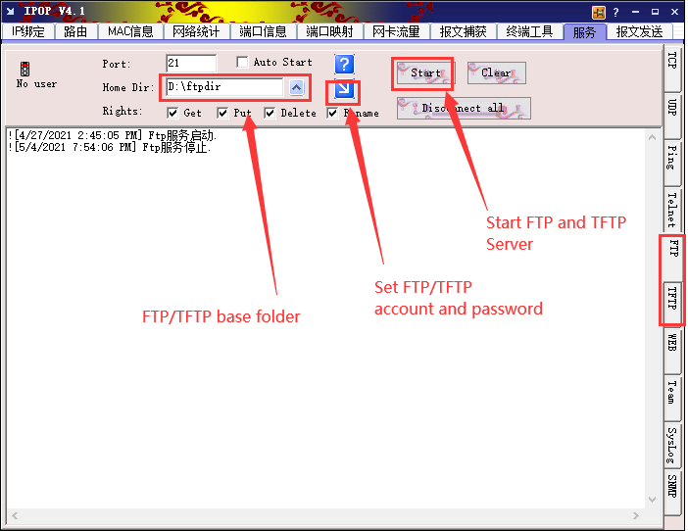

automatically configure information update after reboot.

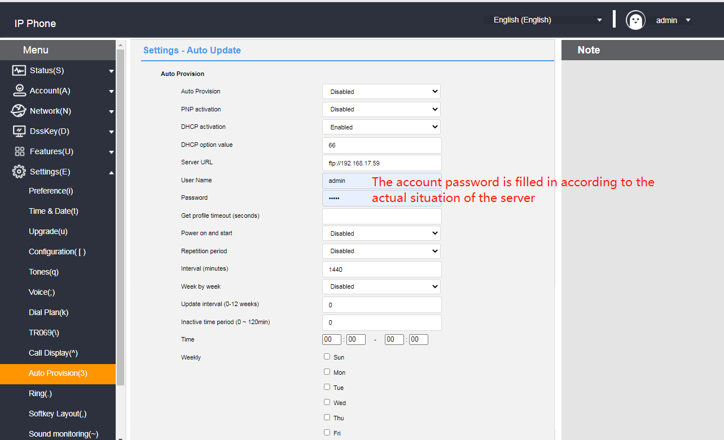

## **Remote control**

Used to control the configuration related to remote XML push.

**- Configure remote control via web page**

1. Log in to the web user interface.

2. Click **Features (U) -> Remote Control (i).**

3. Configure remote control.

a) XML push server address;

b) User name: Set the XML push server address user name;

c) Password: Set the XML push server address password;

d) SIP NOTIFICATION: Enable/disable phone call SIP NOTIFY message processing XML push;

e) Blocking XML push in calls;

f) Allow control IP list: Multiple IPs are separated by ",", allowing all IPs to fill in any;

g) CSTA control;

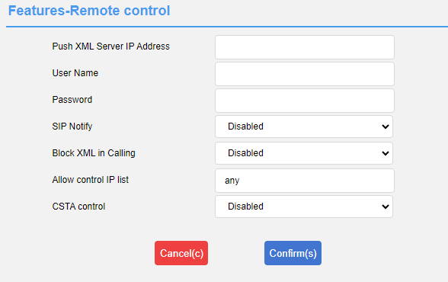

1. Click the **Submit** button to save the changes.

Note: If you perform operations related to calls through remote control (such as making call, connecting, and hanging up), the phone will display a box asking for the customer's authorization to prevent theft. If the control IP address list is modified after authorization or fails after the device is restarted, you need to re-authorize the IP address list. As shown below:

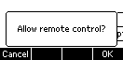

XML can perform the following operations:

Displaying menu options, displaying text prompts, collecting user submissions, downloading address books from the server, prompting the phone for status information, notifying the phone to perform a series of commands, modifying phone configuration (e.g., registration, etc.), displaying text prompts in a fixed format on the interface, displaying graphic prompts on the interface, displaying menu items in graphic format, and customizing function softkeys.

**- Server pushes XML to phone**

Remote control application, the server can push XML to the phone by POST, and the end user does not need any action. This time we don’t do introduction of server building .The interested parties can learn a programming language. Here we take the PHP environment as an example to push the XML file to the terminal of the phone:

The file format is as follows, just access it after the configuration is complete.

|  |
| --- |
| <?php #  function pushtophone($server,$phone,$data){  $xml = "xml=". $data;  $post = "POST / HTTP/1.1\r\n";  $post . = "Host: $phone\r\n" ;  $post . = "Referer: $server\r\n";  $post . = "Connection: Keep-Alive\r\n" ;  $post . = "Content-Type: text/xml\r\n";  $post . = "Content-Length: ".strlen($xml)." \r\n\r\n".  $fp = @fsockopen ( $phone, 80, $errno, $errstr, 5);  if($fp){  fputs($fp, $post.$xml); flush();  fclose($fp);  }  }  $xml = "<IPPhoneTextScreen Beep=\"yes\">\n";  $xml . = "<Title>Push test</Title>\n";  $xml . = "<Text>This is a test for pushing text to a phone.</Text>\n";  $xml . = "</IPPhoneTextScreen>\n" ;  pushtophone("192.168.17.xx", "192.168.17.xx",$xml);  ? > |

## **SIP Configuration**

### **SIP Session Timer**

SIP session timers T1, T2 and T4 are SIP transaction layer timers defined in RFC 3261.

**- Configure SIP session timer via web page (only via web page)**

1. Log in to the web user interface.

2. Click **Settings (E) -> SIP Configuration (\*).**

3. Configure T1, T2 and T4.

4. Click the **Submit** button to save the changes.

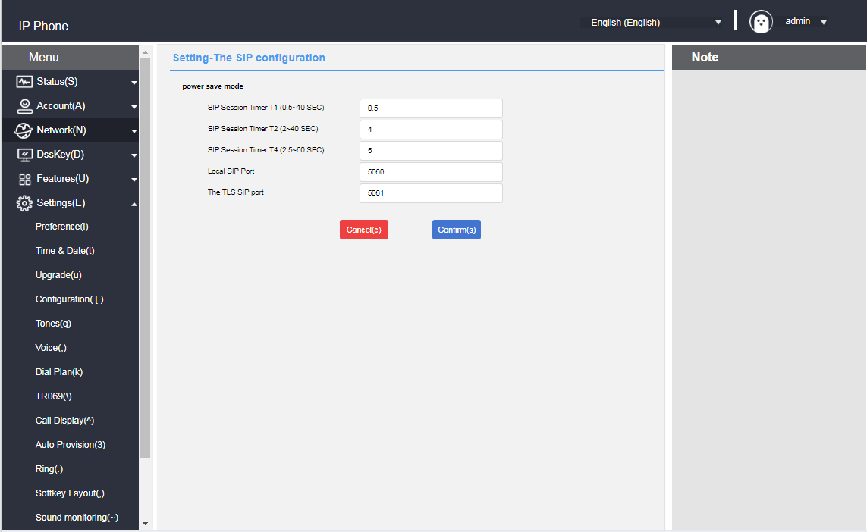

SIP Session Timer T1: Timer T1 is an estimate of the round-trip time (RTT) of a transaction between a SIP client and a SIP server.

SIP Session Timer T2: Indicates the maximum retransmission time for any SIP request message. the retransmission multiplication of T1 will continue until the retransmission time reaches the value of T2.

For example, a user registers a SIP account and sets the values of timer T1 and timer T2 respectively (timer T1:0.5, timer T2:4). the SIP registration request message will be retransmitted between the phone and the SIP server. The retransmission multiplication of timer T1(0.5) will continue until the retransmission time reaches timer T2(4). The total registration request retry time will be less than 64 times T1(64 \* 0.5 = 32). The retransmission intervals are in order:0.5s, 1s, 2s, 4s, 4s, 4s, 4s, 4s, 4s, 4s, 4s.

SIP Session Timer T4: Indicates how long it takes for the network to clear messages between the SIP client and server.

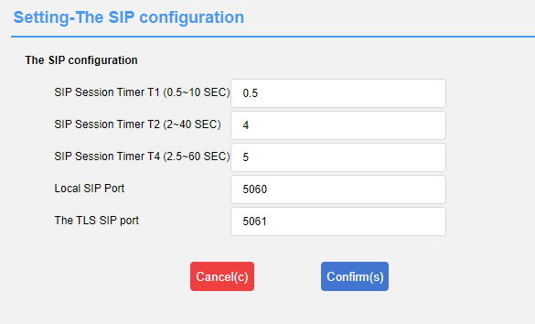

### **Native SIP ports vs. TLS SIP ports**

If NAT is not enabled, the port number is displayed in the header of the SIP message for via and contact. If NAT is enabled, the phone will use the port and address for NAT in the header fields for via and contact, but will still use the configured source port.

**- Configuring Local SIP Ports and TLS SIP Ports via Web Page**

1. Log in to the web user interface.

2. Click **Settings (E) -> SIP Configuration (\*).**

3. modify the local SIP port and TLS SIP port.

4. Click the **Submit** button to save the changes.



## **Action URL**

The Action URL function is mainly used for the phone to report its own behavior to the computer, an action generates a URL on the phone side, and the actions on the phone side include incoming call, outgoing call, call transfer, etc. The web management interface lists all the supported actions, and each action corresponds to a user-defined URL. when an action is generated, such as an incoming call, the phone sends out an HTTP/HTTPS GET to the computer of the corresponding URL, so as to achieve the purpose of reporting its own actions. HTTP/HTTPS GET to the computer to report the action.

This function works in conjunction with the Action URI to enable mutual control between the phone and the computer.

URL format: http(s)://server address/help.xml?mac=$mac

### **Enables actions to be reported to the server**

Enables reporting of server actions and a list of variables supported by each action:

|  |  |  |
| --- | --- | --- |
| **Reportable actions** | **clarification** | **Supported Variables** |
| Startup complete. | When phone startup is complete | $mac  $ip  $model  $firmware (base) |
| registered | When SIP account registration is successful | $mac  $ip  $model  $firmware  $local |
| unregistered | When the SIP account is not registered | ibid |
| Registration Failure | When SIP account registration fails | ibid |
| Drop the handle. | When the handle is hanging | $mac  $ip  $model  $firmware (base) |
| Pick up the handle. | When the handle is off | ibid |
| When there is an incoming call | When the phone calls | $mac  $ip  $model  $firmware  $active\_url  $active\_user  $active\_host  $local  $remote  $display\_local  $display\_remote  $call\_id  $callerID  $calledNumber (call related) |
| send a call | When the phone dials | ibid |
| establish a session | When the call establishes a session | ibid |
| end a call | At the end of the call | $mac  $ip  $model  $firmware |
| Turn on Do Not Disturb | When Do Not Disturb is turned on | ibid |
| Turn off do-not-disturb | When you turn off Do Not Disturb | ibid |
| Turn on unconditional forward | When unconditional call forwarding is turned on | ibid |
| Close unconditional forward | When unconditional call forwarding is turned off | ibid |
| Open up a busy forward | Turn on the busy call forward | ibid |
| Turn off busy forward | Turn off call forwarding when busy | ibid |
| Turn on no-answer forward | Turn on No Answer Forward | ibid |
| Turn off no-answer forward | Turn off no answer forward. | ibid |
| transfer a call | When a call transfer occurs | $mac  $ip  $model  $firmware  $active\_url  $active\_user  $active\_host  $local  $remote  $display\_local  $display\_remote  $call\_id  $callerID  $calledNumber |
| Blind transfer | blind transfer | ibid |
| Advisory Transfers | Consultation transfer | ibid |
| Call hold | hold a call | ibid |
| Discontinue holding | When canceling call holding | ibid |
| mute | When mute is on | ibid |
| unmute | When mute is canceled | ibid |
| unanswered call | When there is a missed call | ibid |
| IP Change | When changing the IP address of the phone | ibid |
| Idle Entry Call | When the phone enters a call from the idle state | $mac  $ip  $model  $firmware  $active\_url  $active\_user  $active\_host  $local  $remote  $display\_local  $display\_remote  $call\_id  $callerID  $calledNumber |
| Calls go into idle | When the phone goes from talking to idle | ibid |
| Rejection of calls | When rejecting an incoming call | ibid |
| Answer new calls | When answering a new call | ibid |
| transfer failure | When call forwarding fails | ibid |
| Transfer complete. | When call forwarding is complete | ibid |
| forward call | forward call | ibid |
| Auto provision | When the automatic update is complete | ibid |
| Turn on call waiting | When call waiting is turned on | $mac  $ip  $model  $firmware |
| Turn off call waiting | When call waiting is turned off | ibid |
| Using a headset | When using a headset | ibid |
| hands-free | hands-free | ibid |
| Cancel Outbound | When canceling an outgoing call | ibid |
| remotely busy | Remote call on busy | ibid |
| Cancel Remote Call | When canceling a remote call | ibid |
| Peripheral Information | When updating peripheral information | ibid |
| VPN IP | When the VPN obtains an IP | ibid |

### **Description of variables**

Variables supported in the Action URL:

|  |  |
| --- | --- |
| **Reportable actions** | **clarification** |
| $mac | Phone MAC address. |
| $ip | Phone IP address. |
| $model | Phone Type. |
| $firmware | The firmware version number of the phone. |
| $active\_url | The sip\_uri of the current active account (only in effect for inbound, outbound, and calls). |
| $active\_user | User account replenishment for the sip\_uri of the currently active account (only in effect for inbound, outbound, and calls). |
| $active\_host | The server portion of the current active account's sip\_uri (only in effect for inbound, outbound, and calls). |
| $local | The local sip\_uri. |
| $remote | The sip\_uri of the opposite end. |
| $display\_local | The local display name. |
| $display\_remote | The name of the opposite end of the display. |
| $call\_id | Call ID. |
| $callerID | The display name of the caller on an outgoing call. |
| $calledNumber | The number that is called out on an outgoing call. |

### **Web Configuration Instructions**

**- Configuring Action URLs on Web Pages**

1. Log in to the web user interface.

2. Click **Features (U) -> Action URL (6)**.

3. Enter the information to be reported to the server in the appropriate fields.

Example:

http(s)://server address/help.xml?mac=$mac

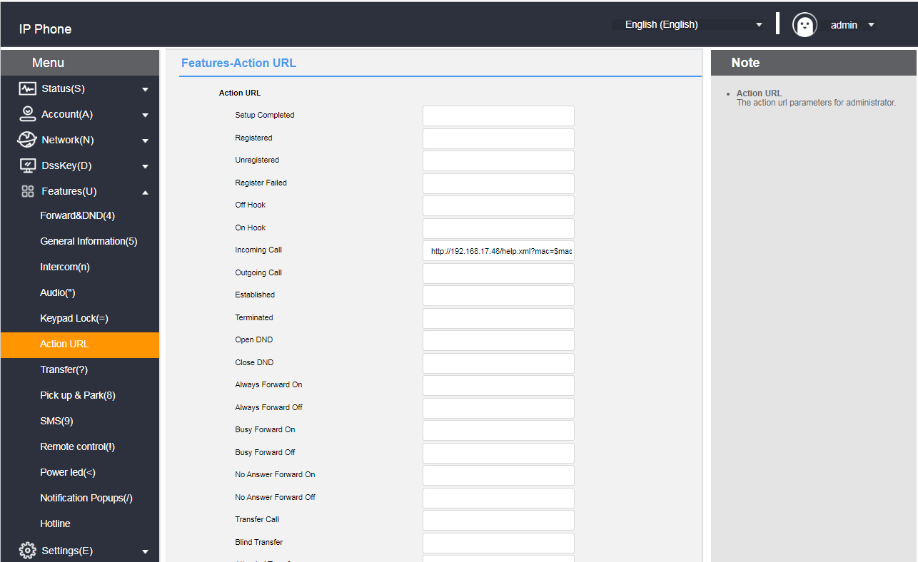

4. Click the **Submit** button to save the changes.

## **Type of web access**

You can configure the web access type to restrict web logins.

**- Configuration of web access types through web pages**

1. Log in to the web user interface.

2. Click Network Configuration **(N) -> Advanced (v).**

3. Configure the type of network access click web server.

a) Enable/disable http access;

b) Configure the http access port.When using the default 80 access without adding the port when others port need to be added after the IP to access;

c) Enable/disable https access;

d) Configure the https access port, default 443 access without adding the port,when other ports need to be added after the IP to access;

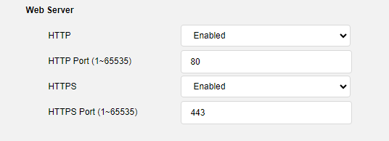

4. Click Submit to save the configuration.

Pages cannot be accessed via web pages after disabling http and https, you can enable access via phone menu->Settings->Advanced Settings->Network->Network Access Type.

- Set the login password on the web page

1. Log in to the Web user interface.

2. Click Security (F) -> Password.

3. Enter the old password, new password, and confirm password.

4. Click Submit to confirm the operation or cancel the current operation.

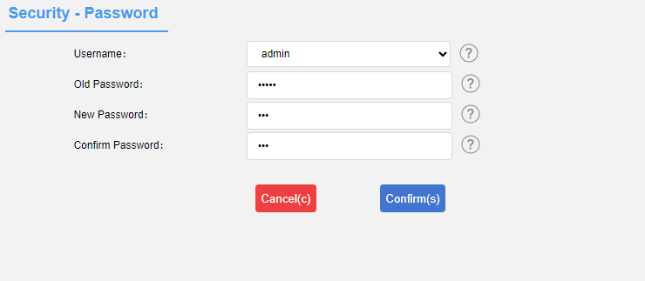

- Set the advanced password on the web page

1. Log in to the Web user interface.

2. Click Security (F) -> Advanced Password Settings.

3. Enter the old password, new password, and confirm password.

4. Click Submit to confirm the operation or cancel the current operation.

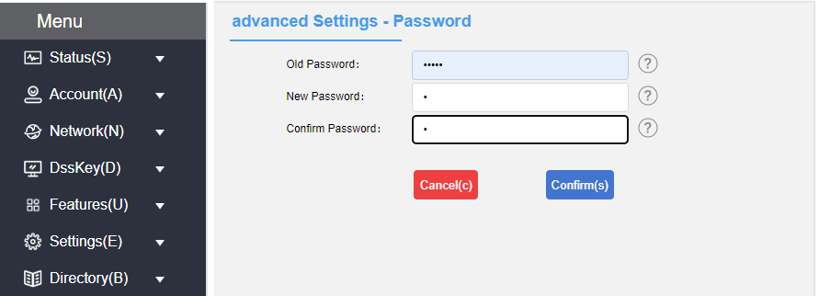

Note: The password is used in the phone menu -> Settings -> Advanced Settings. The default password is admin.

## **Trusted Certificates**

You can upload specific CA certificates to your phone.

**- Configuration of trusted certificates via web page**

1. Log in to the web user interface.

2. Click **Security (F) -> Trusted Certificates (@).**

3. Select the appropriate value from **Allow only trusted certificates**, **User name confirmation**, **CA certificates**.

4. Click **Submit to** confirm the operation.

A dialog box pops up, prompting for a reboot to take effect.

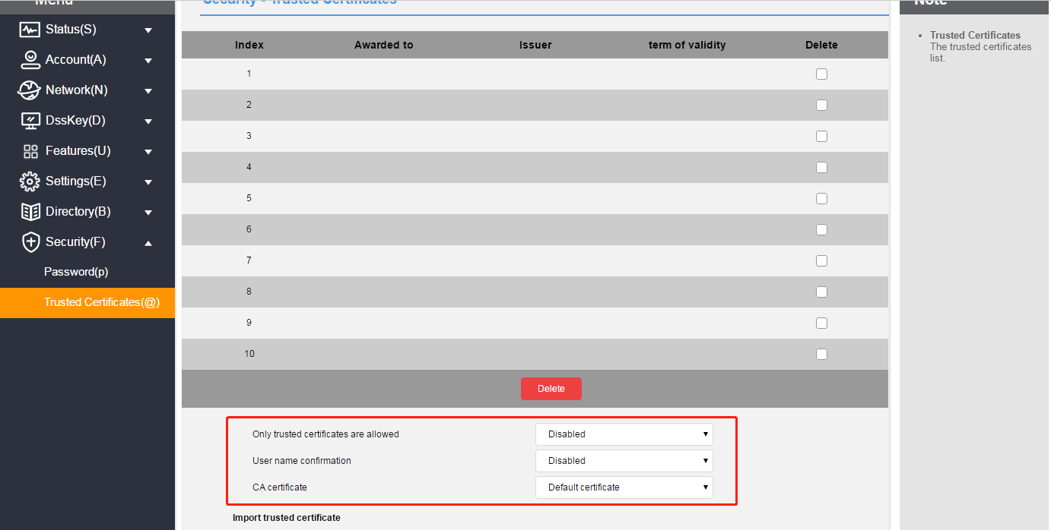5. Click Confirm to restart the phone.

**- Uploading trusted certificates via the web**

1. Log in to the web user interface.

2. Click **Security (F) -> Trusted Certificates (@).**

3. Click **Browse** in the **Load Trusted Certificate File** area to select a local certificate file (\*.pem, \*.crt, \*.cer or \*.der).

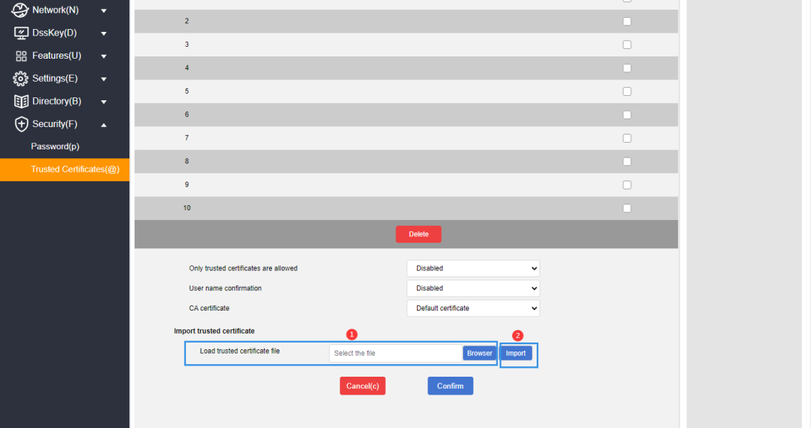4. Click **Import to** upload the certificate.**After the import is successful, a message is displayed indicating that the loading is successful. Refresh the page two seconds later.**

- View and delete certificates through web pages

1. Log in to the Web user interface.

2. Click Security (F) -> Trusted Certificates (@).

3. You can view in the list that the uploaded certificate contains information about the issue to , issuer and validity period;

4. You can also select an unnecessary certificate and click the Delete button at the bottom to delete the certificate.

